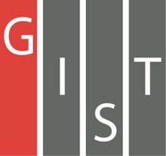
Gwangju Institute of Science and Technology

Official Press Release (https://www.gist.ac.kr/)

Section of Hyo Jung Kim Nayeong Lee
Public Relations Section Chief Senior Administrator
(+82) 62-715-2061 (+82) 62-715-2062

Contact Person Yeon-gil Jeong, Administrator
for this Article Business Support Center
062-715-6301

Release Date 2020.09.09

GIST hosts intensive start-up camp
for the first half of 2020

□ GIST (Gwangju Institute of Science and Technology, President Kiseon Kim) Business Support Center (Director Byung-kwan Cho) held an intensive start-up camp for the first half of 2020 at the end of August to raise interest in start-ups and to expand the start-up culture for GIST students.

∘ The theme of the intensive start-up camp for the first half of this year is "Innovation and Design Thinking," whose purpose is to cultivate the ability to define problems on various subjects and seek solutions by learning design thinking* techniques, which has been in the spotlight as a creative method to make news ideas for start-ups and business management.

* design thinking: Design thinking is a creative strategy that designers use in the design process. It is also an approach that can be used to deliberate on problems and solve problems more broadly than professional design practices, and it has been applied to industrial and social problems. Design thinking is a technology-enabled business strategy that can create customer value and market opportunity to meet people's needs by using the senses and methods of designers.

□ GIST undergraduate and graduate students were openly recruited as camp participants until the end of August, and the total number of participants was limited to less than 30 to follow COVID-19 safety rules for face-to-face event. In addition to identifying basic movements of participants, special attention was paid to the safety rules, such as the mandatory wearing of KF94 masks, temperature checks, and frequent use of hand sanitizers during the camp.

∘ The camp organized a total of 24 selected students into six groups of 4 students each to induce teamwork and idea development on various topics* such as COVID-19, digital transformation, climate change, education, and social contribution. The camp was held for two days and one night using the Creative Space G.

* ▲ topic 1: post-corona health and hygiene (COVID-19 highlights issues of health/hygiene and life extension) ▲ topic 2: digital transformation (rapid digitalization of things we use requires centralization) ▲ topic 3: UN Sustainability Goals (SDGs) and climate change (as global damage increases as a result of abnormal weather conditions, awareness and solutions are needed) ▲ topic 4: qualitative education (new teaching methods and equal educational opportunities are required due to COVID-19 and changes in the environment) ▲ topic 5: sharing and social contribution (as the social concept of possession changes to the concept of sharing, new awareness and methods are needed)

□ At the end of the project, with the aim of developing students' creativity, there was a group presentation session to discuss the proposed topics and ways to solve social problems from the perspective of students as well as a discussion session to further enhance the groups' ideas.

∘ Various ideas were shared, including a multi-channel network for the elderly to solve social problems through sharing, a digital pen for digital transformation with more analog sensibility, a digital exercise coach with digitization of human movement, and online education programs using VR/AR. The shared ideas will be further enhanced through consultation and expert mentoring, and contents discussed in the first half of the year will be actively reflected in the selection and planning during the intensive start-up camp for the second half.

□ GIST Business Support Center Director Byung-kwan Cho said, "The GIST intensive start-up camp was an opportunity to ponder and discuss innovative startup ideas through a timely student startup program. In the post-corona era, when digital transformation is essential, we will put a lot of effort into discovering student start-up programs that GIST should consider and lead."

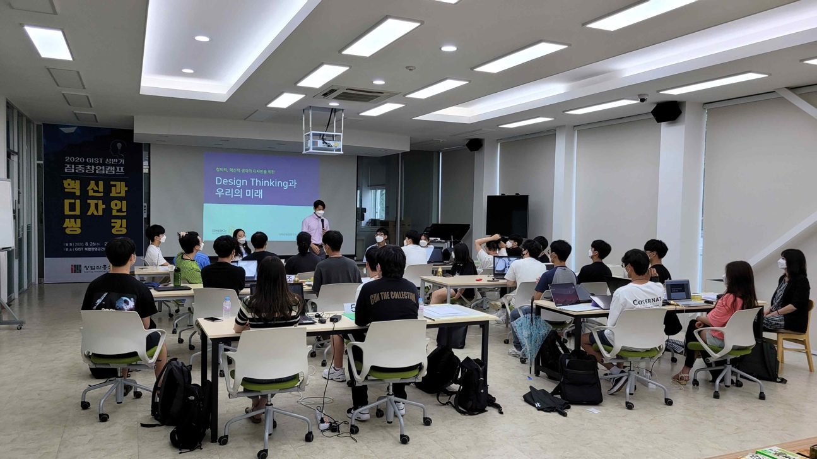
▲ Intensive start-up camp for the first half of 2020 (Education Instructor: Director of Design Thinking Research Institute, and 3 others; Training: 24 college students; Place: Creative Space G)

