Gwangju Institute of Science and Technology

Official Press Release (https://www.gist.ac.kr/)

Section of Hyo Jung Kim Nayeong Lee
Public Affairs Section Chief Senior Administrator
(+82) 62-715-2061 (+82) 62-715-2062

Contact Person Su Yeon Kim, Administrator
for this Article School of Integrated Technology
(+82) 62-715-5303

Release Date 2018.08.26

The 3rd GIST Creative Convergence Competition (2019) hosts a contest to develop a ping-pong robot

□ GIST (President Kiseon Kim) School of Integrated Technology at the Institute of Integrated Technology held the 3rd Creative Convergence Competition (Professor Mun Sang Kim of the Institute of Integrated Technology) to dramatically enhance the practical convergence of education required by the 4th Industrial Revolution.

∘ The event, which marks its third anniversary this year, was held at GIST for two months from July to August 27, 2019. The final winners were selected in the final round of the ping-pong contest on August 23, and an exhibition game will be held at the GIST Oryong Hall on August 27 with an award ceremony at 3:00 p.m. in the afternoon.

□ In addition to GIST, five teams of 17 undergraduate students from Korea University, Seoul National University, Kwangwoon University, and Handong University participated in the contest during two months of their summer vacation to concentrate on developing innovative ping-pong robots.

∘ Ping-pong is a sport that requires instant sensing, situational awareness, and very fast and accurate reactions. If a robot can beat a human being in a game of table tennis, it will be considered a milestone comparable to the victory of Alpha Go over Lee Se-dol.

□ The event is introducing new and diverse ways to for the GIST Creative Convergence Competition to move beyond the framework of other competitions in Korea and abroad. Participants are provided with a two-month stay on campus along with basic hardware modules for robots, sensors, and software resources. In addition supporting the material costs, the teams are able to utilize 3D printers.

∘ The most important purpose of hosting this competition is to develop the collective creativity and cooperative skills required by the 4th Industrial Revolution by having students perform research in teams of three or four. The faculty and graduate students of the School of Integrated Technology also serve as mentors to the participants, providing the team with support and assistance. Most of all, the results of the competition will be shared so that the students participating in the next competition will continue to make progress based on the achievements accumulated by past participants.

□ GIST Institute of Integrated Technology Professor Mun Sang Kim said, "This competition requires a lot of advanced preparation regardless if it is held in Korea or abroad, such as a having the proper infrastructure support as well as fundamental educational practices that incorporates a philosophy for convergence education. The new educational requirements of the 4th Industrial Revolution will be realized in this this process, especially when participants have so much enthusiasm for the contest that they happily stay up all night to do their best."

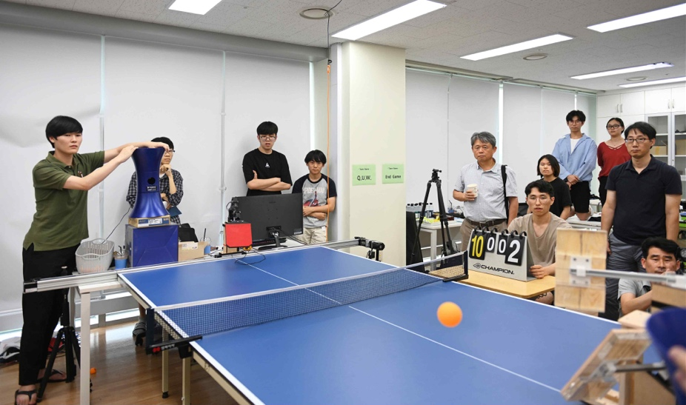
▲ Final round of the 3rd GIST Creative Convergence Competition to develop a ping-pong robot

