Gwangju Institute of Science and Technology

Official Press Release (https://www.gist.ac.kr/)

Section of Mi-Yeon Kim Nayeong Lee
Public Affairs Section Chief Senior Administrator
(+82) 62-715-2020 (+82) 62-715-2024

Contact Person Min-yong Kim, Administrator
for this Article Section of Public Affairs
(+82) 62-715-5027

Release Date 2018.09.04

GIST 25th Anniversary Celebration on September 6th (Thurs): GIST Honorary Ambassador Ji-Hae Park performs concert

□ GIST (President Seung Hyeon Moon) celebrates its 25th anniversary with the 'New Work Experience' concert performance by Ji-Hae Park at the Oryong Hall on September 6, 2018, which is scheduled for ninety minutes.

□ To celebrate its 25th anniversary, GIST has commissioned violinist Ji-Hae Park for one year (2018.5.14 to 2019.5.13) as an honorary ambassador to promote GIST's research achievements and vision. Violinist Ji-Hae Park plans to promote the 25th anniversary of GIST with a concert talk.

∘ Violinist Ji-Hae Park graduated from Karlsruhe National University of Music in Germany and served as a goodwill ambassador for the Korean Committee for Peace and Arts as well as the 2018 Pyeongchang Winter Olympics. She also participated in a 2017 GIST cultural event as an invited performer.

□ Violinist Ji-Hae Park said, "As a honorary ambassador for GIST, I will share GIST's outstanding research results and vision with GIST members and local residents and will take the lead in promoting GIST this year through performances such as this one."

□ GIST, which celebrates its 25th anniversary this year, will hold various large and small events until November when the celebration will culminate with student festivals, exhibitions, and events.

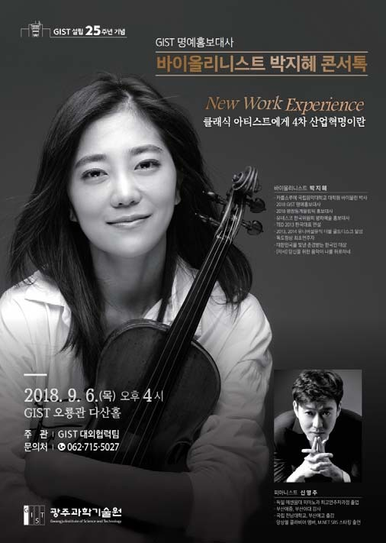
GIST Honorary Ambassador Ji-Hae Park

