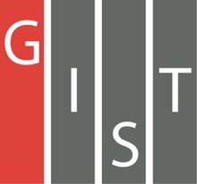
Gwangju Institute of Science and Technology

Official Press Release (https://www.gist.ac.kr/)

Section of Hyo Jung Kim Nayeong Lee
Public Relations Section Chief Senior Administrator
(+82) 62-715-2061 (+82) 62-715-2062

Contact Person Deuk-jo Kong, Senior Researcher
for this Article GIST Institute for Artificial Intelligence
062-715-2934

Release Date 2020.10.06

GIST and CJ Olive Networks signs MoU for
industry-academic cooperation in AI

□ GIST (Gwangju Institute of Science and Technology, President Kiseon Kim) Institute for Artificial Intelligence (Director JongWon Kim) has signed an MoU with CJ Olive Networks (CEO In-hyuk Cha) industry-academic research and development in AI.

∘ The signing ceremony was conducted to provide social-distancing to protect against COVID-19. GIST and CJ Olive Networks decided to maintain a system of mutual exchanges and collaboration in such areas as artificial intelligence research and development, manpower training, and technology information.

□ In the agreement, GIST and CJ Olive Networks plan to work on matters necessary for mutual development and closer relations, including: ▲ job creating through the AI Industrial Convergence Complex ▲ participation in AI-based start-up support competitions ▲ joint research and business collaboration in AI.

□ In particular, CJ Olive Networks will participate in 'Dreaming Child (AI)' AI Startup Competition, which will be held in June. 'Dreaming Child (AI)' is an AI start-up competition held as part of the 'AI Industrial Convergence Complex Development Project' promoted by the Ministry of Science and ICT. The AI startup contest is held as part of the AI Business Convergence Project Team (Director Chae-sik Lim) and is hosted by the GIST Institute for Artificial Intelligence.

∘ This contest is designed to solve AI issues companies have from forming ideas to establishing business models. The preliminaries and finals for each event include culture, healthcare, automobiles, and home appliances. The total prize money is about 230 million won, the largest in Korea.

□ CJ Olive Networks has provided problems that need to utilize AI for cultural contents in industries. It is a virtual fitting that automatically creates and searches drama background music with two questions and allows consumers to try on clothes virtually.

∘ By developing algorithms that automatically generate and explore drama background music and by presenting virtual fitting algorithms based on fitting data from shopping malls, the company will increase its competitive edge in the market by solving problems tailored to corporate demands. In addition, the company will also provide servers and various infrastructures of CJ Olive Networks Data Center (IDC) to help participants solve problems smoothly.

□ GIST Institute for Artificial Intelligence Director JongWon Kim said, "This agreement is expected to play a positive role in the field of cultivating start-up specialists for the AI Industrial Convergence Complex Development Project. We expect a synergy effect with CJ Olive Networks, which will rapidly respond to market trends through the future development of new technologies through constant change and innovation."

∘ CJ Olive Networks CEO In-hyuk Cha said, "In an era when digital transformation (DT) capabilities using artificial intelligence are competitive in the country and region, we are pleased to join hands with GIST to contribute to the creation of Korea's leading AI Industrial Convergence Complex. It is hoped that the outstanding human resources residing in the province will be trained by IT company experts to contribute to the development of local industries and further expand their capabilities in global companies."

□ The "Dreaming Child (AI)" contest is scheduled to select the final winners of each category through the preliminary round in October and the final round in November by receiving online applications by October 9th. The number of participants and details can be found on the Dreaming Child (AI) website (dreamai.kr).

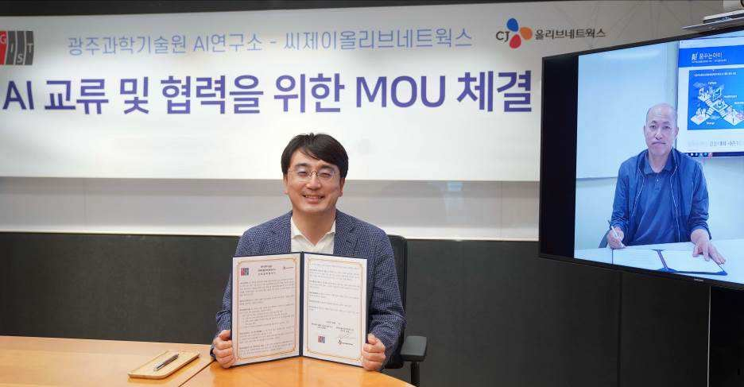
▲ GIST and CJ Olive Networks signs MoU for industry-academic cooperation in AI.
From left: CJ Olive Networks CEO In-hyuk Cha and GIST Institute for
Artificial Intelligence Director JongWon Kim

