Gwangju Institute of Science and Technology

Official Press Release (https://www.gist.ac.kr/)

Section of Hyo Jung Kim Nayeong Lee
Public Relations Section Chief Senior Administrator
(+82) 62-715-2061 (+82) 62-715-2062

Release Date 2020.05.19

GIST joins Global Sustainable
Technology & Innovation Community

□ GIST (Gwangju Institute of Science and Technology, President Kiseon Kim) International Environmental Research Institute (IERI, Director Kyoung-Woong Kim) in conjunction with Vlaamse Instelling voor Technologisch Onderzoek (VITO), * an independent Belgian research institute focusing on clean technology and sustainable development, will be co-hosting the G-STIC 2020 **.

* VITO: a policy organization under the Ministry of Economy, Science and Innovation in Belgium responsible for responding to the social challenges caused by climate change, food stability, resource depletion, sustainable energy supply, and aging

** G-STIC 2020: Global Sustainable Technology & Innovation Community (to be held on October 27-29 in Brussels, Belgium)

∘ GIST will lead discussions on the spread and activation of climate adaptation technology, climate service, reduction and adaptation techniques, and diffusion of carbon adaptation technologies and carbon resources by overseeing climate themes, focusing on the School of Earth Sciences and Environmental Engineering and IERI. In addition, in the field of water, GIST plans to participate in discussions on problems and solutions for water resource management, application of gravity membrane filtration technology, etc. with the Energy and Resources Institute (TERI) of India and VITO.

□ Currently around the world, the United Nations is making efforts to achieve the Sustainable Development Goals (SDGs) by 2030, and science and technology innovation has been proposed as one of the important means of achieving them. In line with this, the VITO has been holding the G-STIC every year since 2017 in conjunction with the UN discussions, and has been discussing ways to derive science and technology solutions related to the six major areas of climate, education, energy, health, marine, and water among the 17 sustainable development goals, as well as to promote them effectively.

∘ The scale of G-STIC increased every year, and in 2019, 150 speakers from over 80 countries and 2,000 participants were held, and 50 sessions were prepared. The outcomes of these G-STICs are expected to contribute substantially to achieving the goals of sustainable development through the UN Science and Technology Innovation Forum and the High-Level Policy Forum.

□ G-STIC 2020 co-organizers include VITO and GIST ▲ ACTS (African Center for Technology Studies, Kenya) ▲ FIOCRUZ (Fundação Oswaldo Cruz; Brazil) ▲ GIEC (Guangzhou Institute of Energy Conversion, China) ▲ IITD (Indian Institute of Technology) Delhi, India) ▲ NACETEM (National Center for Technology Management, Nigeria) ▲ TERI (The Energy and Resources Institute, India).

∘ In addition to Gist's expertise and excellence in achieving the Sustainable Development Goals, the G-STIC 2020 official website introduced the activities of the IERI on supplying safe drinking water with gravity-type membrane filtration devices.

□ GIST IERI Director Kyoung-Woong Kim director said, "By co-organizing G-STIC 2020, I hope that GIST's excellent research results will become known as a solution to achieving the global sustainable development goals. GIST's leading role in water, climate services, and carbon resources will be a good opportunity to expand joint research based on this."

□ GIST IERI has been operating a joint program of UN University-GIST from 2004 to 2018 since it was founded in 2001 with the aim of establishing a UN University research institute for sustainable technology.

∘ It has continued to contribute greatly to international R&D cooperation to solve environmental problems in developing countries, train environmental experts and strengthen capabilities, and has been actively carrying out international development cooperation activities in the water sector through the Korea-UNDP project since 2014. Since 2016, it has actively participated in international climate technology cooperation and climate change response through the UNFCCC technology mechanism.

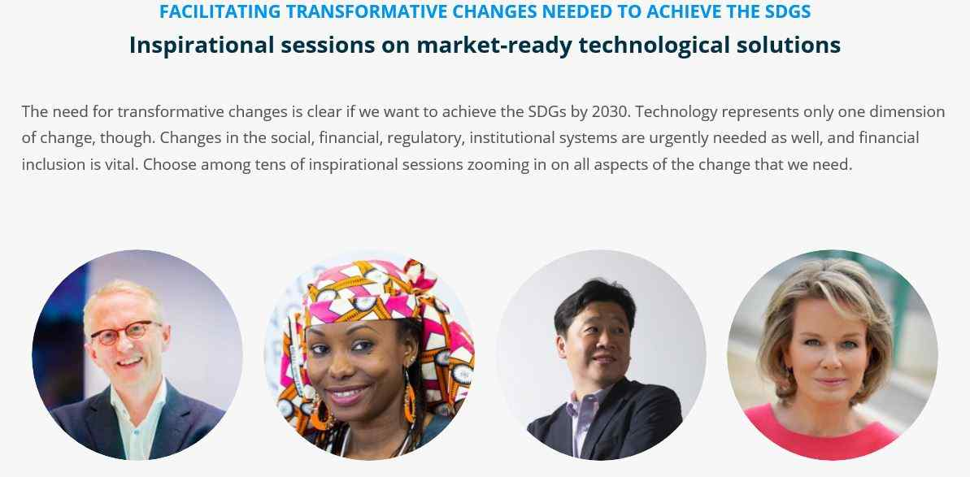
▲ [Photo 1] The G-STIC 2020 introduction data capture screen posted on the official website of G-STIC 2020: It introduces major speakers of sessions discussing the need for transformative changes to achieve SDGs and for technology solutions that can enter the market. The third photo from the left is GIST IERI Director Kyoung-Woong Kim.

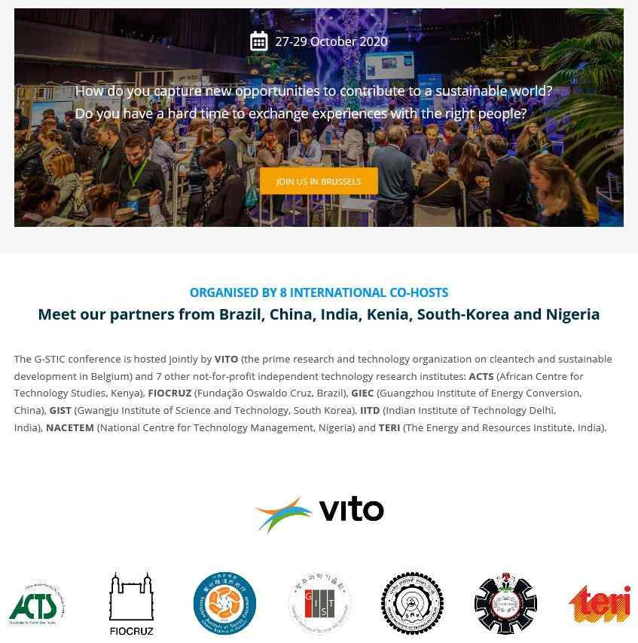
▲ [Picture 2] G-STIC 2020 Introduction Material Capture Screen: Co-hosts of G-STIC 2020 are introduced, and the names and emblems of a total of eight organizations, including VITO and GIST, are introduced.

