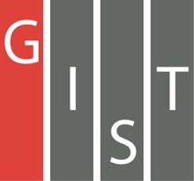
Gwangju Institute of Science and Technology

Official Press Release (https://www.gist.ac.kr/)

Section of Mi-Yeon Kim Nayeong Lee
Public Affairs Section Chief Senior Administrator
(+82) 62-715-2020 (+82) 62-715-2024

Contact Person Dr. Sung-gu Lee
for this Article Advanced Photonics Research Institute
(+82) 62-715-4715

Release Date 2018.11.2

GIST APRI signs MoU with the Czech Institute of Physics to cooperate on ultra-high-speed lasers and applications

□ GIST (President Seung Hyeon Moon) Advanced Photonics Research Institute (APRI, Director Hyyong Suk) signed a memorandum of understanding (MoU) for the research and development of high output ultra-high-speed lasers and applications with the Institute of Physics of the Czech Academy of Sciences, HiLASE Center (IOP, Chief Director Michael Prouza) *.

* The Czech Republic has invested €32M of EU structural and national funding in the construction of an advanced, next generation laser, HiLASE, at Dolní Břežany in the Central Bohemia Region. HiLASE has the potential to be an outstanding science and technology asset for the region and for Europe, driving innovation and enabling world leading science.

□ Under the agreement, the two organizations have agreed to research and develop ultra-high power and ultra-high-speed lasers and utilization technology, ultrafine machining, bio-optics, information and personnel exchanges, and joint research projects.

□ APRI Director Hyyong Suk said, "I hope that it will be possible to expand the utilization of the technology of ultra-high-speed laser and utilization technology based on this agreement."

□ HiLASE Director Thomas Mocek said, "I hope that the agreement with GIST's Advanced Photonics Research Institute, Korea's only research institute in the field of laser optics, will be an opportunity to develop technologies for use in optics as well as for ultra-fast lasers."

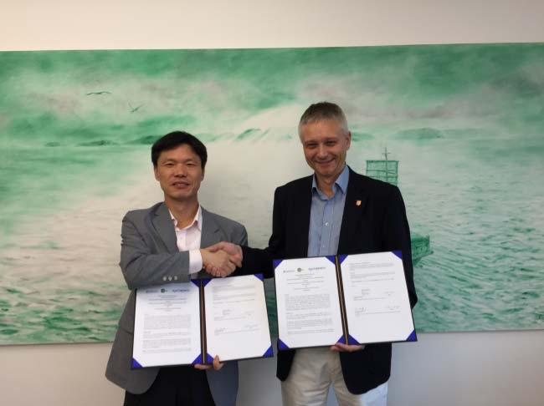
▲ APRI Director Hyyong Suk and HiLASE Director Thomas Mocek

