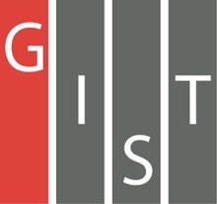
Gwangju Institute of Science and Technology

Official Press Release (https://www.gist.ac.kr/)

Section of Mi-Yeon Kim Nayeong Lee
Public Affairs Section Chief Senior Administrator
(+82) 62-715-2020 (+82) 62-715-2024

Contact Person Professor Sun-Kyu Lee
for this Article School of Mechanical Engineering
(+82) 62-715-2388

Release Date 2018.07.26

GIST Ultraprecision Machine System Laboratory signs MoU with CAMTIC Advanced Mechatronics Technology Institute

□ GIST (President Seung Hyeon Moon) – Ultraprecision Machine System Laboratory (Professor Sun-Kyu Lee, School of Mechanical Engineering) has signed a memorandum of understanding (MoU) with CAMTIC Advanced Mechatronics Technology Institute (Director Gyun-eui Yang), which is an excellent venture company in the smart factory field and automation, to foster human resources and to cooperate in developing common technologies.

□ The GIST Ultraprecision Machine System Laboratory is regarded as one of the best labs in the field of precision machining and meteorological measuring technology in Korea and specializes in NC machine tool technology and ultra precise machine design. Professor Sun-Kyu Lee leads the laboratory and is the president of the Korean Society of Mechanical Engineers and was the former president of the Korea Precision Engineering Society. In 2017, he received the Best Paper Award from the Japan Machine Tool Technology Promotion Foundation.

□ Founded in 1999, CAMTIC Advanced Mechatronics Technology Institute has been engaged in research, business development, and engineering of smart factories including auto parts, moldings, and factory automation. Leading in education and training, it quickly grew into a model as a leading venture capitalist business in the manufacturing sector. It has also been recognized by the Ministry of Science and ICT for its excellence as a leading private research institute in the field of smart factories.

∘ It is renowned for rapid detection and follow-up processing of tool damage based on sensor signal processing and an adaptive control technology for preventing wear and breakage, especially in automated manufacturing lines.

□ Professor Sun-Kyu Lee said, "Through this memorandum of understanding, we will build a system of cooperation to develop smart technology based on the demands of the 4th Industrial Revolution and nurture personnel, and we will do our best to make mutual progress."

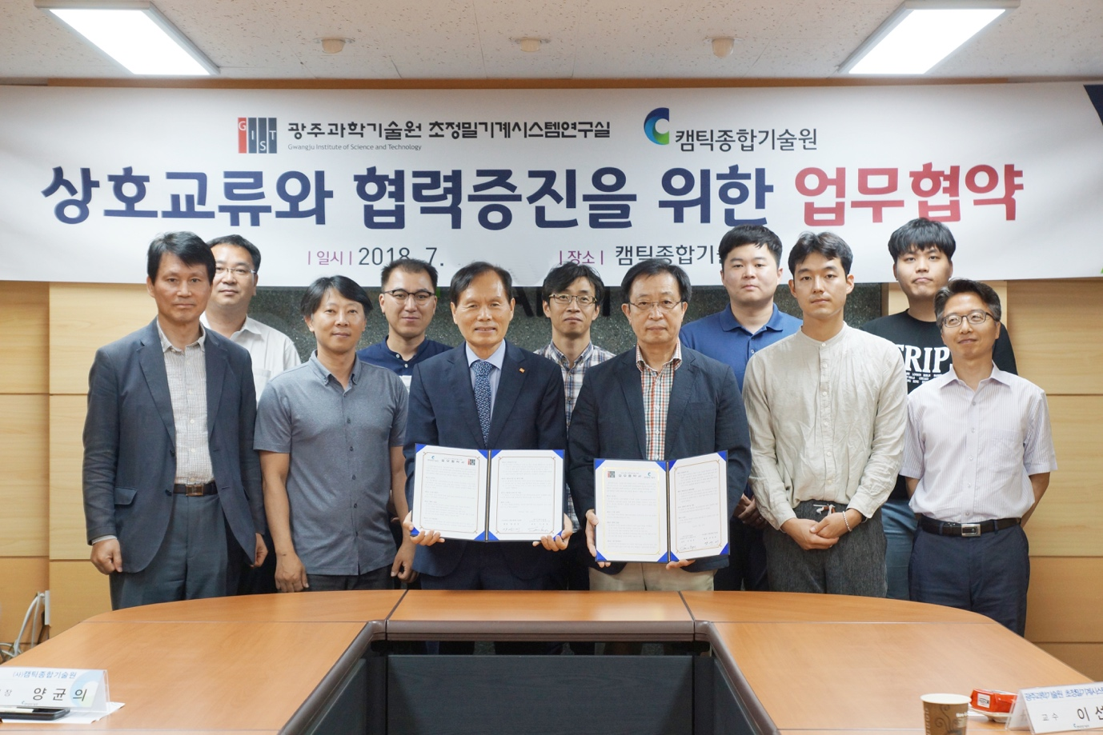
▲ Commemorative photo of the MoU Signing Ceremony between
GIST and CAMTIC Advanced Mechatronics Technology Institute

