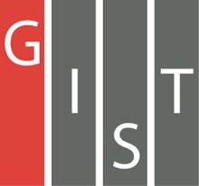
Gwangju Institute of Science and Technology

Official Press Release (https://www.gist.ac.kr/)

Section of Hyo Jung Kim Nayeong Lee
Public Relations Section Chief Senior Administrator
(+82) 62-715-2061 (+82) 62-715-2062

Contact Person Seung-soo Yoo, Administrator
for this Article Section of Public Affairs
+(82) 62-715-2025

Release Date 2020.07.07

GIST expands joint cooperation with Marine Energy Co., Ltd., for community development and has a 100 million won donation ceremony

□ GIST (Gwangju Institute of Science and Technology, President Kiseon Kim) and Marine Energy Co., Ltd., (CEO Hyung-soon Kim) held an MoU signing ceremony and a donation ceremony to contribute to the development of the community through social contribution programs supporting local children's centers.

∘ The signing and donation ceremony were held at GIST on July 6, 2020, and was attended by GIST President Kiseon Kim, Marine Energy Co., Ltd., Director Kwang-ho Oh, and five officials.

∘ The main contents of the agreement include ▲ joint implementation of social contribution programs through the Gwangju Regional Children's Center (GIST: hosting and managing social contribution programs, Marine Energy Co., Ltd.: providing financial support), and GIST will receive a total deposit of 100 million won (20 million won/5 years) from Marine Energy Co., Ltd.

□ GIST President Kiseon Kim said, "Through various social contribution programs, GIST has successfully laid the foundation for future student development and co-prosperity growth in Gwangju and Jeonnam. Along with Marine Energy Co., Ltd., we will gradually expand educational support for marginalized groups in the region and actively contribute to cooperation and development with local communities."

□ Marine Energy Co., Ltd., Director Kwang-ho Oh said, "GIST and Marine Energy Co., Ltd., share a common goal with the aim of developing the community. Marine Energy Co., Ltd., will not only provide financial support but will also actively cooperate with executives and employees in visiting local children's centers and volunteering for classes."

∘ Marine Energy Co., Ltd., donated 100 million won to GIST in 2017 with an agreement and donation ceremony and is conducting classroom reading service with GIST at the local children's center.

□ Meanwhile, the GIST Social Contribution Team provides various activities such as 'Learning Zone,' 'GIST Science Outreach Program (GSOP)' where GIST students mentor middle and high school students in math and science, 'Science School' that delivers scientific information in a fun and easy manner to students and the general public, and various volunteer activities every year, including the "donation of science books" to expand science and culture, at the Gwangju Multicultural Family Support Center and the local children's center.

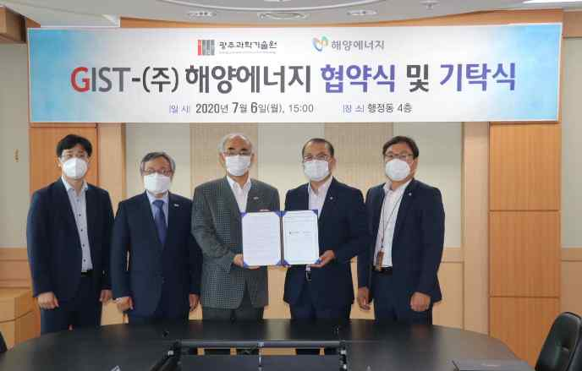
[Photo 1] GIST and Marine Energy Co., Ltd., signing ceremony

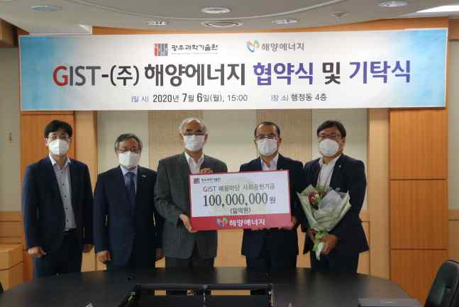
[Photo 2] GIST and Marine Energy Co., Ltd., donation ceremony

