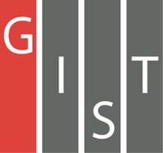
Gwangju Institute of Science and Technology

Official Press Release (https://www.gist.ac.kr/)

Section of Mi-Yeon Kim Nayeong Lee
Public Affairs Section Chief Senior Administrator
(+82) 62-715-2020 (+82) 62-715-2024

Contact Person Min-young Kim, Administrator
for this Article Section of Public Affairs
(+82) 62-715-5027

Release Date 2018.11.19

GIST co-organizes the 1st High-Tech
Science Golden Bell Competition

□ GIST (President Seung Hyeon Moon) hosted the 1st High-Tech Science Golden Bell Competition in cooperation with Buk-gu in Gwangju City, National Gwangju Science Museum, and Gwangju City's Eastern Education Support Agency on November 17, 2018.

∘ This competition was held for elementary school students in grade 5 and above in Buk-gu, Gwangju. A total of 214 teams of 107 students (37 primary schools) participated in the survival quiz contest, consisting of one student and one parent. The final winner was determined after a two-man team competition, a losing game, an individual match, and a final round.

□ Winners of the contest ▲ Winner of the Bukgu Office Award (Golden Bell Prize), Kang-ryul Lee (5th grade student) won a certificate and a crystal medal ▲ Gwangju prefecture (5th grade student), Ei-hyun Park (5th grade student), and Hyo-jae Lee (5th grade student) ▲ Gaham Yun (6th grade student at Moon Heung-Cho), Young-Han Ko (6th grade student) and Moo-Jin Kim (5th grade student at Samgakcho) ▲ Tae-kyung Kwon (5th grade), Dong-hyun Kim (5th grade), and Cheong-hui Kim (6th grade) received the certificates and medals, respectively.

□ Dean of International and Public Affairs Yong Chul Kim said, "GIST, which celebrates its 25th anniversary this year, is carrying out various social contribution activities based on its sense of social responsibility. Today, I expect that the first high-tech science golden bell will contribute to spreading a healthy science culture in our area and be a good start leading to the second and third golden bell events."

□ As part of the industry-academia-related exchange and cooperation project, the competition was co-hosted by GIST, Buk-gu in Gwangju City, National Gwangju Science Museum, and Gwangju City's Eastern Education Support Agency. It was designed to raise the status science and technology for residents and students and to provide healthy learning and leisure opportunities for young people.

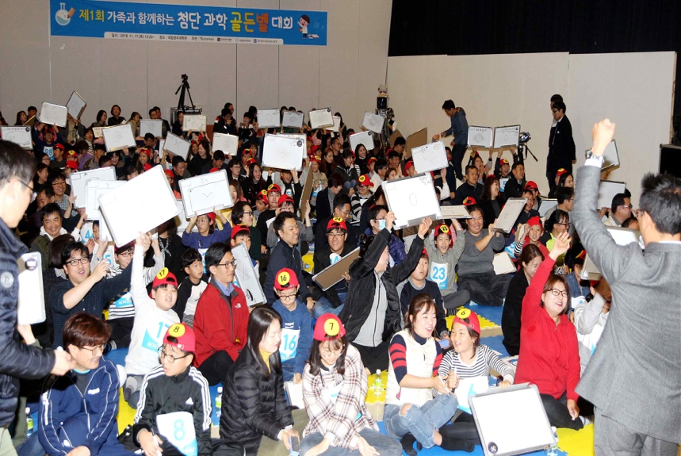
▲ 1st High-Tech Science Golden Bell Competition

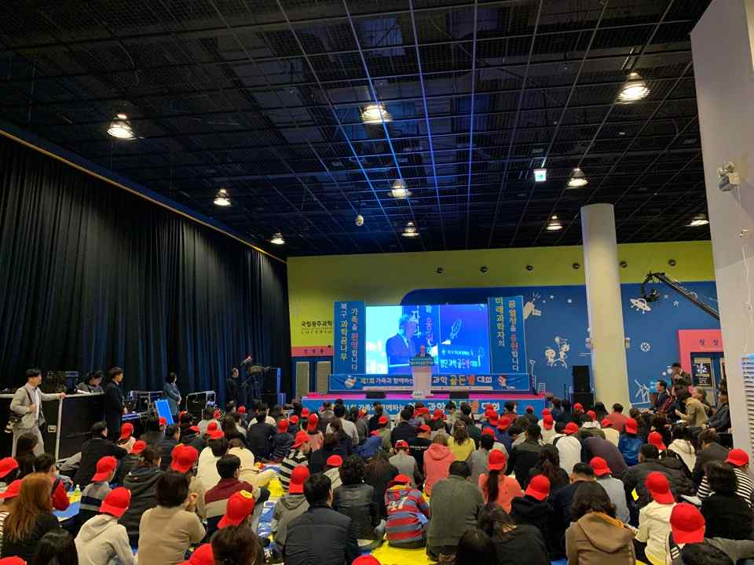
▲ Dean of International and Public Affairs Yong Chul Kim

