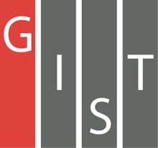
Gwangju Institute of Science and Technology

Official Press Release (https://www.gist.ac.kr/)

Section of Hyo Jung Kim Nayeong Lee
Public Relations Section Chief Senior Administrator
(+82) 62-715-2061 (+82) 62-715-2062

Contact Person Semi Park, Administrator
for this Article Section of Public Relations
(+82) 62-715-2960

Release Date 2020.05.26

GIST publishes a translation of
'Benefits of Aging' for successful aging

□ GIST (Gwangju Institute of Science and Technology, President Kiseon Kim) PRESS has published Division of Liberal Arts and Sciences Professor Wonil Choi's translation of a psychology book about successful aging.

∘ Professor Wonil Choi, the translator, received his doctorate in cognitive psychology from the Chapel Hill campus of the University of North Carolina in the U.S. and is currently teaching psychology as a professor in the Division of Liberal Arts and Sciences at GIST College. He is conducting research on what happens in the eyes and brain when humans think, understand, and speak a language, and he has recently expanded his area of interest into interactions between humans and machines and society.

□ 'The Benefits of Ageing' is a translation of the book 'Better With Age,' written by Alan D. Castel, a world-renowned cognitive scientist and authority on aging psychology who leads the field of aging and memory psychology.

∘ This book solves various problems (happiness, memory, wisdom, brain training, habits and hobbies, etc.) that are experienced in old age through interesting research, easy and interesting illustrations, and vivid interviews. The negative and distorted stereotypes or views on aging are reversed through objective and empirical evidence, and the 'benefit of ageing' is revealed.

∘ The book also offers a wealth of diverse and feasible methods for successful aging, and above all, it is interesting in that it shows excellent views and insights on how our lives can improve as we age and enjoy the benefits of old age.

□ Professor Wonil Choi the translator said, "I hope this book will serve as a practical guide for finding out what we can do right here and now for successful aging."

□ 'The Benefits of Ageing, a psychological book for successful aging will be available at online and offline bookstores nationwide from June 1.

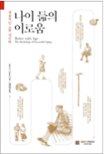
▲ Book cover: 'Benefits of Aging'

