Gwangju Institute of Science and Technology

Official Press Release (https://www.gist.ac.kr/)

Section of Mi-Yeon Kim Nayeong Lee
Public Affairs Section Chief Senior Administrator
(+82) 62-715-2020 (+82) 62-715-2024

Contact Person Moon-sub Yoon, Administrator
for this Article Section of Public Affairs
(+82) 62-715-2021

Release Date 2018.09.19

Haedong Science and Culture Foundation Chairman Jung-sik Kim donates 500 million won for the Haedong Academic Information Room

□ GIST (President Seung Hyeon Moon) has received a donation of 500 million won from Haedong Science and Culture Foundation Chairman Jung-sik Kim to construct a new Haedong Academic Information Room at GIST.

∘ The Haedong Science and Culture Foundation was established in 1991 by Chairman Jung-sik Kim of Daeduck Electronics Co., Ltd., a manufacturer and seller of printed circuit board (PCB), to continuously contribute to academic development and technological advancements.

∘ Chairman Kim previously donated 500 million won to the GIST Development Fund in 2016 for the construction of the Haedong Academic Information Room. Chairman Kim's cummulative contributions have surpassed 1 billion won, which is the highest amount donated by an individual since the start of the GIST Development Fund.

□ The donation ceremony was held on September 18, 2018, at the Haidong Science Foundation in Seocho-gu, Seoul, with the participation of GIST Vice President Hor-Gil Hur and the Section of Public Affairs Chief Mi-Yeon Kim.

□ Chairman Jung-sik Kim said, "I have been impressed by the fact that GIST has shown world-class research capabilities, and I have decided to contribute to GIST's future vision of leading the 4th Industrial Revolution. I am hopeful that my donation will expand the academic information room so that professors and students can concentrate on research and study."

□ The donation to the GIST Development Fund will be used to build a new academic information room through in recognition of the donor's noble intent.

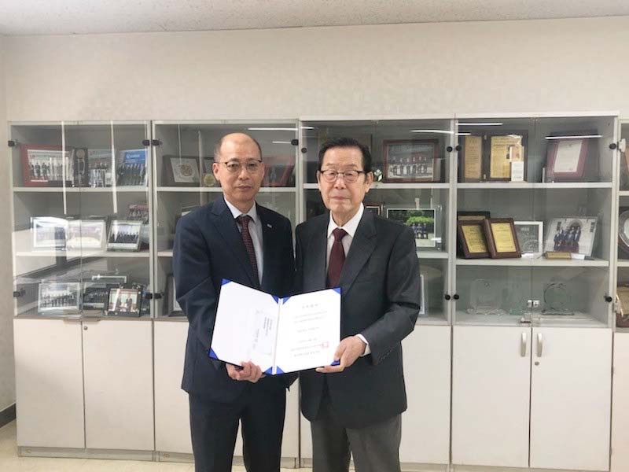
▲ GIST Vice President Hor-Gil Hur and Haedong Science
and Culture Foundation Chairman Jung-sik Kim

