“AI-based Decentralized Exchange” Opens This Year
GIST LiberVance Selected as AICA Support Project

- Professor Lee Heung-no’s start-up “LiberVance” receives support for commercialization of AI products and services for 2023.
- Laying the groundwork for AI startups to take off ... AI-DEX service scheduled to open within the year.

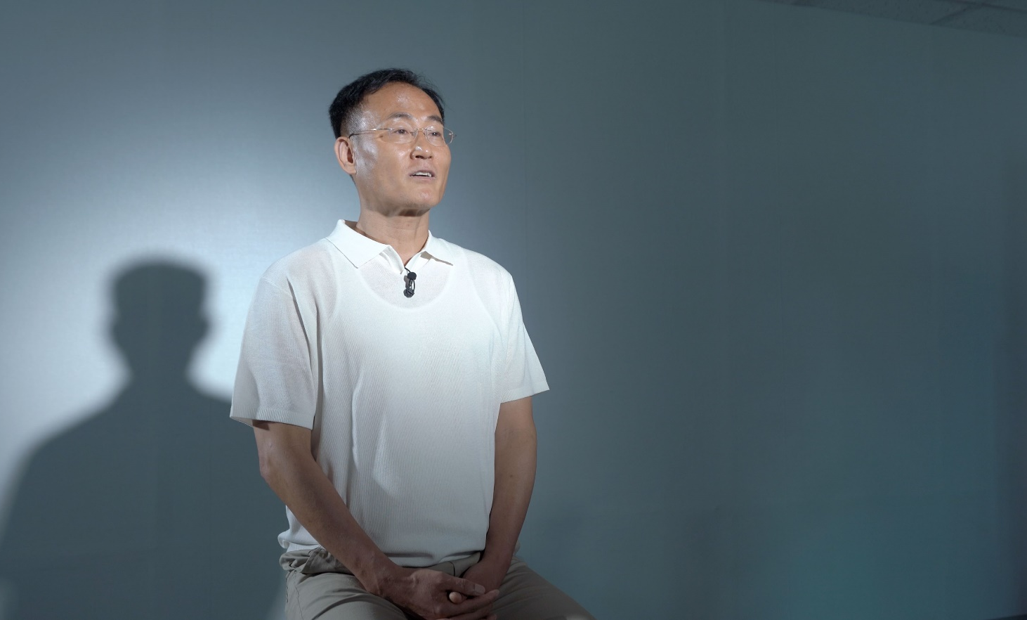
▲ Lee Heung-no, CEO of LiberVance (professor of GIST’s School of Electrical and Computer Engineering)

GIST (Gwangju Institute of Science and Technology, Acting President Park Rae-gil), professor’s start-up company, LiberVance (CEO, Lee Heung-no) has been selected for the 2023 AI Product/Service Commercialization Support Project, supported by the AI Industry Convergence Agency (AICA; Director, Kim Jun-ha) The agreement was signed on June 27th.

This project is part of the Gwangju AI-Integrated Cluster Development Project promoted by the Ministry of Science and ICT and by Gwangju Metropolitan City. It is a business project that assists early-stage startups enter the market and continue to grow by improving or commercializing AI products and services that have already been produced. The selected company must register its name or launch a product on domestic or foreign platforms within the business period.

Through this agreement, LiberVance, a blockchain mainnet and artificial intelligence integration company, plans to commercialize an AI-based decentralized exchange (AI-DEX*) service and open within this year. In accordance with AICA's program, LiberVance is expected to be provided with education, consulting, use of demonstration equipment, and computing resources necessary for project implementation, commercialization, and dissemination of success.

* DEX (Decentralized Exchange): Unlike centralized exchange (CEX), it is an exchange that enables peer-to-peer (P2P) financing.

LiberVance aims to change the existing market paradigm by securing intellectual property rights for AI-DEX technology and successfully commercializing the service.
Lee Heung-no, CEO of LiberVance, stated, "After FTX, a cryptocurrency exchange, went bankrupt last year, distrust in centralized exchanges grew, and interest in DEX to replace it increased." He went on to reveal, “The risk factor of impermanent loss* was high for existing centralized exchange users to access DEX, but LiberVance plans to change the paradigm of the virtual asset trading market and lead the market with the launch of AI-DEX, which has greatly reduced this risk.”

* Impermanent Loss: Temporary loss due to price fluctuations of deposited assets when liquidity is supplied to the liquidity pool (i.e., when assets are deposited).

Meanwhile, LiberVance, founded in 2020 by CEO Lee Heung-no, a professor in the Department of Electrical and Computer Engineering at GIST, was recognized for its blockchain technology expertise and succeeded in attracting venture capital (VC) angel investment in 2022. In the same year, it was selected for the private investment-led technology start-up support (TIPS) program supervised by the Ministry of SMEs and Startups, and is taking the initiative in TIPS R&D and start-up commercialization projects.

LiberVance is currently negotiating to attract Pre-A* investment, and is expected to receive external investment of 5.5 billion won to commercialize the service and supply DEX liquidity. The head office of LiberVance is located in the GIST Industry-Academia Cooperation Research Institute, and there are a total of 13 executives and employees.

* Pre-A: Investment right before Series A investment, which is the phase of preparing for the official opening of a prototype/beta version that has completed market verification. It is an investment before the actual investment phase and not limited to A.

