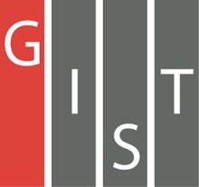
Gwangju Institute of Science and Technology

Official Press Release (https://www.gist.ac.kr/)

Section of Mi-Yeon Kim Nayeong Lee
Public Affairs Section Chief Senior Administrator
(+82) 62-715-2020 (+82) 62-715-2024

Contact Person Yonghyeok Choi, Administrator
for this Article Section of Public Affairs
(+82) 62-715-2025

Release Date 2018.07.25

GIST selected as one of Asia's Top 75
Most Innovative Universities (2018) by Reuters

□ GIST (President Seung Hyeon Moon) was selected as one of Asia's Top 75 Most Innovative Universities (2018) by Reuters.

∘ On July 24, 2018, President Moon received a commemorative plaque from Jin-woo Kim who is the Korean branch of Clarivate Analytics in recognition of GIST receiving the 'Top75' award, which was sponsored by Reuters.

□ Reuters, the world's largest news provider, has selected Asia's Most Innovative Universities every year since 2016, ranking high-tech scientific research institutes in the Asia-Pacific with excellent development capabilities for new technologies. This year, GIST was selected for Asia's Top 75 Most Innovative Universities based on the number of patent applications, which can measure the level of practical technological development, and on citations to published papers: ▲ patent application rate ▲ patent success rate ▲ international patent ratio ▲ patent citation rate ▲ patent citation rate ▲ influence of patent cited articles ▲ ten other indicators

□ GIST President Seung Hyeon Moon said, "GIST is making every effort to create a cyclical ecosystem that links outstanding research achievements based on world-class education and research capabilities to start-ups, technology transfers, and technological commercialization. In the era of the 4th Industrial Revolution, GIST will make more efforts to revitalize the economy and industrial development through technology that can lead to regional growth and innovation."

□ In addition, three scientists who received thier Ph.D's from GIST were selected as the world's top 1% of highly cited researchers by Clarivate Analytics last November.

∘ Clarivate Analytics has been announcing the top 1% of researchers in the world since 2014 after analyzing the number of ciations for papers published by researchers in science and social studies.

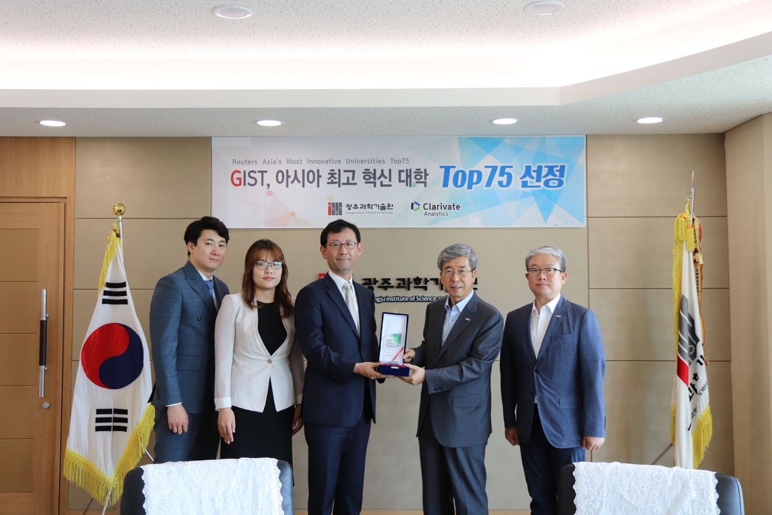
▲ Korean branch of Clarivate Analytics Jin-woo Kim presents award to GIST President
Seung Hyeon Moon and International and Public Affairs Dean Yong Chul Kim

