Gwangju Institute of Science and Technology

Official Press Release (https://www.gist.ac.kr/)

Section of Mi-Yeon Kim Nayeong Lee
Public Affairs Section Chief Senior Administrator
(+82) 62-715-2020 (+82) 62-715-2024

Contact Person Donjoong Lee, Administrator
for this Article Optimal Dementia Management
Technology Research Center
(+82) 62-715-3082

Release Date 2018.10.19

GIST Optimal Dementia Management Technology Research Center signs MoU with Sinan County and Chosun University National Research
Center for Dementia

□ GIST (President Seung Hyeon Moon) Optimal Dementia Management Technology Research Center (Director Jong-In Song) signs memorandum of understanding (MoU) with Sinan County and Chosun University National Research Center for Dementia.

□ The MoU signing ceremony was held at the Sinan County Office on October 18, 2018, and was attended by officials from three organizations, including Optimal Dementia Management Technology Research Center Director Jong-In Song, Sinan County Supervisor Woo-ryang Park, Chosun Professor Kun-ho Lee.

∘ The main contents of this MoU are for the three organizations, including GIST, are △ research and development △ regional cooperation programs △ joint use of research facilities and equipment △ materials and information sharing, and education and exchanges among researchers such as conferences, seminars, and workshops.

∘ To accomplish this, the three organizations decided to develop cooperation with local science and technology-related organizations, human-material sharing, and joint PR marketing.

□ Director Jong-In Song said, "With this agreement, I hope we are able to focus on the excellent researchers and competence of the three agencies for close cooperation for early prediction, research, diagnosis and management of dementia."

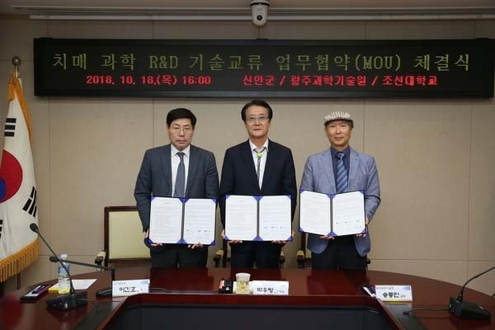
From the left, Chosun Professor Kun-ho Lee, Sinan County Supervisor Woo-ryang Park,
and GIST Professor Jong-In Song

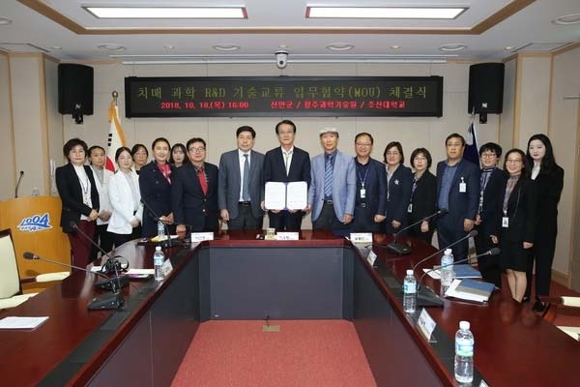
MoU signing ceremony official photo

