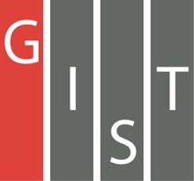
Gwangju Institute of Science and Technology

Official Press Release (https://www.gist.ac.kr/)

Section of Hyo Jung Kim Nayeong Lee
Public Relations Section Chief Senior Administrator
(+82) 62-715-2061 (+82) 62-715-2062

Contact Person Kyung-jin Cho, Administrator
for this Article GIST Business Incubator
(+82) 62-715-2596

Release Date 2020.04.29

GIST Angel Club created

□ GIST (Gwangju Institute of Science and Technology, President Kiseon Kim) Business Incubator (Director Sung-geun Ki) formed the GIST Angel Club *, recently enrolled in the Angel Investment Support Center, and founded and invested in an excellent start-up company utilizing GIST technology to actively support growth.

* angel club: A group of individual investors who foster high-tech industries by investing capital in start-up companies that has technologies but lacks funds

∘ The GIST Angel Club was formed with the aim of promoting angel investment through investment exchange and investment cooperation with related organizations and GIST startups with promising technologies, and Woo Jin Park Director of Science and Technology Applications and Research (School of Life Sciences Professor) was invited as the first president of the competition along with the participation of professional consultants, 17 GIST members, venture capitalists, accountants, and lawyers.

□ GIST Angel Club President Woo Jin Park said, "The GIST Angel Club utilizes excellent GIST technology to help startup companies grow quickly with investment capital and technology, and the goal is to grow into a unicorn company within a short period of time by providing mentoring from management experts. Furthermore, the company plans to create quality jobs and supply outstanding companies for the upcoming AI start-up complex in Gwangju."

∘ When the COVID-19 situation settles down, the GIST Angel Club plans to carry out IR (Inventor Relations) every month and will continue to discover and invest in outstanding startup companies in the region other than those from GIST.

□ Meanwhile, GIST operates a variety of technology startup training programs, including excellent startup support and know-how training centered on the GIST Business Support Center, which opened in 2000. Since last year, GIST has been selected for the startup leap package support project and the preliminary business startup package from the Ministry of SMEs and Startups to support new entrepreneurs. In the meantime, it has carried out various external projects such as Korean-style i-core, fostering prospective entrepreneurs, Innopolis Campus, the Global Startup Migration Center, and start-up customized commercialization.

∘ GIST ranked first in the 'College Start-up Index' selected by an economic media company for the third consecutive year and first for the 'Student Start-up Ratio' in the '2019 Evaluation of Science and Engineering Universities.' GIST provides full support, including free space for each team's office space and a common prototype production space for prospective startups.

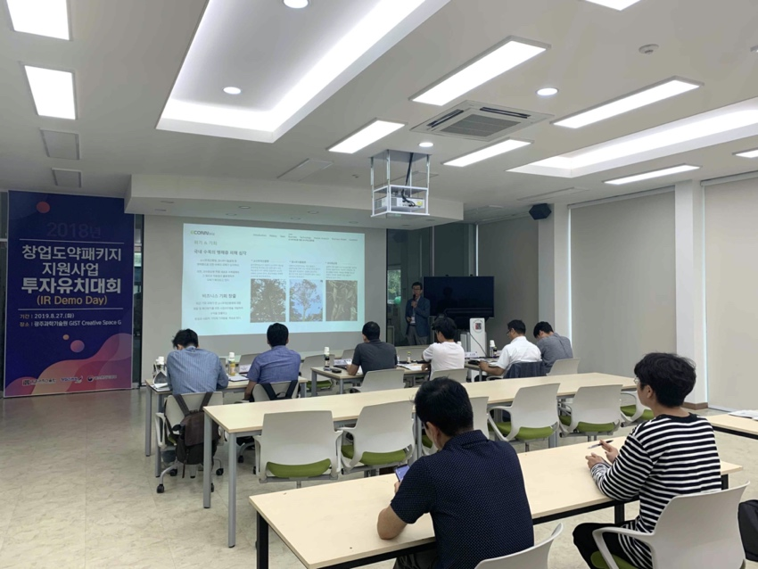
▲ Photo of a briefing session by the GIST Business Support Center on attracting
investment from outstanding companies during the startup leap package

