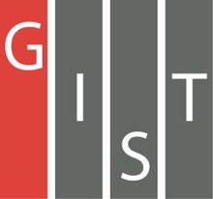
Gwangju Institute of Science and Technology

Official Press Release (https://www.gist.ac.kr/)

Section of Hyo Jung Kim Nayeong Lee
Public Relations Section Chief Senior Administrator
(+82) 62-715-2061 (+82) 62-715-2062

Contact Person Ha-neul Lee, Administrator
for this Article Section of Student Affairs
062-715-2054

Release Date 2020.09.14

GIST hosts online 2020 alumni job mentoring

□ GIST (Gwangju Institute of Science and Technology, President Kiseon Kim) hosted an online 2020 alumni job mentoring program for current students.

∘ The event was organized to provide information on companies and help students prepare for employment through online job mentoring with currently employed alumni based on their job experience at large companies such as Samsung Electronics and Samsung SDI.

□ A total of 106 students applied in advance, and the mentoring was conducted by three employed alumni for three sessions of one hour each. The program introduced the mentor's main tasks and duties as well as the required skills to perform their job. They shared useful information based on field experience, such as corporate recruitment processes and successful job strategies.

□ Office of Academic and Student Affairs Dean Kangwook Kim (a professor in the School of Electrical Engineering and Computer Science) said, "Based on actual field experience, we hope that the experiences and advice of alumni will help current students prepare for career choices and employment. In the future, we will provide support for the systematic preparation of career paths for students by utilizing our networking and mentoring programs."

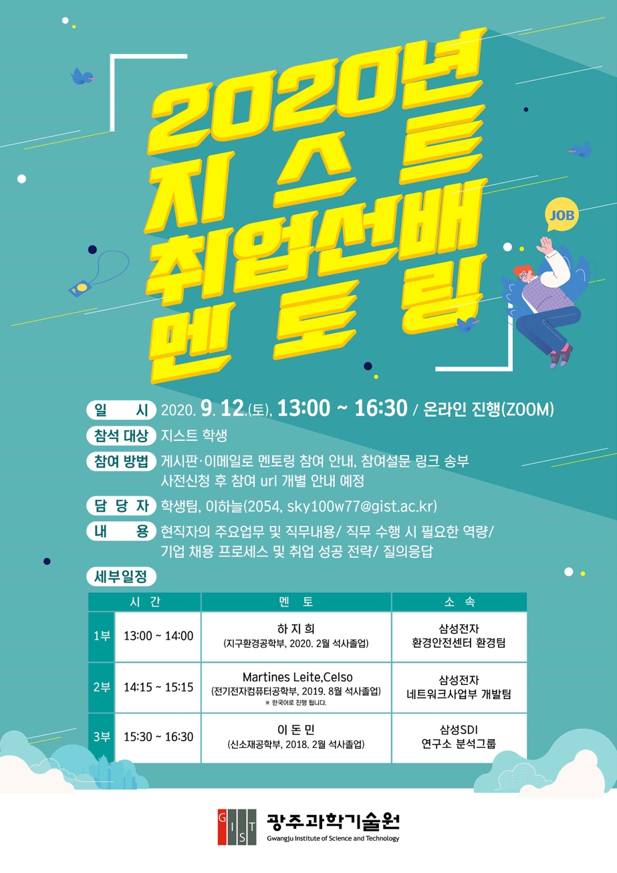
▲ 2020 online job mentoring program poster

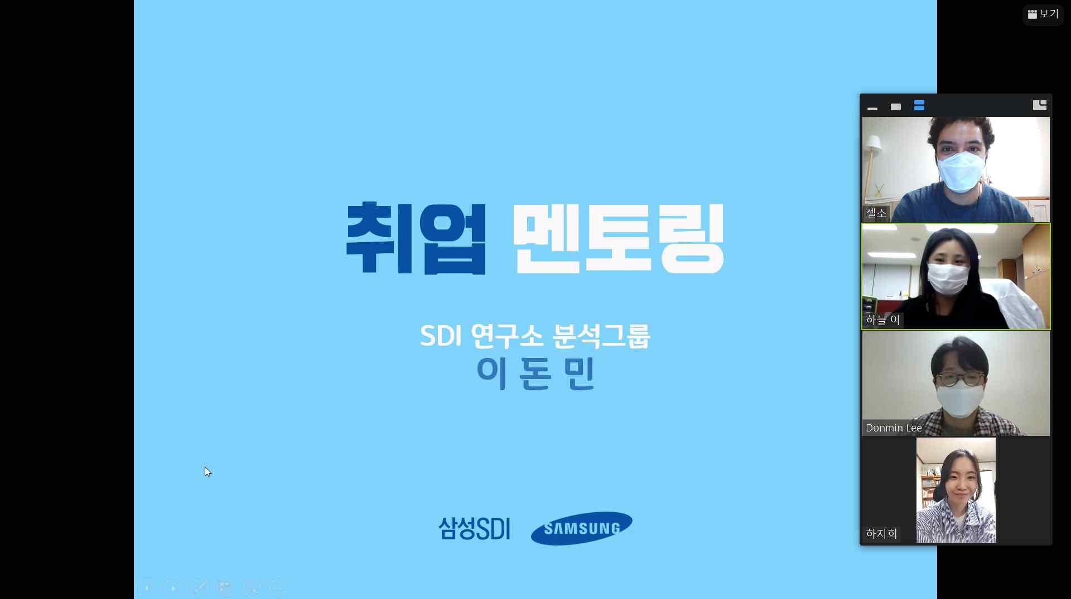
▲ 2020 GIST alumni job mentoring online photo

