Gwangju Institute of Science and Technology

Official Press Release (https://www.gist.ac.kr/)

Section of Mi-Yeon Kim Nayeong Lee
Public Affairs Section Chief Senior Administrator
(+82) 62-715-2020 (+82) 62-715-2024

Contact Person Sung-hoon Im, Section Chief
for this Article Section of Undergraduate Administration Services
(+82) 62-715-3601

Release Date 2018.11.21

"2018 GIST Infinite Challenge Project"
hosts presentations

□ GIST (President Seung Hyeon Moon) will host the '2018 Infinite Challenge Project Presentation' on November 23, 2018. With the launch ceremony back in May, 14 teams of 67 GIST students will present their results from the past six month on their various projects and topics.

* The Infinite Challenge Project, is a new type of educational learning program that gives GIST students the opportunity to challenge themselves with the idea of "it's okay to fail, so try your best anyway." Each April, students organize their own teams with a specific goal and apply for the Infinite Challenge Project. Selected teams receive an average of 2.5 million won, and one course credit will be given based on the results of the project.

∘ The 2018 Infinite Challenge Project Presentations will be held at GIST College Building C room 104 at 1:30 pm on November 23, 2018. The results of each team's project will be on display from the 22nd in the lobby of Building C.

□ This year, the GIST Rocket Engineering (GRE) team with students Dae-young Jeon, Ju-hoon Kim, and Min-jae Jeon competed in the section of "Creative Work Production" to develop an active posture control rocket.

∘ The GRE team created a water rocket as a prototype to verify its proprietary attitude control algorithms, but it failed due to its slower-than-expected speed. To create a launch pad for fire the rocket at a specific angle from the ground, the team visited a duct manufacturing plant near GIST to ask for help.

□ The Penguin Report Team with students Min-seok Kim, Na-hyun Kwon, Eun-su Ryu, Ji-yoon Seo, Ji-yeon Yu, and Na-yeon Jeon chose an everyday topic. The Penguin Report Team was able to experience a series of entrepreneurial processes by gathering high quality food data and systematically demonstrated it with the goal of providing "reliable restaurant information."

∘ Facebook's Penguin Report page recorded over 120,000 views. The Penguin Report Team decided to establish and develop its brand and will continue to collect data, analyze the date, and to create a long-term goal of developing artificial intelligence that provides personalized information about restaurants.

□ Professor Hisam Kim of the Division of Liberal Arts and Sciences has played a leading role in GIST's Infinite Challenge Project, and he said, "The GIST Infinite Challenge Project is a 'self-motivation' initiative sponsored by the school. The content and focus of the activities are creative. Not only is this compatible with human nature, it also provides an opportunity to revive motivation and vitality for students who are exhausted from competitive education."

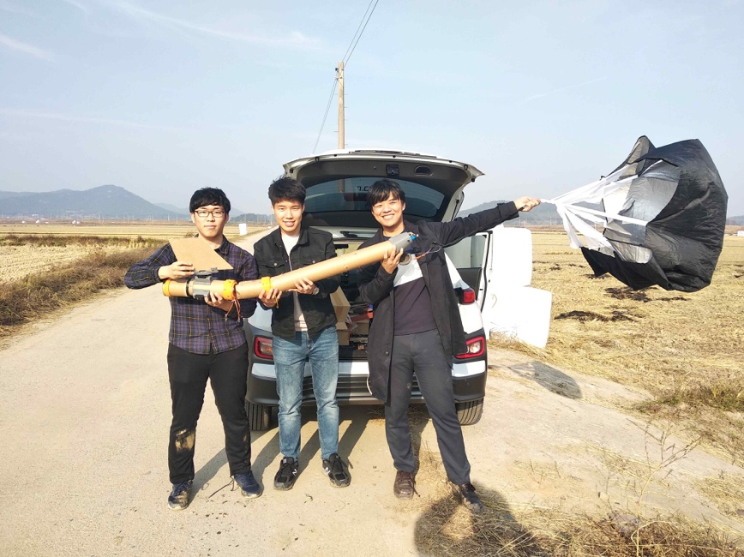
▲ The GRE Team with their Mk1 rocket

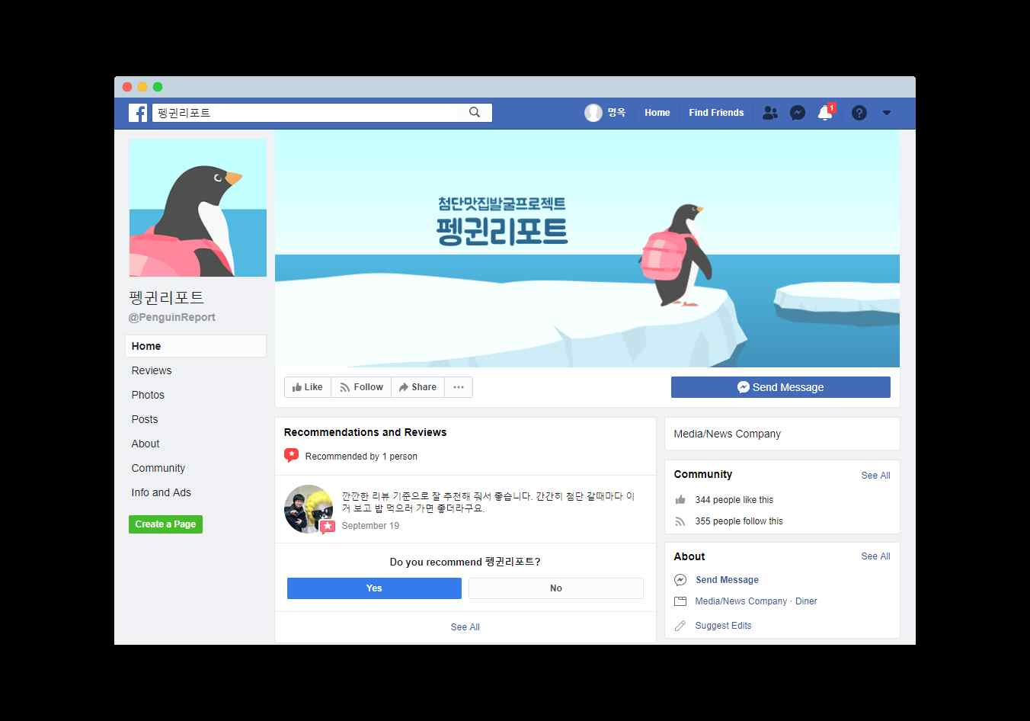
▲The Penguin Report Facebook page

