

**Gwangju Institute of Science and Technology**

**Official Press Release (https://www.gist.ac.kr/)**

**Section of** Hyo Jung Kim Nayeong Lee

**Public Relations** Section Chief Senior Administrator

(+82) 62-715-2061 (+82) 62-715-2062

**Contact Person** Semi Park, Administrator

**for this Article** Section of Public Relations

062-715-2960

**Release Date** 2020.10.19

**GIST publishes a translation of 'The Latest Electronic Warfare Technology' in preparation for the**

**next generation of threats**

□ A book has been published on the latest electronic warfare technology issues, including an introduction of traditional electronic warfare technologies as well as the development of digital electronics and wireless communication technologies.

∘ GIST (Gwangju Institute of Science and Technology, President Kiseon Kim) publisher GIST PRESS published "The Latest Electronic Warfare Technology Against Next-Generation Threats," in which Professor Kiseon Kim (President) and Professor Kangwook Kim of the School of Electrical Engineering and Computer Sciecne participated as translators in preparation for next-generation electronic warfare technology threats.

∘ The 11 translators of this book (Tae-sun Yoo, Un-seop Jeong, Kiseon Kim, Shi-chan Ryu, Sang-wook Nam, Jung-soo Lim, Byeong-nam Lee, Dong-won Yun, Kangwook Kim, Gil-young Lee, and Seok-ju Doo) are members of the Korea Electromagnetic Engineering Society, which leads the field of electronic warfare technology in Korea. This translation was published on the 20th anniversary of the research society's founding.

□ "The Latest Electronic Warfare Technology" is a translation of "EW104," the fourth book in the EW series, written by David L. Adamy, a world-recognized electronic warfare technology expert. While the previous series "EW101," "EW102" and "EW103" were written with an emphasis on the basics of electronic warfare technology and telecommunications electronic warfare, "EW104" is a hands-on book for soldiers and government workers on the frontlines.

∘ In the 21st century, electronic warfare has expanded not only to the ground, sea, and air, but also to cyber and outer space. With the advent of technologies related to the 4th Industrial Revolution such as artificial intelligence, intelligent weapon systems have been newly developed, which is completely changing both the battlefield space and the concept of war. This book covers not only traditional electronic warfare technologies but also various radar technologies and general communication systems, electronic warfare element technologies as communication threats, signal information systems including infrared bands, and practical topics of electronic warfare.

□ As a translator, Professor Kiseon Kim said, "We hope that this newly published professional book in Korean will contribute greatly to wireless electronic communication technology as well as defense propagation technology by being used in various lectures, practical sites, and research. In particular, it is expected to provide useful information to beginners in defense science and technology, intermediate scientists in the field of information and communication technology, and advanced scientists and engineers studying electronic warfare systems."

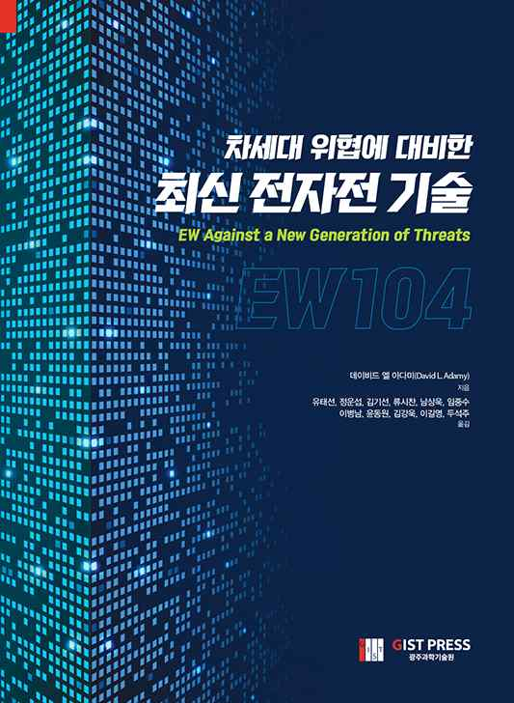

▲ Book cover: 'The Latest Electronic Warfare Technology'