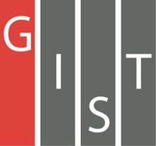

**Gwangju Institute of Science and Technology**

**Official Press Release (https://www.gist.ac.kr/)**

**Section of** Hyo Jung Kim Nayeong Lee

**Public Affairs** Section Chief Senior Administrator

(+82) 62-715-2061 (+82) 62-715-2062

**Contact Person** Professor JongWon Kim

**for this Article** AI Graduate School

(+82) 62-715-2219

**Release Date** 2019.10.25

**GIST Institute for Artificial Intelligence hosts workshop with KISTI to discuss the construction and operation of a high-performance AI computing infrastructure**

□ GIST (President Kiseon Kim) Institute for Artificial Intelligence and the Korea Institute of Science and Technology Information (KiSTi, President Hee-yoon Choi) National Supercomputing Headquarters held a joint workshop in Seoul on October 25, 2019, to discuss building and operating a high-performance AI computing infrastructure suitable for Korea.

∘ This workshop was jointly prepared by the GIST Institute for Artificial Intelligence (Director Hyuk Lim) and and KiSTi National Supercomputing Headquarters (Director Soon-wook HWang) and discussed ▲ building and operating a desirable AI computing infrastructure ▲ efficient AI computing infrastructure operation and utilization platform ▲ next generation AI computing chips ▲ intensive presentations and discussions by 14 domestic computing researchers and experts on AI computing equipment HW and SW topics.

□ To flexibly support AI, which is rapidly affecting all areas of activities involving human beings, massive amounts of data, which is good for high-performance products that act as engines, must be injected according to the situation and operated at optimum power. According to openAI's analytical data *, the learning time (calculations) of leading AI technology innovations like AlphaGo tends to double every 3.5 months.

* https://openai.com/blog/ai-and-compute/

∘ As a result, competition is being waged to equip larger AI computing engines and data storage sites around the world, and most of the cases currently being pursued are national AI computing infrastructures, either by AI specialization or by HPC/AI.

∘ For example, Japan has deployed and utilized computing infrastructure directly supporting national AI R&D from May 2018 (ABCI AI-only supercomputer) and Taiwan from late 2018 (Taiwania-2 HPC/AI supercomputer). In addition, exascale-class supercomputer sites, which are being developed as next-generation supercomputing projects in the U.S., China, and Europe from 2020 to 22, will all be built in a form that can use a combination of HPC/AI.

□ In addition to supporting AI computing using KiSTi's Nurion supercomputer, which was opened in November 2018, a project to provide additional infrastructure that supports GPU-focused ultra-high performance computing that is specialized for AI to Korean industry and academic institutes is underway.

∘ This is part of the 'AI Industrial Convergence Complex' project to be established in Gwangju's 3rd high-tech district in accordance with the Data-Network-AI (DNA) strategy for responding to the 4th Industrial Revolution between 2020 and 2024, and GIST is planning to establish a demonstration testbed that will be linked to AI Cloud Data Center, which is ranked 10th in the world as of 2019 *.

* 100Peta-Flops (Peak/Single-Prevision) calculations and 128Peta-Bytes storage-scale AI infrastructure

□ GIST Institute for Artificial Intelligence Director Hyuk Lim said, "For the successful construction of Korea's AI computing infrastructure, we hope to operate in the Gwangju area through the open collaboration of academic centers, governments, Gwangju city, GIST AI Graduate School, the supercomputing research center, and specialized institutions. This will be an opportunity for domestic experts to come together and create the best infrastructure."

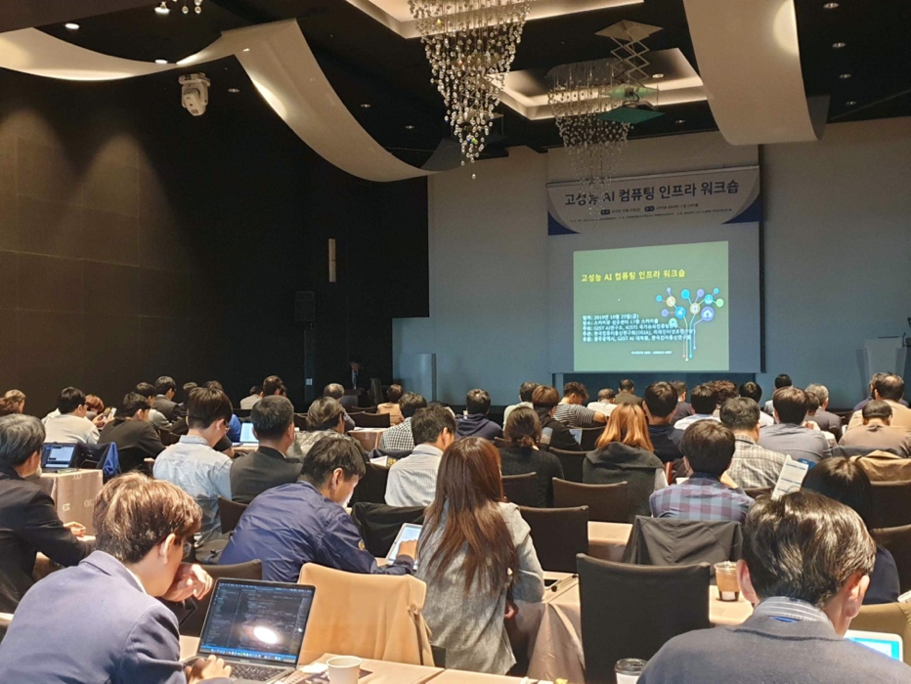

▲ Photo of high-performance AI computing infrastructure workshops

