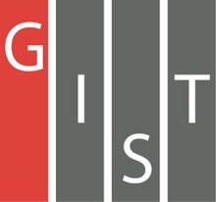

**Gwangju Institute of Science and Technology**

**Official Press Release (https://www.gist.ac.kr/)**

**Section of** Hyo Jung Kim Nayeong Lee

**Public Affairs** Section Chief Senior Administrator

(+82) 62-715-2061 (+82) 62-715-2062

**Contact Person** Moon-seop Yoon, Administrator

**for this Article** Section of Public Affairs

(+82) 62-715-2021

**Release Date** 2020.03.06

**Second official launch of the**

**GIST Development Foundation**

□ Gwangju Institute of Science and Technology (GIST, President Kiseon Kim) announced the official launch of the second GIST Development Foundation (Chairperson Jung-joo Ko) for the revitalization and co-prosperity of the local economy based on industry-academic cooperation.

∘ Since the establishment of the Gist Development Foundation in 2016, the 11th regular board meeting was held on February 10 and formed its second board of directors with the appointment of Hanyoung PNS CEO Yoon-seop Kim and Korea Triaxle CEO Gu Hyeon Ryu to the board.

□ The GIST Development Foundation was newly inaugurated last October with Nayoung Industrial CEO Jung-joo Ko with 12 members including GIST President Kiseon Kim, GIST Office of International and Public Affairs Dean Sung-Gyoo Park, Hyang Industrial Co., Ltd. Vice-Chair Kyung-hyun Song, M.S. CEO Hae-myung Kim, Woosung Trading Co. CEO Hwa-suk Park, Decay CEO Bo-gon Kim, Mujin Services CEO Eun-mo Choi, Echo World CEO Suk-joon Oh, and DH Global CEO Jung-kwon Lee.

□ The term of office for the GIST Development Foundation runs until October 27, 2022, and is subject to the approval of the Ministry of Science and ICT. The GIST Development Foundation is expected to give a big boost to the development of the regional economy, including industrial and academic cooperation activities for regional co-prosperity.

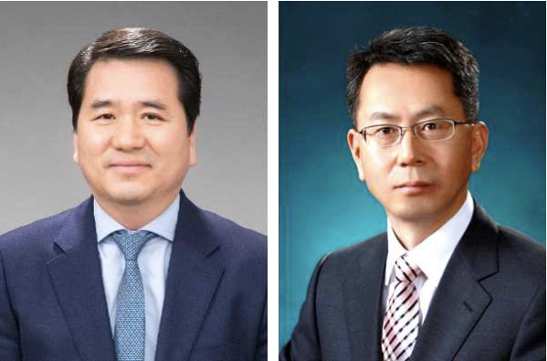

▲ (From left): Hanyoung PNS CEO Yoon-seop Kim

and Korea Triaxle CEO Gu Hyeon Ryu