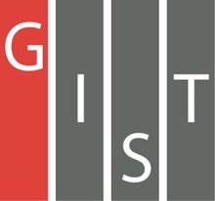

**Gwangju Institute of Science and Technology**

**Official Press Release (https://www.gist.ac.kr/)**

**Section of** Hyo Jung Kim Nayeong Lee

**Public Relations** Section Chief Senior Administrator

(+82) 62-715-2061 (+82) 62-715-2062

**Contact Person** Joon-ho Park, Administrator

**for this Article** Auditor Office

062-715-2009

**Release Date** 2020.11.04

**GIST hosts a conference to improve**

**institutional integrity**

□ GIST (Gwangju Institute of Science and Technology, President Kiseon Kim) Auditor Office (Auditor Kwang-sik Shin) presented letters of appointment to the Integrity Citizen Auditor and Integrity Advisory Group, appointed this year, and held a conference to discuss the development of institutional integrity policies.

∘ At the conference, the Integrity Citizen Auditor and the Integrity Advisory Group discussed ways to establish a clean organizational culture, such as sharing books, improving integrity and strategic promotion measures for preventing corruption, and sharing the results of activities of the Audit Office in 2020.

□ GIST first introduced the Integrity Citizen Auditor System in June 2018, and it was joined by Sang-hoon Lee, the current director of the National Youth Space Center, Jin-hee Song, a non-executive director of Hanul Accounting Corporation, and Joon-hong Baek, a lawyer at Baek Joon-hong Law Office. The Integrity Advisory Group has been in operation since October 2017 to provide advice and policy suggestions on institutional integrity policies, and GIST Professor Jongseok Lee, Dr. So Eun Kim, and Administrator Hye-won Jang attended the meeting as advisors.

∘ The Integrity Citizen Auditor System is a private participatory corruption prevention system introduced by public institutions at various levels and has been introduced and operated since 2018 for the purpose of monitoring, supervising, and evaluating major projects by appointing outside experts to improve unreasonable practices and systems at public institutions and to deal with complaints.

□ GIST Auditor Kwang-sik Shin said, "In order to improve integrity, we must strive to improve the awareness of internal members and to spread the sense of integrity. We will respond to those involved in corruption with the principle of zero tolerance."

□ Auditor Kwang-sik Shin received a commendation from the Ministry of Public Administration and Security on Police Day for securing fairness in the police investigation as the chairman of the review committee of the investigation team of the Jeonnam Provincial Police Agency.

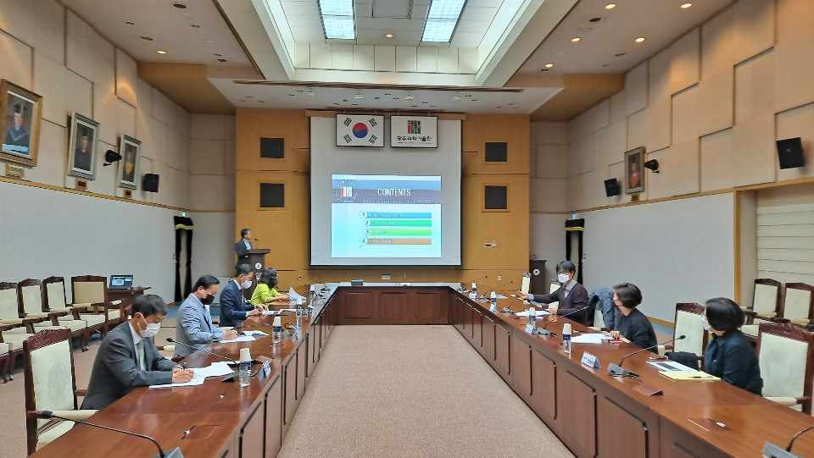

▲ GIST Integrity Citizenship Auditor (on left) and Integrity Advisory Board (on right) Meeting