

**Gwangju Institute of Science and Technology**

**Official Press Release (https://www.gist.ac.kr/)**

**Section of** Hyo Jung Kim Nayeong Lee

**Public Affairs** Section Chief Senior Administrator

(+82) 62-715-2061 (+82) 62-715-2062

**Contact Person** Mina Choi, Administrator

**for this Article** GIST Academy

(+82) 62-715-2622

**Release Date** 2019.11.07

**GIST Techno Management Business Academy hosts friendly sports competitions... Alumni donates funds**

□ GIST (President Kiseon Kim) Techno Management Business Academy (GTMBA, Director Jong-In Song & GIST Vice President) and GIST Alumni Association (Chairperson Kyung-hyun Song & CEO of Thang Industrial Co., Ltd.) held the 6th GIST-GTMBA alumni sports competitions that was attended by 160 alumni.

∘ The alumni made a donation 18 million won at the GTMBA event to celebrate of the spirit of the competition and to help start social contribution projects in Gwangju and South Jeolla Province.

□ GIST Alumni Association Chairperson Kyung-hyun Song said, "The true value of this competition is to inspire pride as a GTMBA alumni and to create stronger harmony by meeting good people. I hope that the friendly sports competition will promote unity among alumni and bring much interest and affection to the development of the GTMBA Alumni Association."

∘ GTMBA Director Jong-In Song said, "I would like to express my deep gratitude for their contribution to the social contribution work of GIST through this sports event. GIST will do our best to help and work with the alumni and local businesses."

□ The donation will be used to support elementary, middle, and high school students at local children's center where GIST students perform volunteer work through the Learning Zone, one of GIST's social contribution projects.

∘ Meanwhile, GTMBA is currently recruiting new students for their 10th program in 2020, which runs for one year starting in March until November.

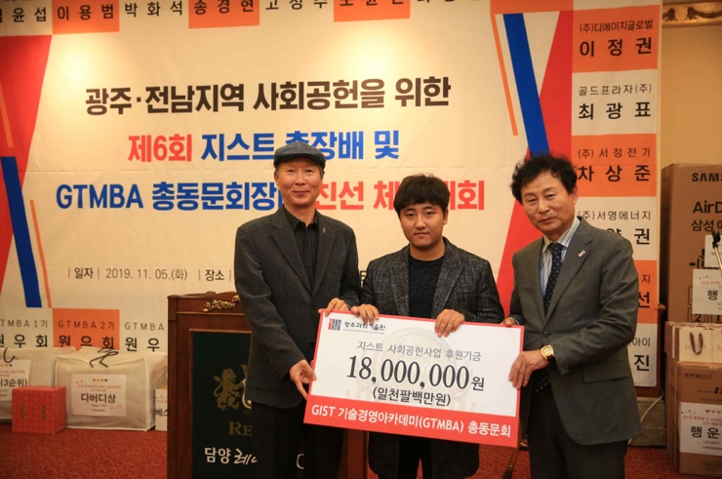

▲ [Photo 1] GTMBA Alumni Association Chairperson Kyung-hyun Song with GTMBA Director and GIST Vice President Jong-In Song delivering the donated funds to Tae-kyun Lee who is a student representative of the Division of Liberal Arts and Sciences

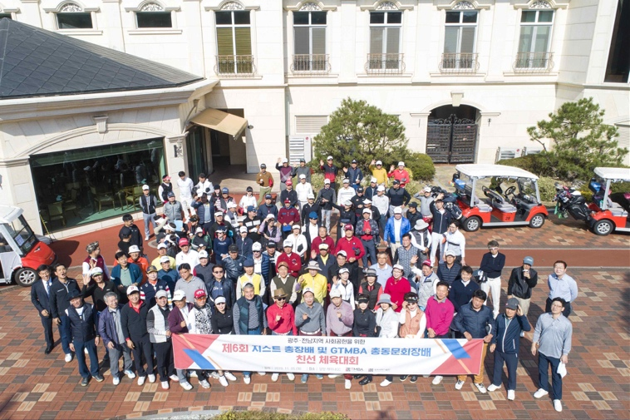

▲ [Photo 2] 6th GIST-GTMBA alumni sports competitions