

**Gwangju Institute of Science and Technology**

**Official Press Release (https://www.gist.ac.kr/)**

**Section of** Hyo Jung Kim Nayeong Lee

**Public Affairs** Section Chief Senior Administrator

(+82) 62-715-2061 (+82) 62-715-2062

**Contact Person** Professor JongWon Kim

**for this Article** School of Electrical Engineering

and Computer Science

(+82) 62-715-2219

**Release Date** 2019.09.30

**GIST Graduate School of Artificial**

**Intelligence opening next semester**

□ GIST (President Kiseon Kim) was selected for a project in the second half of 2019 to support a Graduate School of Artificial Intelligence (Director JongWon Kim).

∘ GIST aims to quickly complete the preparation process for selecting new students and open the program by March of next year, with full-time professors with AI expertise who have been intensively training the most advanced Ph.D. students to lead artificial intelligence R&D at home and abroad, and to select more than 50 AI graduate students from October of this year.

□ GIST Graduate School of Artificial Intelligence is characterized by a joint master's and Ph.D. integrated program that carries out core AI SW/HW practices based on empirical data and infrastructure, and to foster global AI innovation specialists based on field research and technical demonstration with a start-up orientation.

□ GIST Graduate School of Artificial Intelligence has focused on creating synergy with the 'AI Industrial Convergence Complex *', which will be built in Gwangju's high-tech district, focusing on three major areas (healthcare, automobiles, and energy along with global AI basics and core technologies as well as plans to conduct AI for X education and research.

* Create AI R&BD integrated ecosystem in Gwangju (406.1 billion won from 2020 to 2024)

∘ Specifically, the goal is to foster global innovative specialists for the advancement of AI: ▲ (education) cultivate industry-oriented AI convergence specialists to solve problems faced by companies using their knowledge and skill of AI core technologies ▲ (research) leading convergence research for 3 major AI specialized fields in healthcare, automotive, and energy based on world-class AI research capabilities ▲ (start-up) the AI Ph.D. program will focus on laying the foundation for future job creation by promoting the creation of innovative companies based on sustainable technology demonstration.

∘ Furthermore, GIST has developed various creative collaborative research and educational cooperation programs with global companies such as Google, Google Deep Mind, Facebook, Microsoft, Nvidia, overseas research institutes and universities, and domestic industry-university research institutes. The AXEL * Together joint project with the “AI Industrial Convergence Complex” is planning to build an AI innovative enterprise startup ecosystem that connects people, technology, and companies.

* Creative self-help programs designed to help AI graduate students create start-ups naturally under the AXEL (AI X Everything for Life) theme of the “AI Industrial Convergence Complex.”

□ Under the "Data-Network-AI" strategy to respond to the 4th Industrial Revolution, Korea's largest AI computing infrastructure and demonstration test platforms will be established in stages at the AI Industrial Convergence Complex through demonstration-oriented education and research programs that connect to the Graduate School of Artificial Intelligence education/practice environments.

▲ By utilizing a world's top 10 * ('19) AI cloud data centers to be built at the 'AI Industrial Convergence Complex', AI demonstration education and research model involving international-level training and reasoning is inferencing will be developed. ▲ A collaborative program will be prepared for three specialized areas in the 'AI Industrial Convergence Complex' to demonstrate the AI for X service utilizing sector-specific data.

* 100Peta-Flops (Peak/Single-precision) calculation and 128 Peta-Bytes storage scale AI infrastructure

□ GIST President Kiseon Kim said, "The role of universities in the science and technology entrepreneurship ecosystem is very important, as can be seen from examples where a university-industrial cooperation cluster is formed naturally around universities with abundant human resources such as MIT and Stanford. GIST will contribute to balanced regional development and future job creation by nurturing specialized AI personnel suitable for the region."

□ Gwangju Mayor Yong-sup Lee said, "To create an artificial intelligence industrial ecosystem, which is a key technology for the 4th Industrial Revolution, securing professional workers is very important. Gwangju City will provide support to nurture specialists so that Gwangju can move forwards as a world-class artificial intelligence hub by promoting artificial intelligence."

□ GIST, along with the Gwangju Metropolitan City, is promoting the 'AI Industrial Convergence Complex' project with total budget of KRW 416 billion for five years from 2020 to 2024, focusing on creating synergy and securing AI growth engines centered on healthcare, automotive, and energy.

∘ GIST is leading the development of AI technology for the 'AI Industrial Convergence Complex' project centered on the 'Industrial Intelligence Research Center' to become a global technology hub through domestic and foreign industry-university cooperation. It is expected to create an industrial convergence ecosystem and lay the foundation for improving Korea's AI industry.

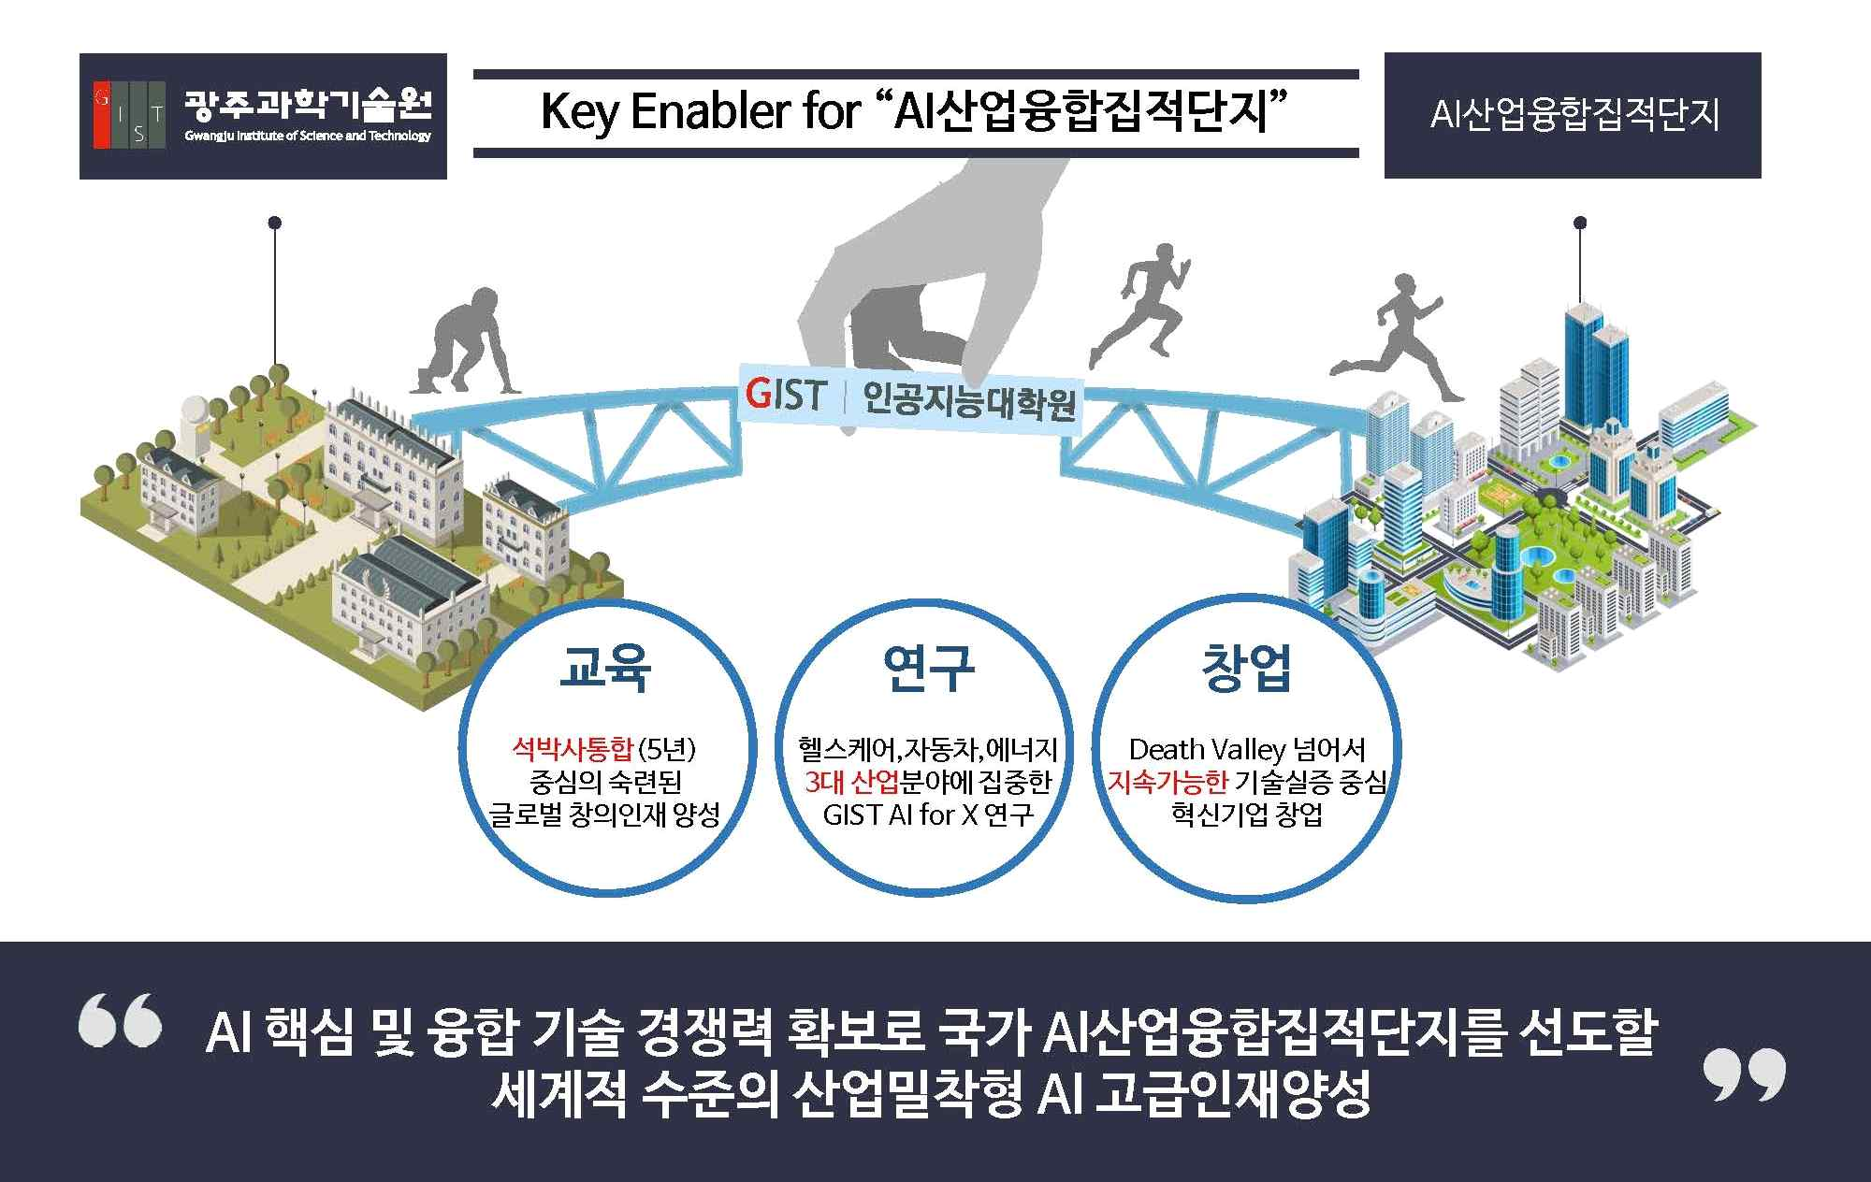

▲ GIST Graduate School of Artificial Intelligence vision