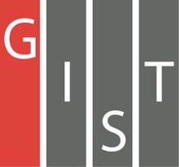

**Gwangju Institute of Science and Technology**

**Official Press Release (https://www.gist.ac.kr/)**

**Section of** Hyo Jung Kim Nayeong Lee

**Public Relations** Section Chief Senior Administrator

(+82) 62-715-2061 (+82) 62-715-2062

**Contact Person** Seung Su You, Administrator

**for this Article** Section of Public Affairs

062-715-2025

**Release Date** 2020.11.03

**Chairman of the Gwangju Metropolitan Council and a group of lawmakers visit GIST to discuss regional development plans**

□ Gwangju Metropolitan City Council Chairman Yong-jip Kim and a group of lawmakers visited GIST (Gwangju Institute of Science and Technology, President Kiseon Kim) on the morning of November 2, 2020, to meet with GIST President Kiseon Kim, Vice President for Public Affairs Young-jip Kim, Office of International and Public Affairs Dean Sung-Gyoo Park, and others to discuss regional development plans based on science and technology, development of artificial intelligence industries, and countermeasures against climate change.

∘ Prior to the meeting, the Gwangju City Council's visiting group visited the GIST's Nobel Research Institute to see GIST's outstanding research results and then moved to the luncheon venue to discuss ways to promote the artificial intelligence industry as well as how to cope with climate change.

□ GIST Présidenct Kiseon Kim said, "GIST is internationally recognized for its excellent research ability, ranking fourth in the world for the number of citations per faculty by QS World University Rankings. Today's meaningful visit by the Gwangju Metropolitan Council is expected to serve as a cornerstone for future cooperation between the two organizations."

□ Gwangju Metropolitan City Council Chairman Yong-jip Kim said, "This meeting was a meaningful occasion to confirm GIST's commitment to regional development based on science and technology. I felt once again that GIST is essential for community development, and I will actively support further cooperation in the future."

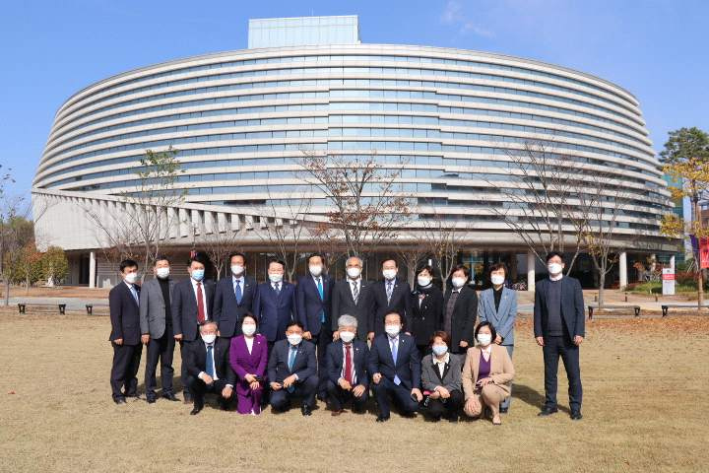

▲ Gwangju Metropolitan City Council Chairman Yong-jip Kim and a group of lawmakers visit GIST to discuss regional development plans based on science and technology, development of artificial intelligence industries, and countermeasures against climate change