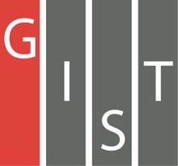
Gwangju Institute of Science and Technology

Official Press Release (https://www.gist.ac.kr/)

Section of Mi-Yeon Kim Nayeong Lee
Public Affairs Section Chief Senior Administrator
(+82) 62-715-2020 (+82) 62-715-2024

Contact Person Juhee Im, Administrator
for this Article Energy Valley Institute of Technology
(+82) 62-715-6976

Release Date 2018.09.07

Energy Valley Institute of Technology hosts 2018 Energy Valley Win-Win Development Workshop

□ GIST (President Seung Hyeon Moon) – Energy Valley Institute of Technology (President Yong-woo Park) held the 2018 Energy Valley Win-Win Development Workshop at the Hyundai Hotel Convention Hall in Mokpo from September 6 to 7, 2018.

∘ This workshop was held four times in total from 2015 to 2017 to lay the groundwork for building an energy valley. The 5th meeting of the 2018 Energy Valley Win-Win Development Workshop included more than 200 participants from local governments, regional universities, and research institutes.

□ The Energy Valley Win-Win Development Workshop is hosted by the GIST Energy Valley Institute of Technology (EVIT), Gwangju/Jeonnam Techno Park, the Gwangju Metropolitan City, Jeollanamdo Province, and the Korea Electric Power Corporation. Local universities, research institutes and energy companies participate to share information and research capabilities among business and technology development innovators and to promote mutual understanding and networking.

∘ On the first day of the workshop, EVIT President Park Yong-woo Park and Mr. Jae-ho Han, the Director of the Gwangju Metropolitan City's Energy Department, gave the opening remarks. In particular, many industry insiders, including Energy Business Council Presidnt Hee-joo Park and Honam University Professor Seung-hak Yang, praised the event.

□ This workshop focused on the theme of 'Energy Conversion and Korea's Choice' by President Chun Taek Rim of the Korea Energy Technology Evaluation Institute. The core products and technologies of major local energy companies were introduced in a separate corporate poster session and included technology transfers, R&D status of power exchange, trends in hydrogen energy in Gwangju, R&D special projects, and research.

□ EVIT Director Yong-woo Park said, "Through this workshop, we expect successful energy valuations to be created that will contribute to the development of related industries through exchange of information and opportunities in the energy industry during the 4th Industrial Revolution."

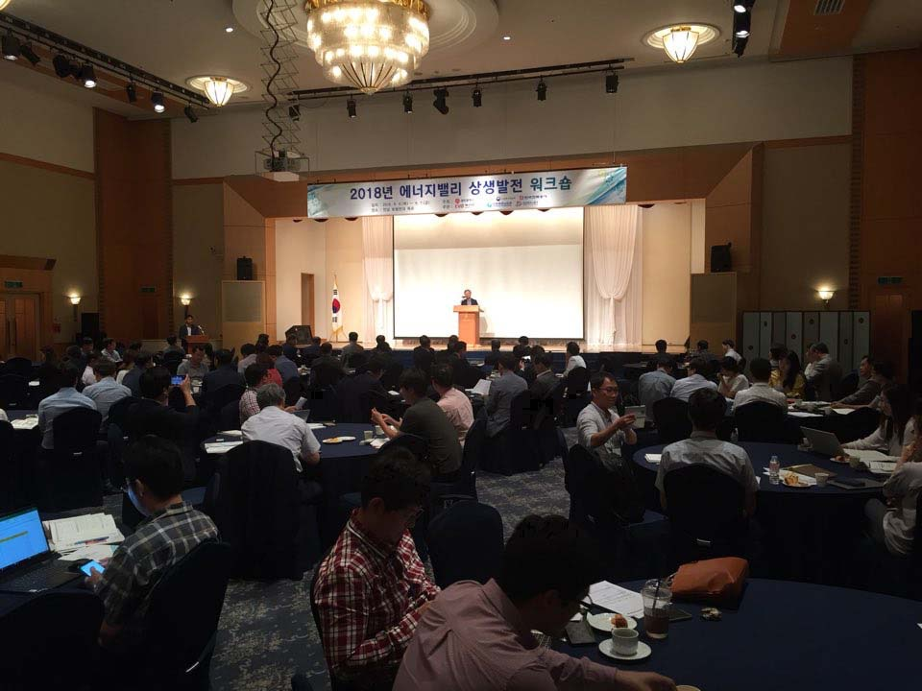
EVIT Director Yong-woo Park at the 2018 Energy Valley Win-Win Development Workshop

