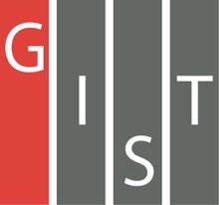
Gwangju Institute of Science and Technology

Official Press Release (https://www.gist.ac.kr/)

Section of Hyo Jung Kim Nayeong Lee
Public Relations Section Chief Senior Administrator
(+82) 62-715-2061 (+82) 62-715-2062

Contact Person Jin Ho Kim, Professor
for this Article School of Integrated Technology
(+82) 62-715-5322

Release Date 2020.06.02

GIST establishes "FLEX Graduate
School of Energy Convergence"

□ GIST (Gwangju Institute of Science and Technology, President Kiseon Kim) 'FLEX Graduate School of Energy Convergence' will be established to train specialized energy master's and doctorate-level convergence experts with the aim of improving the system flexibility of electricity produced by renewable energy in response to energy conversion and a green new deal.

∘ GIST was selected as a university to carry out new projects for energy manpower training in 2020, including the establishment of the Graduate School of Energy Convergence announced by the Ministry of Trade, Industry and Energy on May 27. The energy training project is divided into a convergence track and a convergence graduate school, and only two universities, GIST and Chonbuk National University, have set up a new graduate school.

□ GIST plans to establish FLEX (Flexibility) Graduate School of Energy Convergence with full-time teachers in power and energy to focus on renewable energy, distributed power, and grid system * flexibility due to the expansion of electric vehicles and prosumer.

* grid system: a grid-like structure that interconnects wires and serves to improve the efficiency of the entire process of producing, transmitting and consuming electricity

∘ To accommodate renewable energy and distributed power with high volatility and uncertainty in the power system, innovative market systems, policy development, and technology application are needed. Through this, system flexibility can be improved to provide clean and stable power supply. System flexibility requires access from various perspectives such as new power technologies, flexible power market design, network investment and operation optimization, and innovative technology support books and management, so it is necessary to produce convergence experts that can present creative alternatives by combining multidisciplinary expertise and technologies.

□ GIST 'FLEX Graduate School of Energy Convergence' aims to produce specialized master's and doctorate-level convergence experts related to system flexibility, and will produce high-quality human resources with convergent thinking skills on a multidisciplinary basis such as system analysis operation, policy system design, power conversion application, economic management model, human computer interaction, energy storage and environment, and develop practical skills in addition to the enterprise-linked project process.

∘ The curriculum is classified as specializations in majors, convergence education, corporate links, and start-up links, and plans to support start-ups that create new values by further strengthening their corporate linkage cooperation and supporting start-ups while focusing their educational and research capabilities on convergence subjects such as energy production/storage/transformation/consumption, technology policy/economic management/system, energy system/control/operation, etc.

□ School of Integrated Technology Professor Jin Ho Kim is in charge of the project said, "The GIST Graduate School of Energy Convergence will study the integration flexibility of energy production and consumption to eliminate uncertainties in renewable energy volatility and power consumption. To this end, it will train high-quality convergence talent in the market, technology, and policy and management fields. It is expected to lead the energy conversion and green new deal paradigm by securing efficient and economic system flexibility, and to play a key role in the global new industry that combines energy, environment, artificial intelligence and management models in the future."

□ Meanwhile, the Graduate School of Convergence Studies selected by the Ministry of Industry aims to produce convergence experts with knowledge in other fields such as new technology and humanities/social studies/economy through the opening of departments and is a project to produce experts by linking various R&D activities centered on master's and doctoral students within the graduate curriculum.

∘ The project period is from May of this year to December 2024, which is a total of 5 years, with the first stage lasting until December 2022 and the second stage from 2023 and December 2024. For the Graduate School of Convergence, an amount of about 1 billion won per year will be provided.

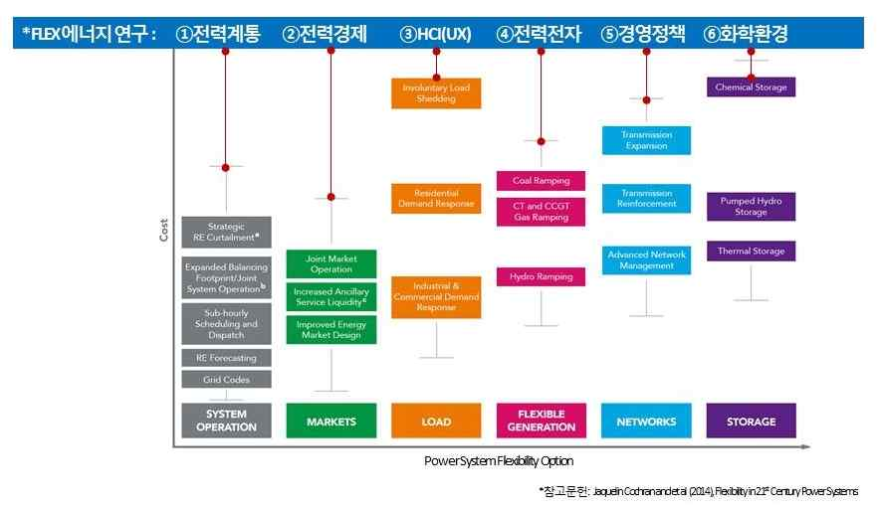
▲ Various ways to increase system flexibility

