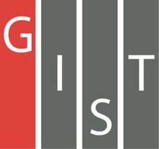
Gwangju Institute of Science and Technology

Official Press Release (https://www.gist.ac.kr/)

Section of Hyo Jung Kim Nayeong Lee
Public Relations Section Chief Senior Administrator
(+82) 62-715-2061 (+82) 62-715-2062

Contact Person Seung-jae Lee, Section Chief
for this Article AI Graduate School
062-715-6351

Release Date 2020.08.12

GIST & DGIST hosts 'Moonlight AI' Workshop

□ A meaningful meeting was held between specialized universities in science and engineering regarding research cooperation in the field of artificial intelligence. GIST (Gwangju Institute of Science and Technology, President Kiseon Kim) and DGIST (Daegu Gyeongbuk Institute of Science and Technology, President Young Kuk) co-hosted the "Moonlight AI Workshop 2020" on August 11, 2020.

□ This workshop, co-hosted by the GIST AI Graduate School and the DGIST information and communication convergence major, was conducted online using Zoom. Under the theme of “AI lightweight and reinforcement learning,” professors, researchers, and university graduates from both institutions gathered to share the latest research and development technologies currently being developed.

∘ This workshop was divided into two sessions. In the first session, DGIST information and communication convergence major Professor Ye-sung Kim introduced and announced a light weight model of AI based on brain engineering developed by his team as well as the introduction of a light quantification model for visual recognition on edge devices developed by GIST AI Graduate School Professor Jonghyun Choi.

∘ In the second session, GIST School of integrated Technology Professor Kyung-Joong introduced offline learning methods and application cases of reinforcement learning to real problems by using vast amounts of accumulated data. Subsequently, a reinforcement learning technique for a Contents Caching network developed by DGIST information and communication convergence major Professor Jung-ho Kwak's team was introduced.

□ GIST AI Graduate School Dean JongWon Kim said, "As this moonlight workshop was held with experts from both organizations in the field of artificial intelligence, it is expected to be a meaningful attempt to share the latest information in the AI field and to promote research exchanges. We hope that the this workshop will continue to be held to provide a foundation for balanced regional development, the training of AI convergence specialists, and, above all, future job creation."

□ DGIST information and communication convergence major Professor Kyung-joon Park said, "The workshop will be held to exchange the latest information on AI light weight research and reinforcement learning technologies that the two schools are focusing on. With this event as an opportunity, we hope to lay the groundwork for joint research and conduct good research that can contribute to the development of artificial intelligence technology in the future."

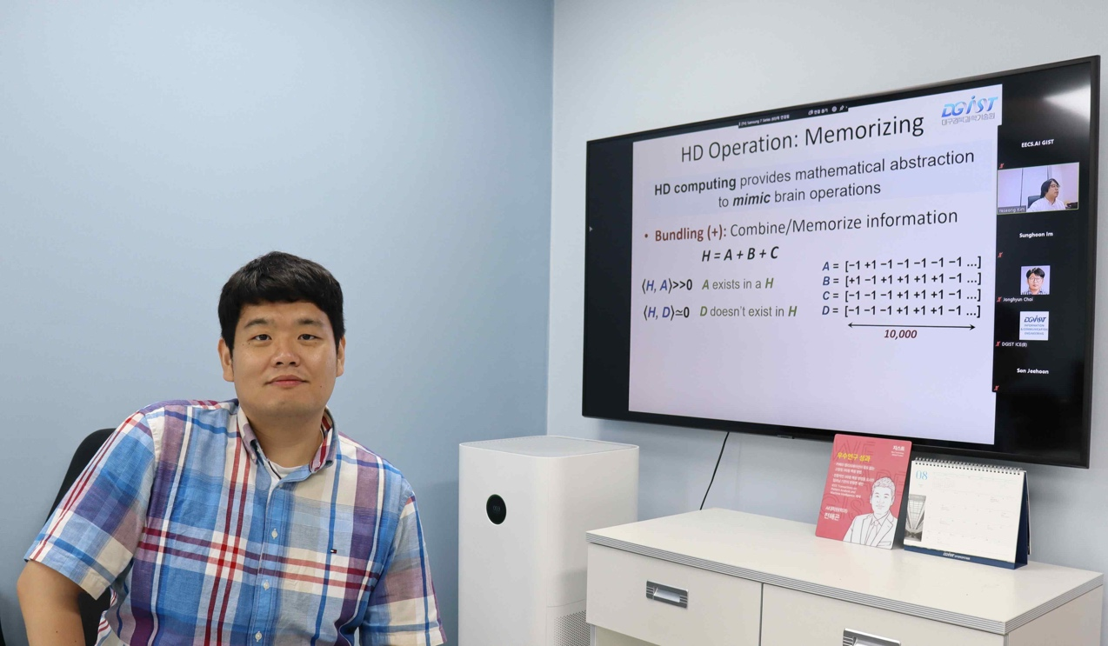
▲ GIST & DGIST 'Moonlight AI' Workshop: GIST AI Graduate School Professor Hae-Gon Jeon

