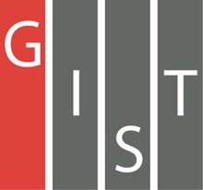
Gwangju Institute of Science and Technology

Official Press Release (https://www.gist.ac.kr/)

Section of Hyo Jung Kim Nayeong Lee
Public Affairs Section Chief Senior Administrator
(+82) 62-715-2061 (+82) 62-715-2062

Contact Person Dean Sung-Gyoo Park
for this Article Office of International and Public Affairs
(+82) 62-715-2022

Release Date 2019.07.31

GIST Social Contribution Team begins knowledge sharing and social welfare activities in Laos

□ GIST (President Kiseon Kim) Social Contribution Team (Dean Sung-Gyoo Park, School of Life Sciences Professor) hosted the second GIST Global Science Camp Vientiane, Laos, for five days from July 22 to 26, 2019, to share the scientific knowledge gained at GIST with students from low-income countries.

∘ A total of 16 GIST college students, graduate students, and researchers volunteered with the GIST Global Science Camp (headed by Senior APRI Researcher Chang-Lyoul Lee and School of Electrical Engineering and Computer Science Ph.D. student Hyeong-chan Song), and a total of 64 students participated, including 47 chemical and environmental engineering students from the National University, Thailand's Khon Kaen University, Suranaree University of Technology, and 17 students from King Mongkut’s University of Technology North Bangkok.

□ The GIST Global Science Camp shared new and diverse experimental experiences and knowledge to students at the National University of Laos. In this year's Global Science Camp, students were reminded of the sense of crisis faced by Laos while collecting water from the Mekong river under the theme of social and environmental issues, applying sewage treatment techniques, and conducting renewable energy experiments through solar waste decomposition.

∘ This year, students from Laos and Thailand conducted experiments with members of GIST by preparing various experiments on bioenergy and water quality improvement. GIST and Laos National University had enjoyed the experience by sharing knowledge through scientific experiments.

□ Vice President Oudom Phonekhampheng of the National University of Laos personally thanked the GIST Global Science Camp team, which visited Laos last year and again this year. The Vientiane Times, a local newspaper in Laos, also reported on the program by the GIST Social Contribution Team and the successful hosting of the Global Science Camp.

□ At the conclusion of the Global Science Camp, the GIST members hosted a Korean Food Event at a local Korean restaurant for Laotian and Thai students and professors. The event introduced Korean culture, the GIST Global Intern Program (GIP), and GIST's support for international graduate students.

∘ In addition, GIST members had a chance to learn about the culture of Laos by interacting with the students of Laos National University and by visiting tourist attractions and tours around Vientiane.

□ GIST Social Contribution Team Dean Sung-Gyoo Park said, "The GIST Social Contribution Team will continue to provide support and build a solid foundation for members to continue their social contribution activities."

□ The GIST Social Contribution Team was formed in 2017 and supports a multitude of programs such as the GIST Global Science Camp, the Learning School, Science Book Donations, Science Camp, GSOP, ICT Programs, and hosting students from Korea's costal islands.

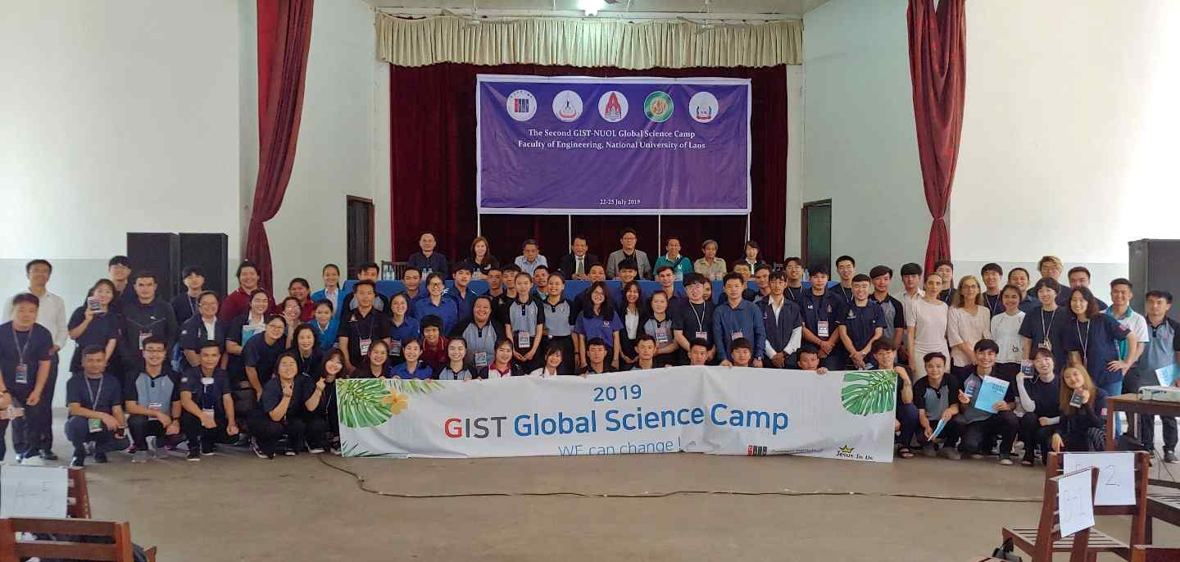
▲ 2019 Global Science Camp group photo

