Gwangju Institute of Science and Technology

Official Press Release (https://www.gist.ac.kr/)

Section of Hyo Jung Kim Nayeong Lee
Public Affairs Section Chief Senior Administrator
(+82) 62-715-2061 (+82) 62-715-2062

Contact Person Mi-ae Kim, Section Chief
for this Article School of Life Sciences
(+82) 62-715-2483

Release Date 2019.11.13

GIST School of Life Sciences and the Aging Research Institute hosts "Multidrug-Resistant Super
Bacteria Research Forum"

□ GIST (President Kiseon Kim) School of Life Sciences and the Aging Research Institute hosted the "Multi-Resistant Super Bacteria * Research Forum" on November 14, 2019, at Oryong Hall, which was attended by GIST researchers, academic experts, and officials from related institutions such as hospitals.

* super bacteria: A bacterium that can resist any powerful antibiotic without dying. The frequent use of antibiotics leads to mutant strains that are resistant to antibiotics, and indiscriminate abuse of antibiotics is cited as the main reason. More than 700,000 people are estimated to die each year from endogenous infections, and more than 10 million are expected to die by 2050, according to a WHO report.

□ Multidrug-resistant bacteria (super bacteria) are caused by resistance to antibiotics, which are essential for treating bacterial infections, and are emerging as a global and national security threat due to the continuous increase. Therefore, it is urgent to protect people's health from antibiotic resistant bacteria.

∘ Despite active research in the U.K. and the U.S. to combat super bacteria, such as identifying key genes that give antibiotic resistance to super bacterial pathogens, experts warn that the problems caused by the abuse and misuse of antibiotics are getting worse. Even if some bacteria are eradicated, other super bacteria could emerge.

∘ In this research forum, experts from various fields such as academia, hospitals, and government agencies participated in a report on the status of domestic development of innovative treatments for multidrug-resistant bacterial infections that are a global problem. Together with the lecture on the s"Reporting the Use of Influenza/Eviral Drugs" and "Reporting the Present Situation and Cases of Innovative Treatment," discussions on the developmental direction of next-generation innovative antibiotics and on strategies for attracting national large-scale R&D projects to overcome the bacterial resistance problem.

□ School of Life Sciences Dean Zee-Yong Park said, "I hope this forum will be a place of active exchange with experts from various fields in the field of multidrug-resistant bacteria, which will pave the way for the discovery of state-to-state research and development projects and ultimately contribute to the improvement of public health and national health competitiveness."

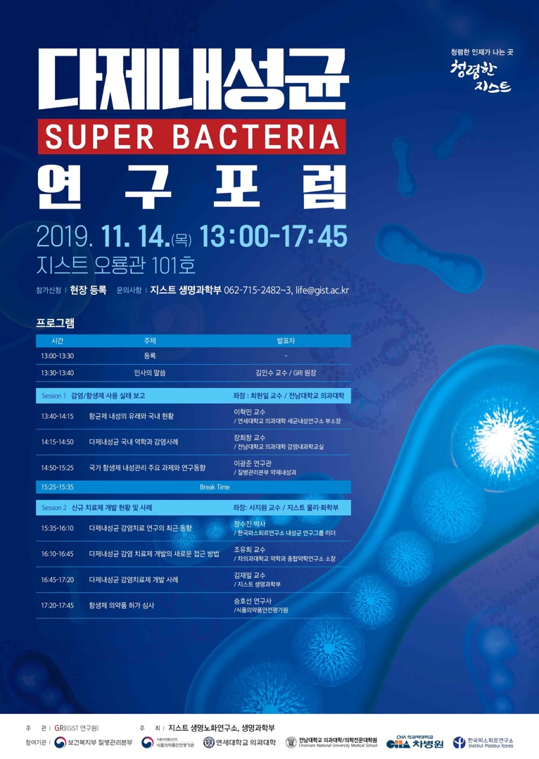
Poster

