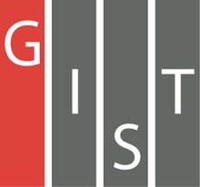
Gwangju Institute of Science and Technology

Official Press Release (https://www.gist.ac.kr/)

Section of Mi-Yeon Kim Nayeong Lee
Public Affairs Section Chief Senior Administrator
(+82) 62-715-2020 (+82) 62-715-2024

Contact Person Professor Gi-hoon Lee
for this Article GIST Center for Security Science and Technology
(+82) 62-715-5208

Release Date 2018.11.22

GIST hosts Security Science and Technology Advisory Meeting to discuss the roles and responsibilities of the scientific and technological community
to support national security

□ On November 21, 2018, GIST (President Seung Hyeon Moon) commissioned 12 experts from various fields as advisors to the GIST-Security Science and Technology Advisory Committee and held its first meeting * .

* The Security Science and Technology Advisory Council, which will be held for the first time this year, is a gathering of experts from various fields of defense, national security, and science and technology to discuss civilian cooperation and institutional improvement issues to establish policies for Korea.

□ GIST Center for Security Science and Technology (Director Hyyong Suk) Professor Gi-hoon Lee hosted a meeting where participants shared various opinions on the responsibility and role of the science and technology community for national security.

□ President Seung Hyeon Moon said, "GIST recognizes its role and responsibilities as a practical backbone of national security with its excellent science and technology. GIST will be a good example for Korea`s science and technology community in developing high-level and advanced convergence research concept in security science technology, ultimately expanding its R&D areas and scale to create a safer Korea."

□ GIST is a leading research institute in Korea's 'security science and technology' field and has established and operated the GIST Center for Security Science and Technology in late 2016 to actively cooperate with domestic and international organizations.

∘ In 2016, GIST was appointed as a specialized research institute by the Defense Agency in the field of electronic warfare, high-performance laser, next-generation energy, military communications and networks. GIST has has specialized laboratories, such as the Advanced Photonics Research Institute (APRI) specializing in lasers.

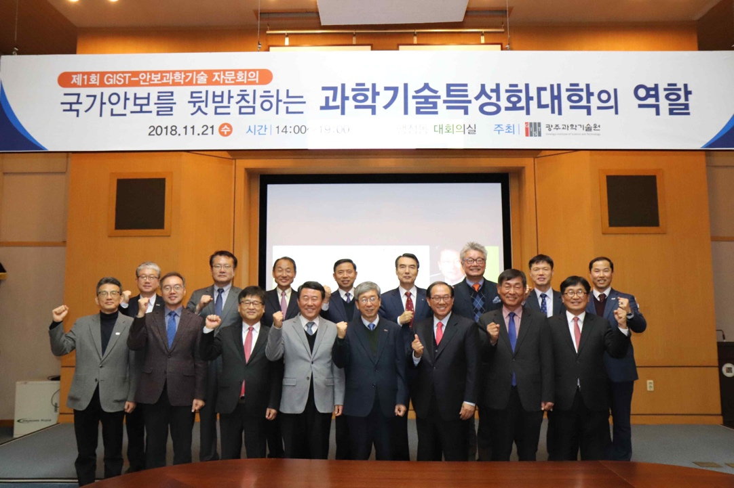
▲ Commemorative photos of the first GIST-Security
Science and Technology Advisory Council meeting

