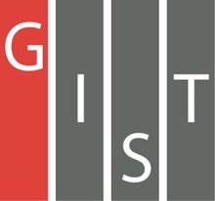
Gwangju Institute of Science and Technology

Official Press Release (https://www.gist.ac.kr/)

Section of Hyo Jung Kim Nayeong Lee
Public Affairs Section Chief Senior Administrator
(+82) 62-715-2061 (+82) 62-715-2062

Contact Person Doo-ok Ko, Administrator
for this Article Business Support Center
(+82) 62-715-2592

Release Date 2019.11.06

[GIST Science and Culture Week] Inaugural meeting of the Industry-Academia Development Committee

□ GIST (President Kiseon Kim) Technology Institute (GTI, Director Woo-jin Park) in conjunction with the GIST Science and Culture Week has held the inaugural meeting of the Industry-Academia Development Committee to develop industry-academia cooperation.

∘ The Industry-Academia Development Committee is composed of representatives from universities and companies to explore the future direction of industry-academia cooperation and to discuss ways to promote it through organic relations.

□ The event was held on November 5 at Oryong Hall by GIST Technology Institute Director Woo-jin Park with nine members of the committee, including Industrial-Academia Development Committee of Korea Chairman Ki-soo Na, GIST Business Incubator Director Seong-geun Ki, GIST Technology Commercialization Center Director Tae-young Kim, GIST Business Incubator Director Byung-kwan Cho, Gwangju Economic Job Office Chief Nam-eon Park, Gwangju South Jeolla Province Small and Medium Business Venture Business Administration Commissioner Moon-hwan Kim, Gwangju Regional Procurement Service Commissioner Sang-chul Park, and Gwangju Techno Park Director Sung-jin Kim.

□ The Industry-Academia Development Committee meeting, which was held after the inaugural ceremony, sought and discussed ways to build and promote an efficient industry-academia cooperation system.

□ GTI Director Woo-jin Park said, "I hope that this committee will be a meaningful venue to share industry-academia cooperation policies, projects, and excellence, and to seek practical ways to promote industry-academia cooperation. In the future, we will do our best to be an important cornerstone for improving the regional industrial structure, such as the regular discovery of various innovative projects based on local industrial sites."

∘ Industrial-Academia Development Committee of Korea Chairman Ki-soo Na said, "Due to the lack of linkage with local industry, efficiency of projects were inferior and there was insufficient aspects to produce the final results of actual industrial sites. Through this committee, we will establish a promotion system that can continuously generate performance by pursuing demand-centered results."

□ The Industrial-Academia Development Committee establishes an innovation platform in which various innovative entities around the region can collaborate systematically for regional development. Under the strategy to operate the project, the government will make joint efforts to promote the project and expand the project by working to find and implement joint industrial-academia cooperation projects."

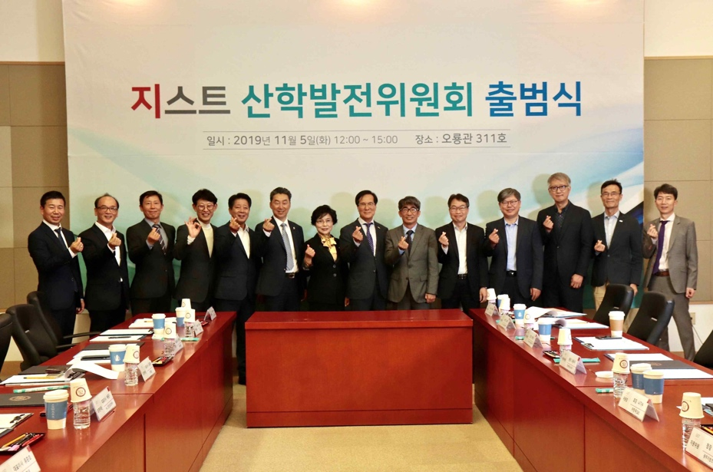
▲ Inaugural meeting of the Industry-Academia Development Committee group photo

