“An era where AI provides the answers: A new path for gifted education” GIST unveils educational framework for AI-focused gifted school set to open in 2029
- Expert roundtable held on October 1 at the GIST Graduate School of Al Policy & Strategy (Seoul Campus) in Jung-gu, Seoul
- Presentation on educational philosophy and core curricular direction... Discussions covered the selection, education, and assessment of gifted students in the AI ​​era, as well as support for their growth
- Comprehensive review of the roles of educators and school operational systems... Detailed formulation of the educational framework for AI-focused gifted schools
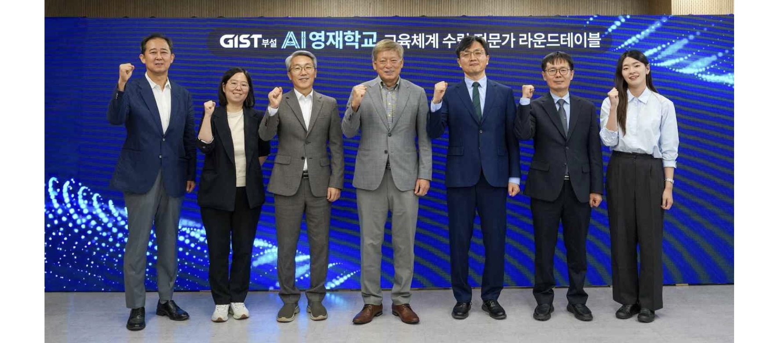

▲ Participants pose for a commemorative photo at the "Expert Roundtable on Establishing the Educational Framework for the GIST-Affiliated AI Gifted School," held on Thursday, October 1, at the GIST Graduate School of Al Policy & Strategy Seoul Campus in Jung-gu, Seoul. (From left) Hyun-chul Jeong, Principal Researcher at the KAIST Center for Gifted Education; Min-kyung Baek, Professor in the Department of Biological Sciences at Seoul National University; Kyung-dae Kim, Vice Principal of the Korea Science Academy of KAIST (KSA); Jae-ho Yeom, President of Taejae University; Tae-Young Kim, Head of the GIST AI Gifted School Establishment Planning Headquarters; Young-kyo Oh, Head of the GIST AI Gifted School Opening Promotion Team; and Chae-rin Lee, CEO of Classum.
The Gwangju Institute of Science and Technology (GIST; President Kichul Lim) announced that it held an "Expert Roundtable on Establishing the Educational Framework for the GIST-Affiliated AI Gifted School" at 4:00 PM on Thursday, October 1, at its Seoul Campus (Graduate School of Al Policy & Strategy) in Jung-gu, Seoul. During the event, the institute gathered expert opinions on the direction of gifted education suited for the AI ​​era and the overall educational and operational vision for the GIST-affiliated AI gifted school (tentative name).
Held under the theme "Gifted Minds Opening a New Era—How Do They Blossom? The First Question Posed by the GIST-Affiliated AI Gifted School," the roundtable marked the first public unveiling of the fundamental direction regarding the curriculum and student development for the school, which is currently being established with the goal of opening in 2029.
Discussions covered a wide range of topics particularly relevant in an era where AI rapidly generates knowledge and information, including the selection criteria for "AI gifted students," the curriculum and experiences to be provided, methods for supporting and evaluating student growth, and the necessary support for teachers and school operations.
The event was attended by experts from the education sector, including Jae-ho Yeom (President of Taejae University), Min-kyung Baek (Professor, Department of Biological Sciences, Seoul National University), Hyun-chul Jeong (Principal Researcher, Center for Gifted Education in Science, KAIST), Chae-rin Lee (CEO of Classum), and Kyung-dae Kim (Vice Principal, Korea Science Academy of KAIST).
Prior to the expert discussions, Tae-Young Kim, Head of the Planning Division and Head of the AI ​​Gifted School Establishment Planning Headquarters at GIST (and Professor of Environment and Energy Engineering), explained the background and educational philosophy behind the school's establishment and outlined the fundamental direction of its curriculum.
A roundtable discussion followed, featuring presentations by experts and open discussions centered on two main themes. The first session, titled "The Post-AI Era: What Is the Direction for Gifted Schools?", explored the educational goals the school should pursue and the operational strategies needed to implement them in actual school life. The second session, titled "How Do We Nurture Gifted Students in the Post-AI Era?", examined concrete measures covering everything from student selection and curriculum/assessment to support for student growth.
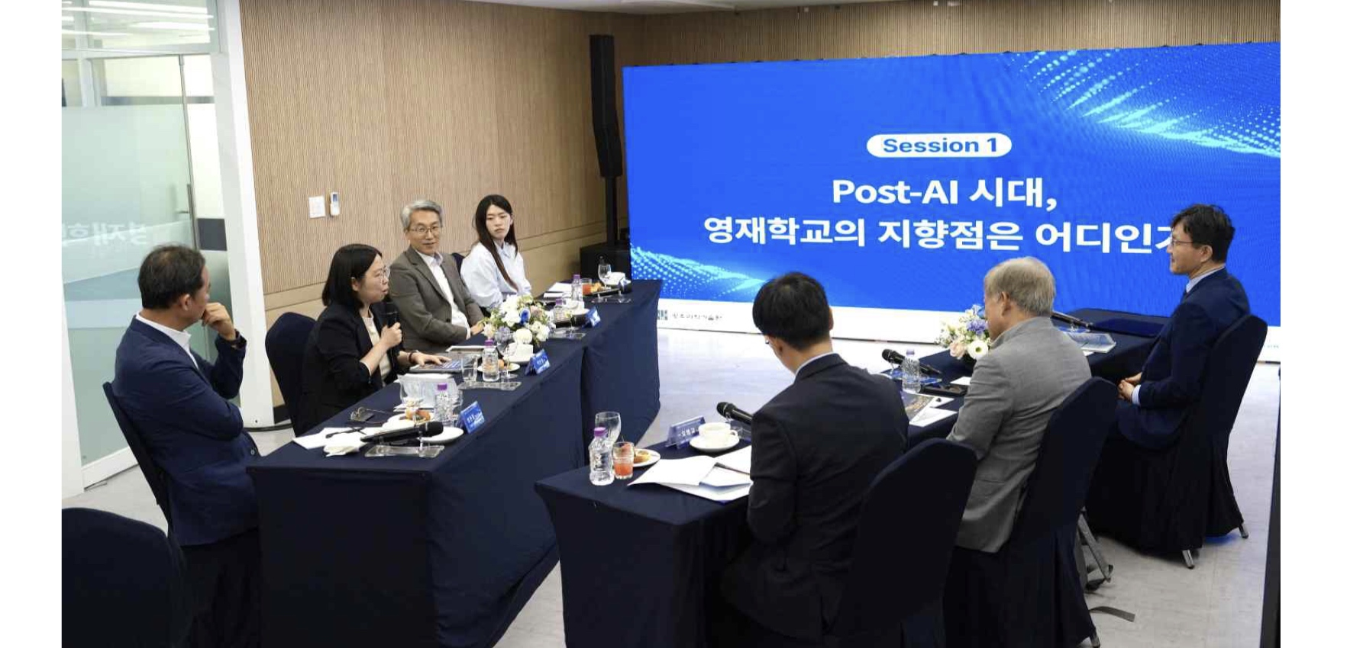

▲ Participants discuss the direction of gifted education in the AI ​​era and the school’s operational framework at the "Expert Roundtable on Establishing the Educational System for the GIST-Affiliated AI Gifted School."
In the first session, presentations were delivered by ▴ Jae-ho Yeom, President of Taejae University; ▴ Tae-Young Kim, Head of the Planning Division for the GIST AI Gifted School; and ▴ Hyun-chul Jung, Principal Researcher at the KAIST Center for Gifted Education. They spoke on the direction of gifted education in the AI ​​era, the educational experiences students would undergo, and the operational systems required to support them.
President Jae-ho Yeom emphasized that education in the AI ​​era must shift away from the mere transmission and acquisition of established knowledge. Instead, he argued for a transition toward "active learning," where students ask their own questions and explore and solve problems independently. He further explained that beyond mastering knowledge and skills, it is crucial for students to gain experience in collaborating with others and growing within a community.
Tae-Young Kim noted that as Korea advances into a developed nation and enters the AI ​​era, existing educational methods require change. He emphasized the need to shift from an education system that produces "passive responders" who simply answer set questions to one that cultivates "active speakers" capable of asking their own questions and voicing their own ideas. To this end, he proposed that the AI ​​Gifted School should nurture talent equipped with communication skills, creativity, initiative, a sense of public duty, a challenging spirit, and a clear sense of purpose.
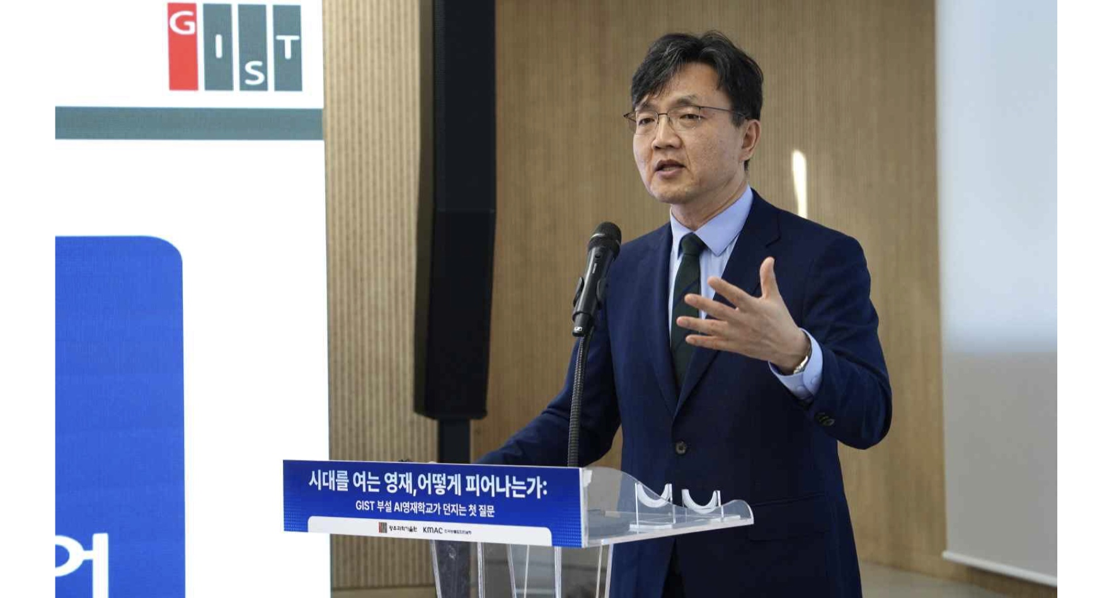

▲ Tae-Young Kim, Head of the Planning Division for the GIST AI Gifted School, delivers a presentation at the "Expert Roundtable on Establishing the Educational System for the GIST-Affiliated AI Gifted School."
Senior Researcher Hyun-chul Jeong emphasized the need for a “student growth support system” that oversees all aspects of school life, including emotions, relationships, career paths, and dormitory living, alongside academics and research, recognizing that students at schools for the gifted are adolescents still in the process of growing.
Furthermore, it was proposed that a comprehensive personnel system, covering everything from teacher recruitment to roles, evaluation, and professional growth, be established to allow teachers to focus on instruction and student guidance. Additionally, the need to design a concrete administrative support system within GIST for school operations prior to the school's opening was highlighted.
In the second session, presentations were delivered by Professor Min-kyung Baek (Department of Biological Sciences, Seoul National University), CEO Chae-rin Lee (Classum), and Vice Principal Kyung-dae Kim (Korea Science Academy of KAIST). They discussed the criteria for selecting gifted students in the AI ​​era, as well as appropriate educational and assessment methods within the school setting.
Professor Min-kyung Baek argued that gifted students in the AI ​​era should not be defined merely by their ability to learn or use AI earlier or more proficiently than others. Instead, she proposed fostering students who can learn and think independently and leverage AI to expand their own reasoning and inquiry. She suggested that assessment should look beyond problem-solving skills to evaluate a student's ability to logically articulate their thoughts and formulate new questions.
CEO Chae-rin Lee explained the need to delineate roles: AI should provide the necessary information and learning materials to students in a timely manner, while teachers and mentors should focus on understanding and supporting student growth, as well as facilitating collaboration and relationship-building among students. She also emphasized the importance of cultivating students' ability to critically review AI-generated answers and make necessary corrections, rather than simply accepting the output at face value.
Vice Principal Kyung-dae Kim advocated for a "growth-oriented assessment" approach. He explained that rather than judging potential solely based on current academic achievement, it is necessary to observe and document the process of problem-solving and growth, including portfolios, over a period of time to assess a student's potential and evolution.
GIST President Kichul Lim stated, "The AI-specialized gifted school is a national initiative to cultivate talent that will usher in a new civilization in the AI ​​era." He added, "Leveraging GIST’s AI research capabilities and educational infrastructure, we aim to establish a new model for gifted education through the so-called 'CHANGE curriculum', which is a program designed to foster students who possess physical vitality (Cha), humanity (In), and intellect (Ge) to bring about positive change in the world."
Based on the various opinions shared during the event, GIST plans to flesh out the details regarding the school's curriculum, student selection and assessment methods, student growth support systems, and operational frameworks for faculty and administration.
Meanwhile, in alignment with the Ministry of Science and ICT’s policy on AI talent development, GIST is pursuing the establishment of a "GIST-affiliated AI-specialized gifted school," targeting an opening in 2029. The school is set to operate as a boarding facility with a total student body of 150 (50 students per grade level).
Ultimately, the goal is to nurture future-oriented, gifted science students who go beyond merely learning AI technology; the aim is to cultivate individuals capable of asking their own questions, conducting inquiries, and utilizing AI to solve novel problems.

