GIST Hosts 64th GIST Academy Breakfast Forum... Invites Artistic Director Cheol Choi of the Jeonnam-Gwangju Integrated Metropolitan City Opera Company
-Artistic Director Cheol Choi asks, “Are you happy?” creating an opportunity to reflect on everyday happiness through music.
- Explores the spirit of the times and the human experience within operas through familiar works such as Carmen and Madame Butterfly
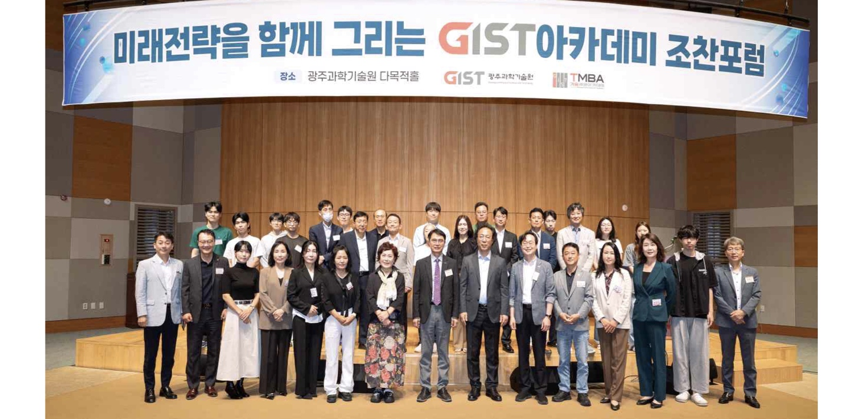

▲ On Monday, September 21, the GIST Academy held its 64th breakfast forum at Oryong Hall, inviting Cheol Choi, Artistic Director of the Jeonnam-Gwangju Integrated City Opera Company.
The Gwangju Institute of Science and Technology (GIST; President Kichul Lim) announced that it held the 64th GIST Academy breakfast forum at Oryong Hall at 7:00 AM on Monday, September 21, featuring Cheol Choi, Artistic Director of the Jeonnam-Gwangju Integrated City Opera Company.
Speaking on the theme "Music: A Happy Addiction & Opera Up Close," Artistic Director Choi explored the impact of music on human life and happiness, as well as the role music has played in reflecting the changes of eras and society. He also introduced the history of opera and the zeitgeist (spirit of the times) embedded in various works, accompanied by musical demonstrations.
Artistic Director Choi began his career as a vocalist, performing over 500 times on domestic and international stages and holding 38 solo recitals. He subsequently expanded his scope of activity to serve as a director and artistic director for various performing arts, including operas, musicals, and regional festivals.
Currently serving as the Artistic Director of the Jeonnam-Gwangju Integrated City Opera Company, he continues to conduct research and write about opera and the performing arts. He also works to make classical music and opera more accessible to the public through lectures, such as "Music: A Happy Addiction" and "Opera Up Close", as well as through broadcasting and writing activities.
The lecture began by posing the question, "Are you happy?" and introducing music as a medium that brings happiness and inspiration to everyday life.
Drawing on a diverse range of examples, from familiar Korean art songs like Yoon Yong-ha’s "Barley Field" and popular music to Ice Cube’s "Black Korea," which addressed racial tensions during the 1992 Los Angeles riots, the speaker explained that music does more than just stir individual emotions; it serves as a reflection of the society and culture of its time.
He then introduced the origins, history, and structure of opera under the theme "Opera: Up Close," explaining how opera, a comprehensive art form blending music, literature, theater, and stage design, has evolved alongside changing times.
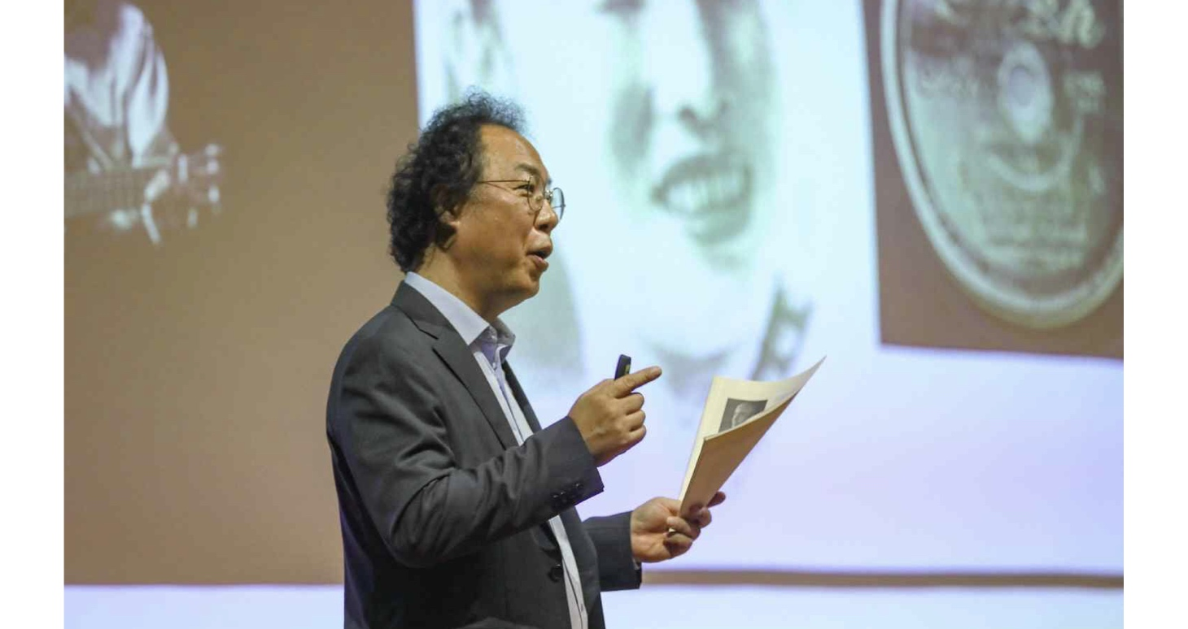

▲ Artistic Director Cheol Choi delivering a lecture titled "Music: A Happy Addiction & Opera: Up Close" at the GIST Academy’s September breakfast forum.
In particular, he used major operas such as Verdi’s La Traviata, Handel’s Rinaldo, Bizet’s Carmen, and Puccini’s Madama Butterfly to explore themes of love and human life, highlighting opera as a performing art that has endured to the present day by capturing the essence of different eras and societies.
Through this lecture, Artistic Director Choi conveyed the message that "music represents the flow of the times," emphasizing that music not only enriches our lives but also serves as an art form that mirrors the society and era in which it exists.
Participants gained a fresh perspective on familiar music, viewing it through the lens of human life and history, while also becoming more familiar with the history and masterpieces of opera.
Sungho Jeong, Dean of the GIST Academy (concurrently serving as Vice President for Academic Affairs and Vice President for Public Affairs), stated, “This lecture offered a meaningful opportunity to view our lives and times from a fresh perspective through music and opera, and to reflect on the meaning of happiness in our daily lives.” He added, “We will continue to provide opportunities for participants to engage with diverse fields, such as science and technology, management, culture, and the arts, and to network with one another through the GIST Academy Breakfast Forum.”
Meanwhile, the GIST Academy, which oversees GIST’s non-degree educational programs, operates the Techno Management Business Academy (GTMBA) as its flagship course. It also regularly hosts breakfast forums for local business leaders and alumni, inviting experts from various fields to speak during the months of March, May, June, September, and October.

