GIST embarks on a ‘World Tour’ with classical melodies on an autumn night
- Classical music concert titled "A World Tour of Masterpieces" to be held by "Culture Sinfonietta" on the 30th at 7 PM in Dasan Hall, Oryong-gwan
- Featuring masterpieces from around the world—including South Korea, Italy, Spain, France, and Russia... The event is open to all local residents free of charge
- Marks the third collaboration with Culture Sinfonietta, following performances in 2020 and 2022
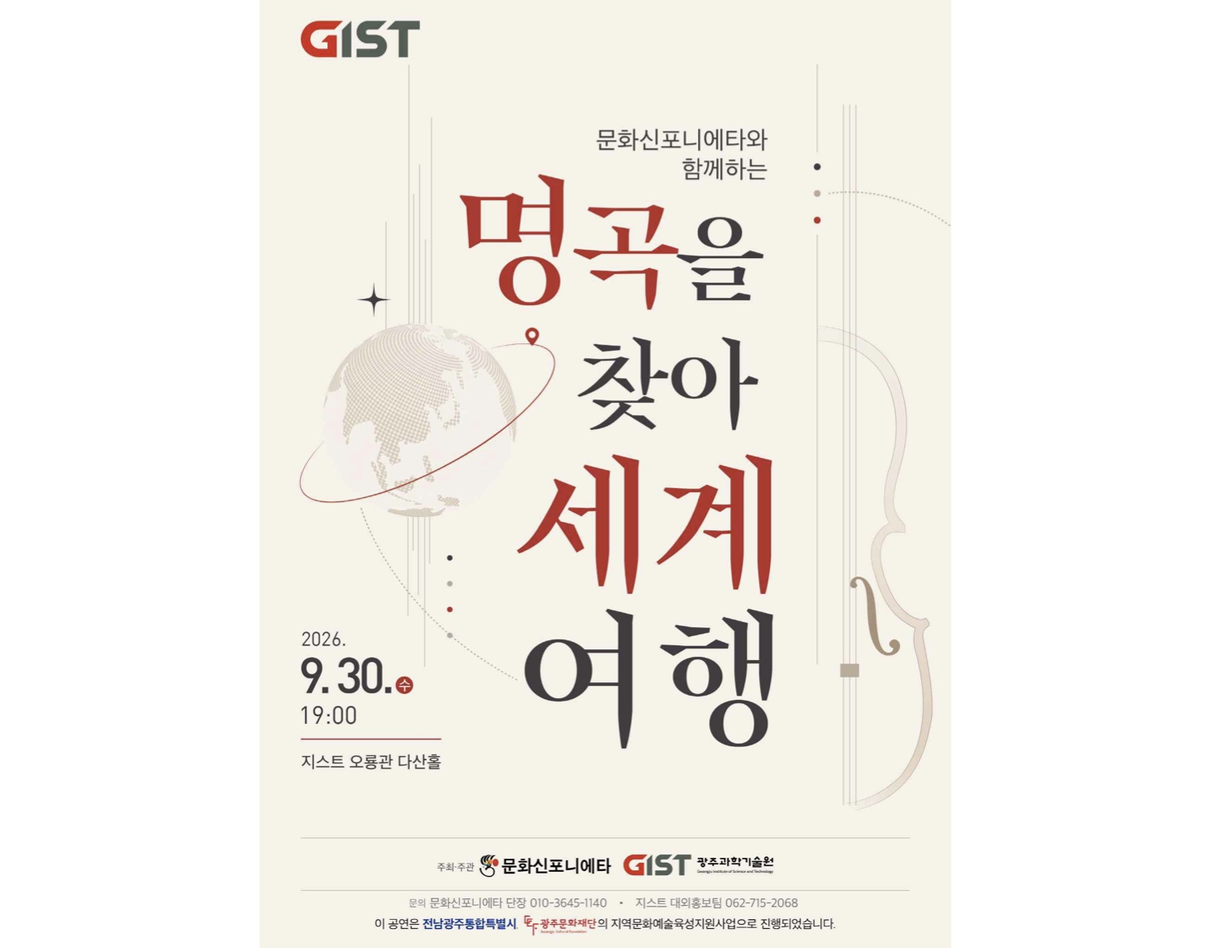

▲ Poster for the classical concert "A World Tour in Search of Masterpieces," to be held on Wednesday, September 30, at 7 PM in the Dasan Hall of GIST’s Oryong Hall.
The Gwangju Institute of Science and Technology (GIST; President Kichul Lim) announced that it will host a classical concert titled "A World Tour in Search of Masterpieces" on Wednesday, September 30, at 7 PM. The event will take place in the Dasan Hall (2nd floor of Oryong Hall) and feature the professional chamber ensemble "Culture Sinfonietta."
Co-hosted and organized by GIST and Culture Sinfonietta, this concert aims to provide an opportunity for local residents and the GIST community to enjoy classical music up close and connect through the medium of music. Admission is free, and no prior registration is required.
The concert is themed "A World Tour Through Music" and will showcase musical pieces from various countries, including Korea, Italy, Spain, France, and Russia, and performed through both vocal and instrumental arrangements.
Part 1 will feature vocal works such as ▴ "Living in the Green Mountain" (Cheongsan-e Salira), ▴ "Stride la vampa," and ▴ "Der Tambour." Part 2 will consist of 11 pieces capturing the atmosphere of different nations, including ▴ "Hands Across the Sea," ▴ "The Emerald Isle," ▴ "Viva Italia!," and ▴ "Tour de France."
Byeong-yeol Jeong, Director of Culture Sinfonietta, will serve as the host. The event will also feature Artistic Director Hae-chul Im, scriptwriter Chae-nam Mo, and music travel guide Ji-hyun Im.
Additionally, the stage will feature vocalists (soprano, mezzo-soprano, tenor, and baritone) alongside instrumentalists playing piano, violin, viola, cello, and double bass.
"Culture Sinfonietta" is a professional chamber ensemble founded in 2004 and based in Gwangju; it is a professional arts organization designated by the Ministry of Culture, Sports and Tourism. The group has been actively performing to popularize classical music and broaden the base of arts and culture within the local community.
This cultural event, a collaboration between GIST and the Cultural Sinfonietta, marks the third edition, following previous events held in 2020 and 2022.
President Kichul Lim stated, "I hope this concert serves as an opportunity for local residents and the GIST community to come closer together while enjoying music," adding, "I hope everyone can savor a moment of relaxation in their daily lives accompanied by masterpieces from around the world on this crisp autumn day."

