“Cultivating AI and semiconductor talent to learn and work locally” GIST and Assemblyman Moon-young Lim host forum on the future of AI and semiconductor education in Gwangju-Jeonnam
- Reviewing the current state of AI and semiconductor education—spanning secondary schooling to university and career-oriented experiences—at the GIST Oryong Hall on the 12th (Sat.)
- Exploring strategies to foster local talent through career guidance, college admissions planning, and linkages between education and industry, in collaboration with students and parents
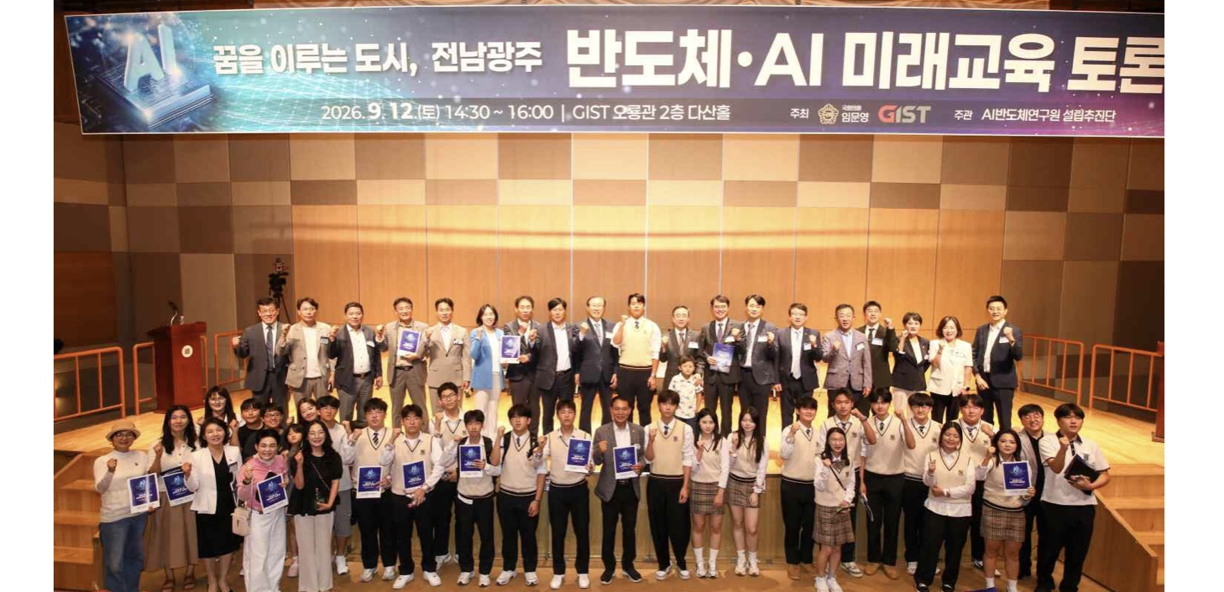

▲ Participants pose for a group photo at the "City Where Dreams Come True: Jeonnam-Gwangju Semiconductor & AI Future Education Forum," held on Saturday, September 12. (Ninth person in the second row) GIST President Kichul Lim; (eleventh person in the second row) National Assembly Member Moon-young Lim (Gwangsan-gu Eul, Gwangju).
The Gwangju Institute of Science and Technology (GIST; President Kichul Lim) announced that it co-hosted the "City Where Dreams Come True: Jeonnam-Gwangju Semiconductor & AI Future Education Forum" with National Assembly Member Moon-young Lim (Gwangsan-gu Eul, Gwangju) on Saturday, September 12, at the Dasan Hall of the GIST Oryong Building.
As investments in semiconductor fabrication facilities ("fabs") ramp up in the Honam region, cultivating local talent in the semiconductor and AI sectors—essential for regional industrial growth—has emerged as a critical task.
This forum was organized to link the growth of the semiconductor industry with the career paths and future job prospects of local students. Participants examined the current state of education in AI and semiconductors—spanning secondary school, university, and career-oriented experiential programs—and explored directions for regional talent development while addressing career and college admission questions of interest to students and parents.
The event proceeded with welcoming and congratulatory remarks, keynote presentations, expert discussions, and an open discussion and Q&A session involving students and parents.
Attendees included National Assembly members Mun-young Lim and Moon-su Kim (representing Suncheon, Gwangyang, Gokseong, and Gurye in South Jeolla/Gwangju); Gwangju Metropolitan City Council members Gwi-sun Lee, Young-hoon Lee, and Pil-sun Park; and Yong-tae Kim, former head of the Moo-hyun Roh Foundation’s Gwangju Citizens' School.
Representatives from GIST included President Kichul Lim, Vice President for Academic Affairs Sungho Jeong, Vice President for R&DB Yong-Chul Kim, Yang Sung (Head of the AI ​​Semiconductor Research Institute Establishment Task Force), Min Jae Lee (Dean of the Graduate School of Semiconductor Specialized Education), and Professor Duk-Jo Kong (Graduate School of AI Policy and Strategy). Also in attendance were Mi-jeong Seon (Head of the University Policy Team, Gwangju Metropolitan City) and Jeong-hoon Jo (College Admissions Support Officer, Gwangju Metropolitan City Office of Education), alongside approximately 220 participants, including professionals from the semiconductor, AI, and education sectors, as well as students and parents.
In the welcoming and congratulatory remarks, speakers emphasized the need to begin preparing talent now to link the growth of the semiconductor industry with local education and job opportunities.
In his welcoming remarks, Representative Moon-young Lim emphasized, "The government handles power and water supply, while companies manage technology and investment. What we must prepare is people, and education is the starting point." He added, "We must prepare now so that our children and citizens can become key players in the industry when the semiconductor fabrication plants open." He also pledged to follow up on the issues raised during the event at the National Assembly.
In his congratulatory remarks, Representative Moon-su Kim stated, "We can create a region where young people choose to stay when industry, education, and jobs are connected like rungs on a ladder." He continued, "As a member of the National Assembly's Education Committee, I will carefully oversee the necessary systems and support to ensure that the shifts in future industries translate into greater educational opportunities for local students."
Subsequently, presentations were delivered by Min Jae Lee, Dean of the Graduate School of Semiconductor Specialized Studies (focusing on higher education); Young-jae Yoon, a teacher in charge of career guidance at Dongil Future Science High School (secondary education); and Yang Sung, Head of the AI ​​Semiconductor Research Institute Establishment Task Force (career and experiential education).
Dean Min Jae Lee outlined the current status of GIST’s AI and semiconductor education—including the planned AI-specialized gifted school (targeting a March 2029 opening), the GIST AI Graduate School (launched on July 1), and the Department of Semiconductor Engineering (a contract department with Samsung Electronics)—and introduced the talent development pipeline spanning from high school through undergraduate and graduate studies to the industrial workplace.
Teacher Young-jae Yoon reviewed the current state of secondary education, particularly within specialized and Meister high schools, and proposed that companies actively participate in curricula to help students cultivate the practical skills demanded by the industry.
Head Yang Sung examined the current landscape of career and experiential education in the AI ​​and semiconductor sectors. He emphasized that, given the multidisciplinary nature of the semiconductor field, students should explore a wide range of career possibilities rather than limiting their thinking to a specific major. He further suggested expanding opportunities for career exploration linked to local industries by building upon existing AI experiential infrastructure to provide hands-on experience with actual semiconductor technology.
Following the presentations, an expert panel discussion moderated by Council Member Lim Moon-young addressed topics such as local support for career and academic advancement, as well as strategies for linking education with the industrial sector.
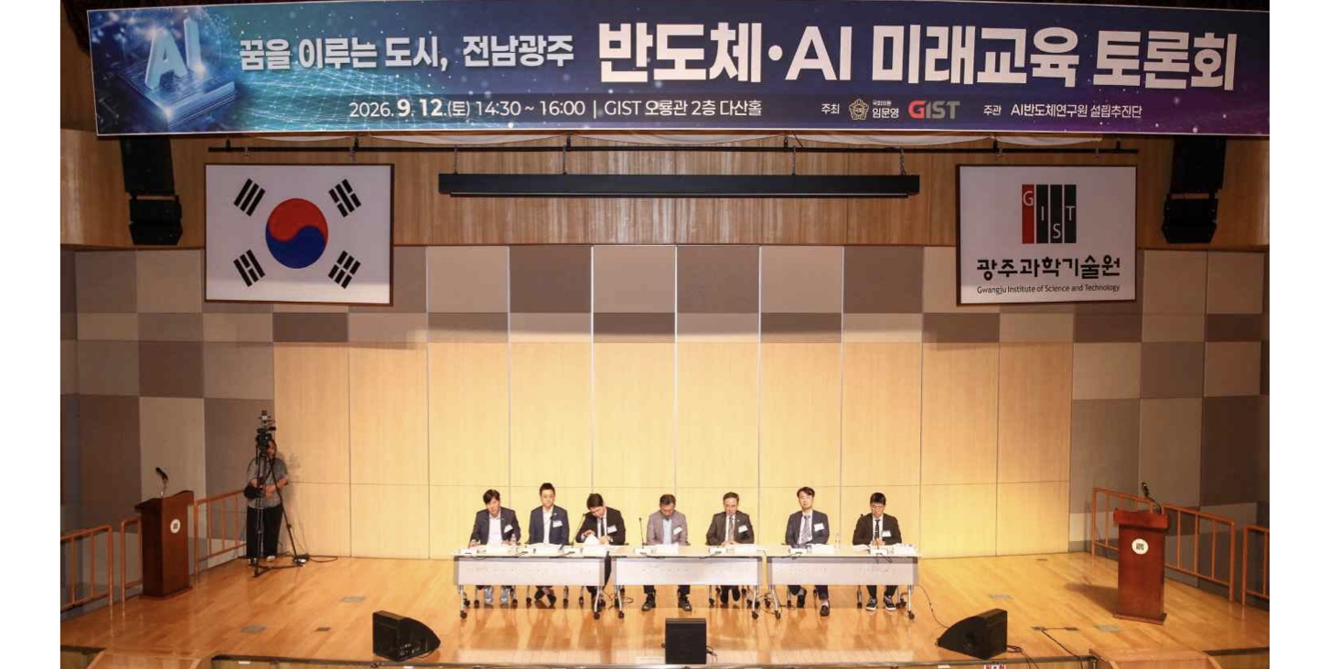

▲ An expert panel discussion, moderated by National Assembly member Moon-young Lim, is underway at the "City Where Dreams Come True: Jeonnam-Gwangju Semiconductor & AI Future Education Forum" held on Saturday, September 12. (From left) Young-hoon Lee, Council Member of the Jeonnam-Gwangju Integrated Special City; Duk-Jo Kong, Professor at the GIST Graduate School of AI Policy and Strategy; Jeong-hoon Jo, College Admission Officer at the Jeonnam-Gwangju Integrated Special City Office of Education; Yang Sung, Head of the GIST AI-Semiconductor Research Institute Establishment Task Force; National Assembly member Moon-young Lim; Min Jae Lee, Dean of the GIST Graduate School of Semiconductor Technology; and Young-jae Yoon, Teacher in charge of Career and Employment at Dongil Future Science High School.
College Admission Officer Jeong-hoon Jo proposed the need to provide accurate information on college admissions to alleviate anxiety among students and parents regarding the changes to the 2028 university admission system, as well as to expand linkage programs between local universities and middle and high schools.
Professor Duk-Jo Kong emphasized the necessity of a "talent growth ladder" that allows individuals to continue their academic and professional journeys from high school graduation through associate, bachelor’s, master’s, and doctoral degrees.
Council Member Young-hoon Lee stated that AI-related education should be expanded to include the general public and those with limited access to information, and that opportunities for retraining should be broadened to help people adapt to the changing industrial landscape.
During the subsequent open discussion and Q&A session, students, parents, and others asked questions about career paths and future jobs in the AI ​​and semiconductor sectors, and shared diverse opinions on how local education systems should respond to changes in future industries.
GIST President Kichul Lim stated, “We must move beyond the era where our children are forced to leave their hometowns to realize their dreams; instead, they should be able to learn, work, and compete on the global stage right here in the Gwangju-Jeonnam region.” He added, “GIST will establish a comprehensive talent development system—spanning education, R&D, and industrial application—by advancing initiatives such as the ‘GIST-Arm School’ (launched on September 4) and the establishment of an AI gifted school and an AI Semiconductor Research Institute.”
Meanwhile, this forum was co-hosted by National Assembly member Lim Moon-young and GIST, and organized by the GIST AI Semiconductor Research Institute Establishment Task Force.

