GIST launches 13.1 billion won 'Honam Region Autonomous R&D' initiative... Recruiting research groups
- MSIT launches ‘Region-Led R&D Project’ (4 Poles, 3 Specialties)... GIST Professor Park Ki-hong appointed head of Honam Regional Project Group
- Recruitment underway for research groups in three key sectors of ▴ semiconductors, ▴ energy, and ▴ mobility... Applications accepted until October 12
- Driving region-led r&d by aligning the industrial policies of the Jeonnam-Gwangju Integrated Metropolitan City with GIST’s research capabilities
The Gwangju Institute of Science and Technology (GIST; President Kichul Lim) announced that it has assumed the role of the Honam regional hub for the "4-Pole, 3-Specialty Regional Autonomous R&D Project" driven by the Ministry of Science and ICT. The institute plans to bridge the industrial and policy needs of the integrated Jeonnam-Gwangju Special City with regional scientific and technological capabilities, while actively pursuing R&D in the semiconductor, energy, and mobility sectors.
To this end, GIST began recruiting research groups on September 11 (Friday) to participate in the "2026 4-Pole, 3-Specialty Honam Region Science & Technology Innovation Support Project."
Earlier, on September 10, the Ministry of Science and ICT held the launch ceremony for the "4-Pole, 3-Specialty Regional Autonomous R&D Project" at KAIST (Korea Advanced Institute of Science and Technology). Professor Kihong Park of GIST’s Department of Environment and Energy Engineering, who serves as the head of the Honam regional hub, attended the event.
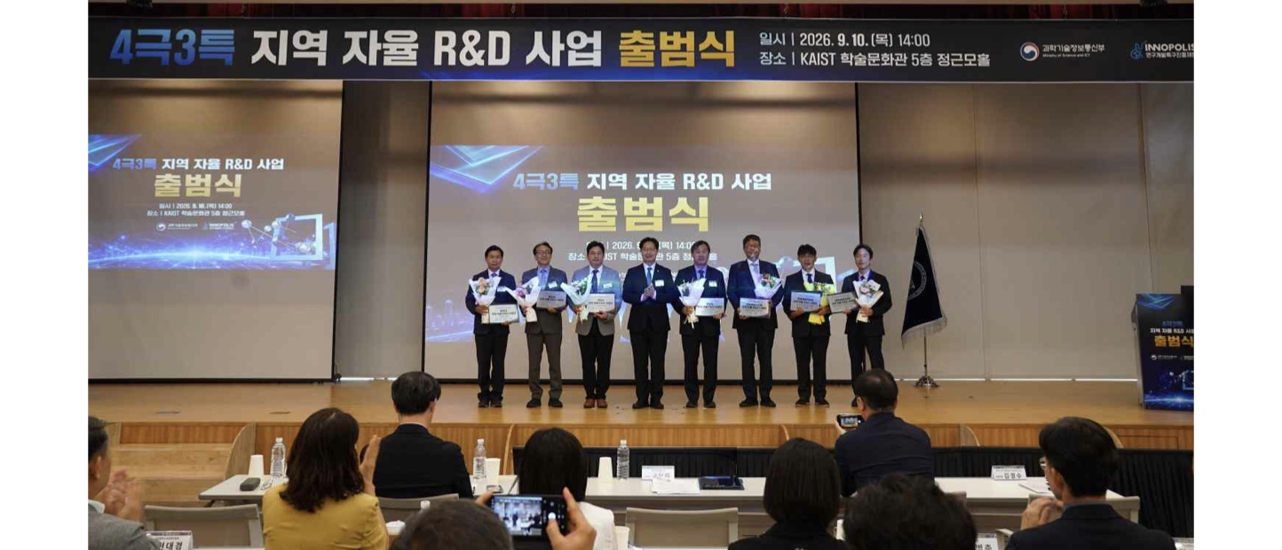

▲ Attendees pose for a commemorative photo at the launch ceremony for the "2026 4-Pole, 3-Specialty Regional Autonomous R&D Project" held at KAIST. (Second from left) Kihong Park, head of the Honam Regional Hub for the 4-Pole, 3-Specialty Regional Autonomous R&D Project (Professor, GIST Department of Environment and Energy Engineering). (Photo courtesy: Innopolis Foundation)
"Regional Autonomous R&D" represents a new support system that moves away from the conventional approach—where the central government determined research topics and execution methods—to one where regions directly plan and implement necessary R&D projects based on their industrial and scientific capabilities as well as corporate needs.
The government will invest a total of 78.9 billion won this year, providing 13.1 billion won each to four major regional hubs (Central, Honam, Daegu-Gyeongbuk, and Southeast) and 8.8 billion won each to three specialized regions (Gangwon, Jeonbuk, and Jeju).
The Honam region project will be implemented through a cooperative framework in which the Gwangju-Jeonnam Integrated Special City outlines development directions based on regional industrial policies and corporate technology needs, while the Gwangju Institute of Science and Technology (GIST) supports R&D planning and execution by connecting key innovation players across industry, academia, and research institutes.
Key focus areas include ▴ semiconductors, ▴ energy, and ▴ mobility. In the semiconductor sector, the project aims to develop, demonstrate, and commercialize AI-based advanced packaging and thermal management technologies, as well as industry-specific, high-reliability AI, optical, and power semiconductor technologies.
In the energy sector, the project will secure next-generation clean energy technologies, including virtual power line (VPL) systems, grid-forming energy storage systems (ESS) based on sodium-ion batteries, and technologies linking green hydrogen with laser nuclear fusion.
In the mobility sector, plans are in place to develop and field-test technologies such as AI-driven autonomous manufacturing using diverse robot types, non-destructive diagnosis and resource circulation for used batteries, and traffic safety and disaster response systems based on urban digital twins.
Kihong Park, head of the Honam region project group for the "4-Hub, 3-Specialty" regional autonomous R&D initiative, stated, "This project is significant in that the region itself identifies necessary technologies and determines the direction of R&D." He added, "We will work closely with the Gwangju-Jeonnam Integrated Special City to integrate the Honam region's capabilities in AI, optical technology, renewable energy, and future mobility, thereby leading region-led scientific and technological innovation."
GIST plans to launch the project in earnest by collaborating with the Gwangju-Jeonnam Integrated Metropolitan City and relevant agencies in the Honam region to define specific R&D tasks and annual objectives.
Details regarding the "Call for Research Groups for the 2026 Honam Region Science and Technology Innovation Support Project (4-Hub, 3-Specialization Model)" are available on the Integrated Research Information System (www.iris.go.kr), and applications will be accepted from Friday, September 11, until 3:00 PM on Monday, October 12.

