“Turning solar-generated village electricity into a new local industry” GIST hosts ‘Jeonnam-Gwangju Sunlight Connection 2026’
- Approximately 100 representatives from industry, academia, research institutes, government, and related companies gathered at GIST on September 9
- Key technologies and business models—including power grids, virtual power plants (VPPs), energy storage systems (ESS), and floating solar power—were shared
- Discussions focused on opportunities for corporate participation and strategies for inter-institutional cooperation arising from the expansion of "Sunlight Income Villages"
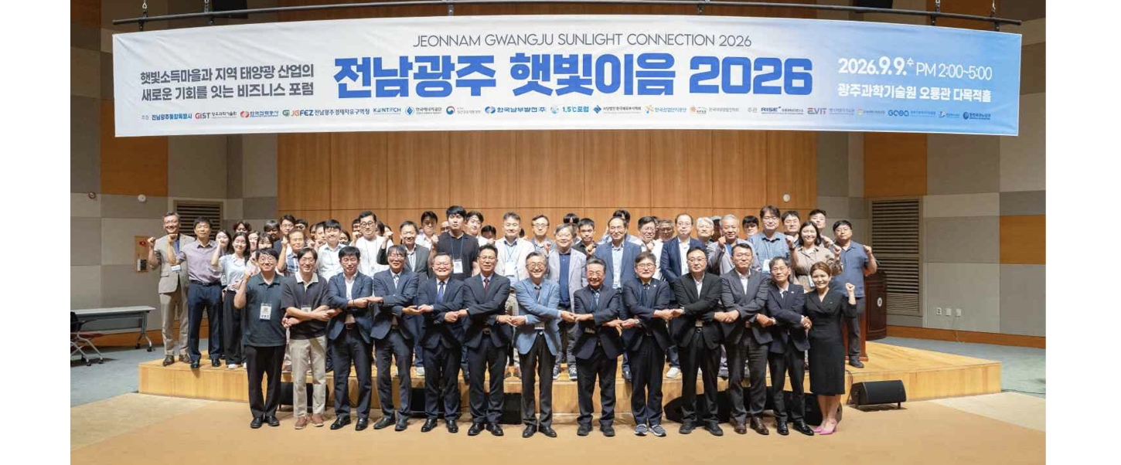

▲ Attendees pose for a commemorative photo at the ‘Jeonnam-Gwangju Sunlight Connection 2026’ forum. (From left, front row) Hongkyu Kang, Deputy Director of the GIST Research Institute for Solar and Sustainable Energies; Yun-su Kim, Director of the Power Grid Research Center at the Research Institute for Solar and Sustainable Energies; Jong-seop Kwak, General Manager at Sebang Lithium Battery; Dong-chan Kim, Director at Scotra; Sang-ok Yoon, Head of the Renewable Energy Division at Korea Southern Power (KOSPO); Professor Woo-kyung Kim of Yeungnam University; Kwanghee Lee, Director of the GIST Energy Valley Institute of Technology; Yong-guk Choi, Chairman of the 1.5°C Forum; Jin-ho Park, Acting President of the Korea Institute of Energy Technology (KENTECH); Cheol-hyun Lim, Industry-Academia Cooperation Professor at KENTECH’s School of Energy Engineering; Jeong-hak Yoo, Head of Division at the Green Energy Institute; and Hyun-jun Kang, General Manager at KEPCO KDN.
The Gwangju Institute of Science and Technology (GIST; President Kichul Lim) announced that it held a business forum titled ‘Jeonnam-Gwangju Sunlight Connection 2026’ on Wednesday, September 9, at the multipurpose hall of the GIST Oryong Hall, focusing on the regional solar power industry.
Held under the theme of “A Business Forum Connecting ‘Sunlight Income Villages’ with New Opportunities in the Regional Solar Power Industry,” the event was attended by approximately 100 people. Participants included representatives from industry, academia, research institutes, and government agencies—such as local energy companies, universities, research bodies, and public institutions—as well as village residents and members of resident cooperatives who are either participating in or interested in the Sunlight Income Village project.
The Sunlight Income Village project involves village residents jointly installing and operating solar power facilities on idle land and using the revenue generated from selling the produced electricity to boost resident income or fund village welfare programs. The government has been expanding this initiative nationwide starting this year.
As the number of "Sunlight Income Villages" grows, there is a rising need not only for the installation and operation of solar power facilities but also for processes to connect the generated electricity to the grid and to store and utilize it. Consequently, new business opportunities are anticipated in related sectors such as power grids, Energy Storage Systems (ESS), and distributed energy.
This forum was organized to explore new business opportunities in the regional solar power industry amidst these changes and to discuss ways to foster cooperation among companies and institutions.
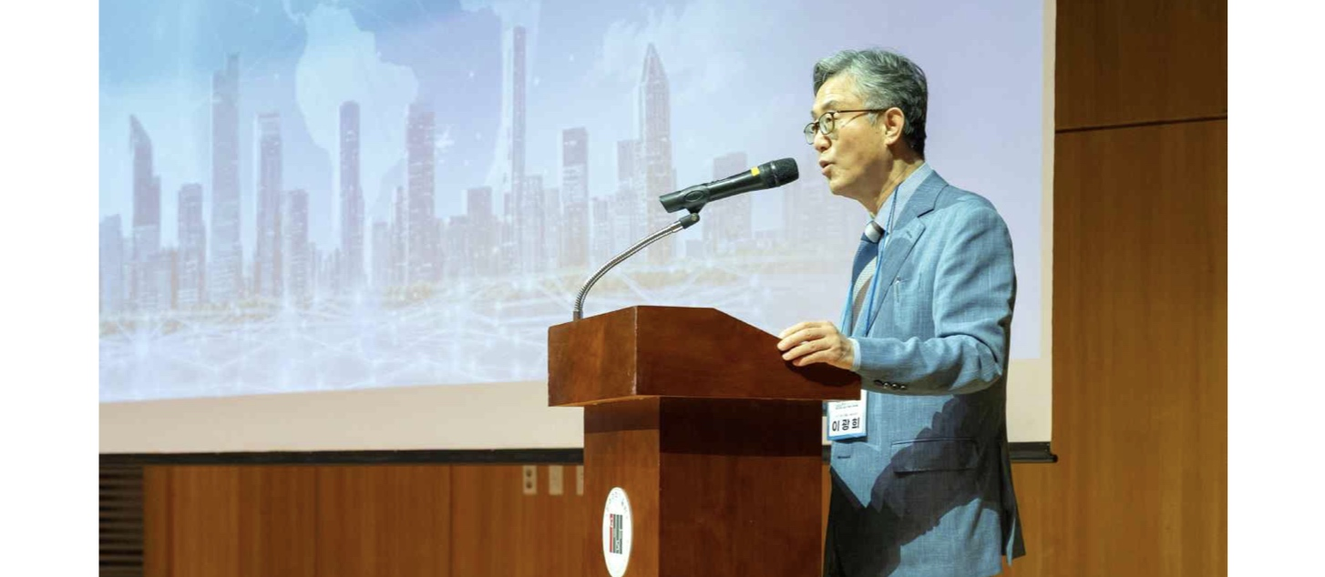

▲ Kwanghee Lee, Director of the GIST Energy Valley Institute of Technology, delivers the opening remarks at the "Jeonnam-Gwangju Sunlight Connection 2026" business forum held on Wednesday, September 9.
The forum was co-hosted by GIST, the Jeonnam-Gwangju Integrated Special City, KENTECH (Korea Institute of Energy Technology), the Korea Energy Agency, the Yeongsan River Basin Environmental Office, and the 1.5°C Forum. It was co-organized by the GIST Research Institute for Solar and Sustainable Energies, the Energy Valley Institute of Technology, the Green Energy Institute, the Gwangju Climate & Energy Agency, Jeonnam Technopark, and Gwangju Technopark.
Experts gave presentations covering policies, technologies, and business models for the regional solar power industry, with a focus on Solar Income Villages.
Jeong-hak Yoo, a division head at the Green Energy Institute, introduced the key features and current status of the Solar Income Village initiative.
Meanwhile, Yun-su Kim, Director of the Power Grid Research Center at GIST’s Research Institute for Solar and Sustainable Energies, explained why power generation, particularly from renewable sources like solar, must sometimes be curtailed within the grid and described how the grid actually manages these operations.
Kang Hyun-jun, a manager at KEPCO KDN, introduced a new business model utilizing Virtual Power Plants (VPPs), which aggregate and manage distributed energy resources like solar power scattered across various locations as if they were a single power plant, and Energy Storage Systems (ESS) that store power for supply when needed.
Subsequently, Professor Cheol-hyun Lim of the Division of Energy Engineering at the Korea Institute of Energy Technology (KENTECH) outlined strategies for implementing "agrivoltaics" (combining farming with solar power generation) in the Jeonnam and Gwangju regions; Director Dong-chan Kim of Scotra presented plans for the installation and operation of floating solar power systems on water surfaces such as reservoirs; and Jong-seop Kwak, a division head at Sebang Lithium Battery, explained the direction for their ESS business operations.
Following the presentations, a panel discussion featuring the speakers was held under the theme, "New Business Opportunities for 'Sunshine Income Villages' and the Local Solar Power Industry."
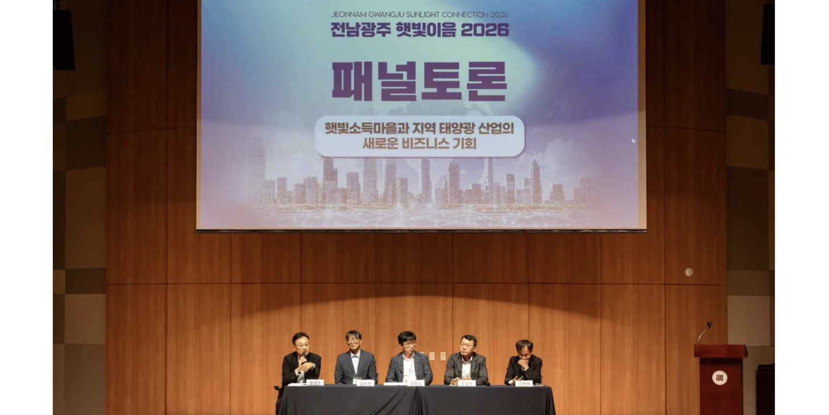

▲ A panel discussion is underway on the topic of "New Business Opportunities for the Local Solar Industry and 'Sunshine Income Villages'." (From left) Cheol-hyun Lim, Professor of Industry-Academia Cooperation at the Department of Energy Engineering, Korea Institute of Energy Technology (KENTECH); Dong-chan Kim, Director at Scotra; Jong-seop Kwak, General Manager at Sebang Lithium Battery; Jeong-hak Yoo, Head of Division at the Green Energy Institute; and Hyun-jun Kang, Senior Manager at KEPCO KDN.
Notably, a representative from a village preparing to participate in the "Sunshine Income Village" project took part in the discussion, asking questions about how output curtailment affects power generation revenue and what the operational plans would be after the project period ends.
In response, the panelists emphasized the importance of securing stable revenue for the continued operation of Sunshine Income Villages and proposed ways to diversify revenue streams by utilizing Virtual Power Plants (VPPs) and Energy Storage Systems (ESS). They also highlighted the need for resident acceptance, a standardized business model, and a cooperative framework among relevant organizations.
Kwanghee Lee, Director of the Energy Valley Institute of Technology, stated, "This forum serves as an opportunity to link the expansion of Sunshine Income Villages to new prospects for the local solar industry and for relevant companies and institutions to explore ways to collaborate." He added, "We will continue to foster cooperation among industry, academia, research institutes, and government bodies to ensure the sustainable growth of the local energy industry."

