“Supporting the dreams of 70,000 people over 41 years”: 20 GIST undergraduates receive 50 million won in scholarships from Kiturami
- GIST undergraduates receive a total of 50 million won in scholarships—2.5 million won per person—supporting their academic pursuits and new challenges
- Kiturami has provided approximately 65 billion won in support to around 70,000 individuals over 41 years, continuing its commitment to sharing for the sake of future talent
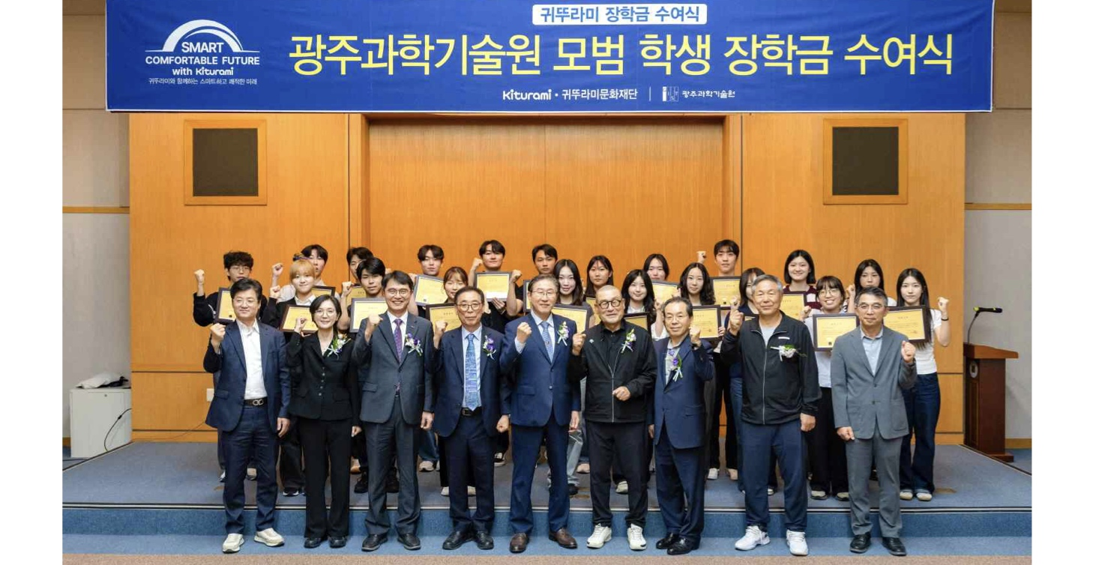

▲ Attendees pose for a commemorative photo at the ‘2026 Kiturami Scholarship Award Ceremony.’ (Front row, fifth from left) GIST President Kichul Lim; (sixth from left) Kiturami Group Chairman Jin-min Choi.
The Gwangju Institute of Science and Technology(GIST, President Kichul Lim) announced that it held the ‘2026 Kiturami Scholarship Award Ceremony’ in collaboration with the Kiturami Cultural Foundation at the GIST Administration Building on September 4 (Fri), awarding a total of 50 million KRW in scholarships to 20 undergraduate students.
Approximately 47 people attended the ceremony, including Kiturami Group Chairman Jin-min Choi, GIST President Kichul Lim, and GIST Development Foundation Chairman Eun-mo Choi, alongside officials from Kiturami Group and the Cultural Foundation, GIST representatives, and the scholarship recipients.
The scholarships were provided to alleviate the financial burden on GIST undergraduates and support their living expenses, enabling them to focus on their studies and diverse experiences; a total of 50 million KRW was distributed, with each of the 20 students receiving 2.5 million KRW.
The recipients were selected based on their exemplary conduct and contributions to the development of GIST and their departments. Candidates were nominated—five from each of the four colleges (College of Artificial Intelligence, College of Natural Sciences, College of Engineering, and College of Life Sciences & Medical Engineering)—and the final selection was made following a review by the Kiturami Cultural Foundation.
The Kiturami Cultural Foundation was established in 1985 in accordance with the vision of Kiturami Group Chairman Jin-min Choi: that everyone should have equal access to educational opportunities. Since then, it has engaged in social contribution activities aimed at fostering future talent, including scholarship programs, support for academic research, and assistance to educational institutions.
Over the past 41 years, Kiturami has carried out social contribution activities across the fields of scholarships, academics, education, and social welfare, providing approximately 65 billion KRW in support to around 70,000 individuals through its cultural and welfare foundations.
GIST President Kichul Lim presented scholarship certificates and funds to the recipients; a student representative expressed gratitude, and Kiturami Group Chairman Jin-min Choi delivered words of encouragement.
President Kichul Lim stated, "I am deeply grateful for the Kiturami Cultural Foundation’s enduring spirit of sharing and talent cultivation, through which it has consistently supported the future talent of our society for over 40 years." He added, "I hope this scholarship serves as both an acknowledgment of the students' hard work thus far and a source of encouragement for them to boldly take on challenges and grow in their respective fields."
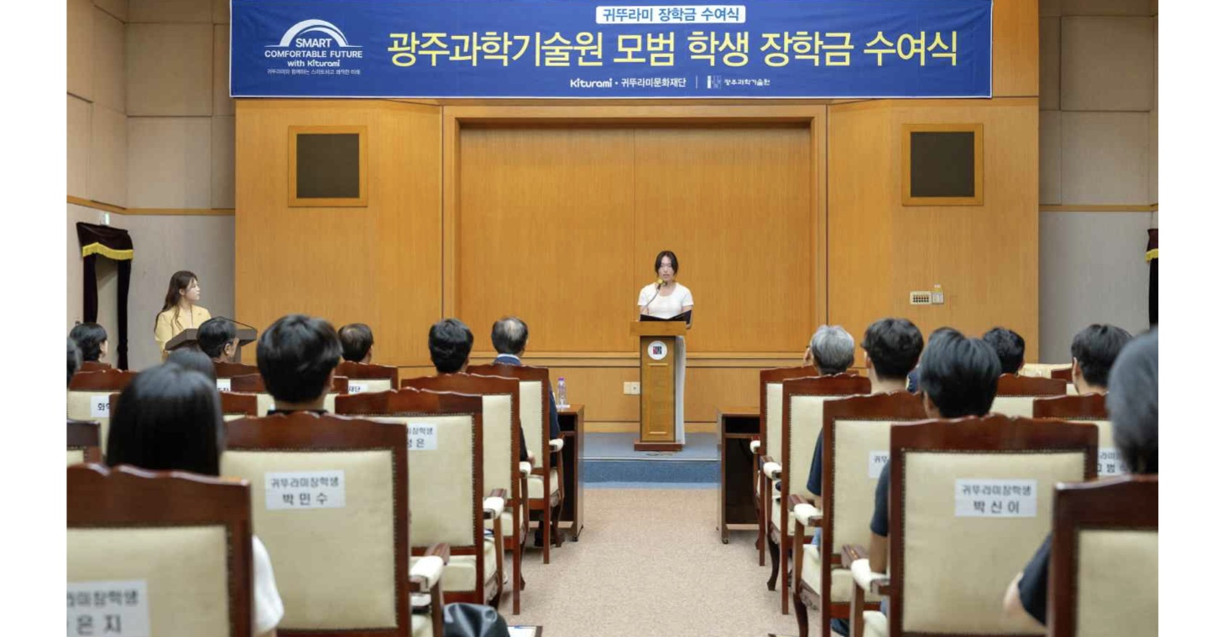

▲ Student representative Jeong-eun Choi (Department of Electrical Engineering & Computer Science, College of Artificial Intelligence) receives her scholarship certificate at the ‘2026 Kiturami Scholarship Award Ceremony.’
Student representative Jeong-eun Choi (Department of Electrical Engineering & Computer Science, College of Artificial Intelligence) shared her thoughts, saying, "This scholarship means more than just financial aid; it represents a vote of confidence and support for my past efforts and future potential." She continued, "I will continue to learn and grow in my own path, and I aspire to become someone who can pass on the encouragement and warmth I received today to others."
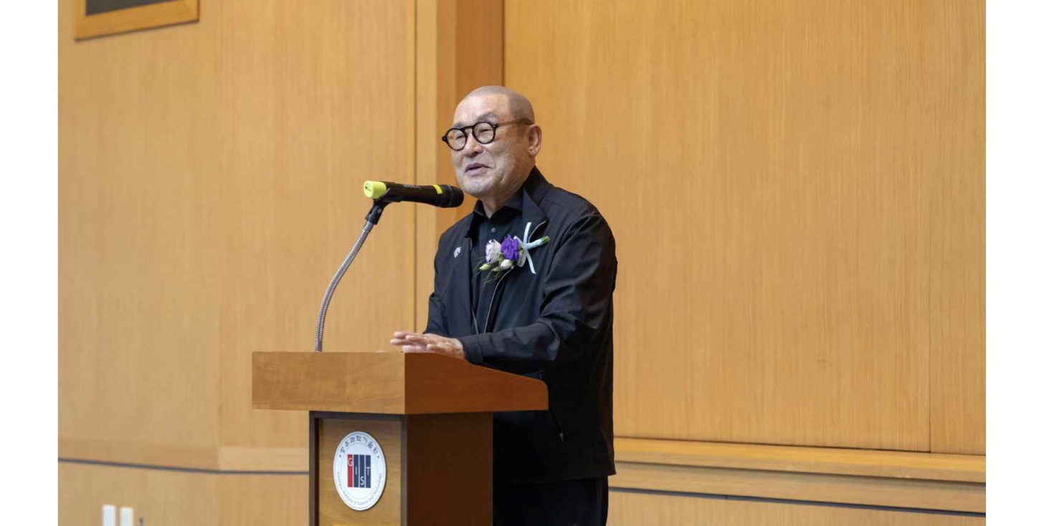

▲ Chairman Choi Jin-min of the Kiturami Group delivers words of encouragement to scholarship recipients at the ‘2026 Kiturami Scholarship Award Ceremony.’
Chairman Jin-min Choi of the Kiturami Group stated, “We have long maintained our scholarship program based on the belief that educational opportunities should be equal for everyone.” He added, “I hope this scholarship empowers GIST students to fully realize their potential and grow into future leaders in science and technology.”

