“Beyond electric vehicles, where is the ‘next market for batteries’?” GIST Hosts “Battery X Jeonnam·Gwangju 2026”
- Battery industry forum at Kimdaejung Convention Center on Thursday, September 3... Six experts from industry, academia, and research participated
- Broad view from market outlook and safety to ESS, robotics, humanoids, and post-use batteries
- Seeking new business opportunities in connection with local industries in Gwangju, Jeollanam-do... Discussion on corporate cooperation and business model discovery
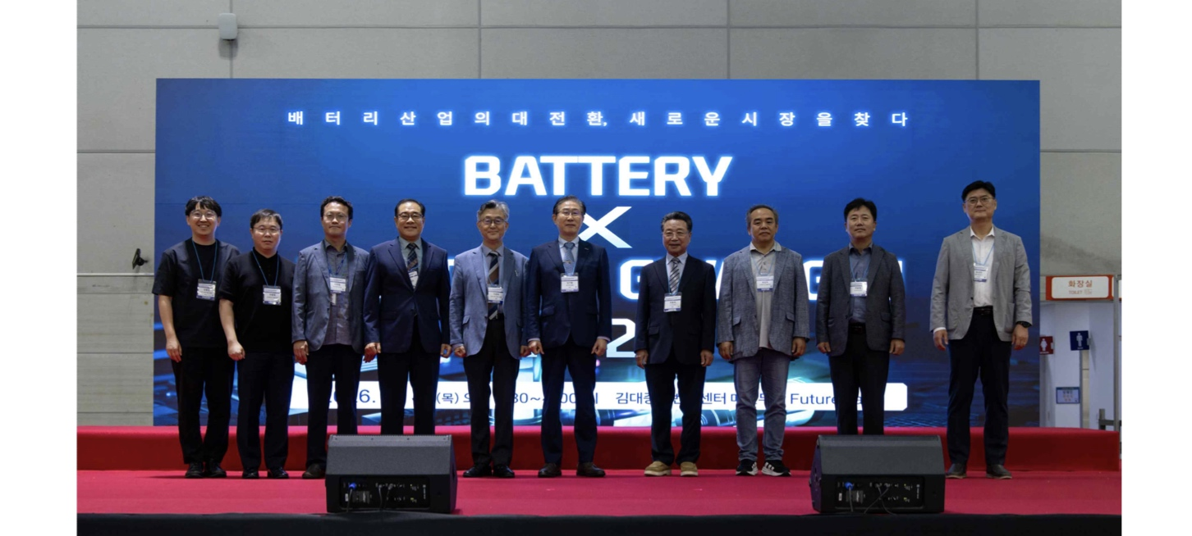

▲ Key attendees of ‘Battery (From left) GIST Energy Valley Institute of Technology Vice Director Hongkyu Kang, Korea Institute of Energy Research Institute Center Director Jung-je Woo, Korea Automobile Research Institute Center Director Hyun-cheol Lee, GIST Department of Chemistry Distinguished Visiting Professor Hyeong-Jin Kim, GIST Energy Valley Energy Valley Institute of Technology Kwanghee Lee, GIST President Kichul Lim, 1.5 degrees Celsius Forum Chairman Yong-guk Choi, Korea Institute of Energy Technology Evaluation and Planning PD Gil-mok Song, Korea Electrotechnology Research Institute senior researcher Yun-cheol Ha, and Sebang Lithium Battery Division Director Seong-bin Lim.
The Gwangju Institute of Science and Technology (GIST, President Kichul Lim) announced that it held the battery industry forum ‘BATTERY
This forum was prepared to share the latest technology and industry trends, such as changes in the global battery industry, next-generation batteries, and reuse and recycling of used batteries, and to explore growth potential and new business opportunities in the new battery market, which is expanding beyond electric vehicles to Energy Storage Systems (ESS), robotics, and humanoids.
The event was co-hosted by GIST, as well as ▴ Jeonnam Gwangju Unified Special City, ▴ Jeonnam Gwangju Free Economic Zone Authority, ▴ Korea Electric Power Corporation, ▴ 1.5 degrees Celsius Forum, ▴ Korea Society for Corrosion of Materials, ▴ Korea Energy Agency, and ▴ Korea Industrial Complex Corporation.
The participating organizations included ▴ GIST Research Institute for Solar and Sustainable Energies, ▴ Energy Valley Institute of Technology Director, ▴ GIST Anchor Project Group, ▴ Jeonnam Techno Park, ▴ Gwangju Techno Park, and ▴ Green Energy Research Institute.
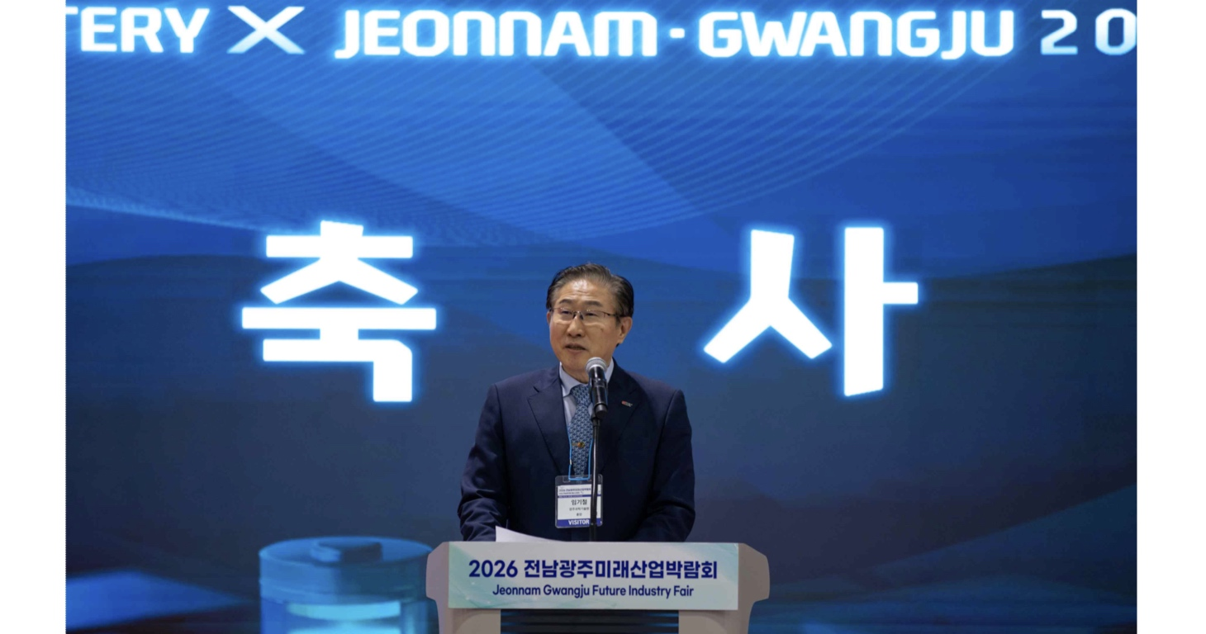

▲ GIST President Kichul Lim is giving a congratulatory speech at ‘Battery
At the forum, six experts from industry, academia, and research in the battery field participated as speakers and pointed out changes in the battery industry and new market possibilities in three sessions: ▴ Market outlook and safety policy ▴ Next-generation applications and new technologies ▴ Global vision and circular economy.
In the first ‘Market Forecast and Safety Policy’ session, PD Gil-mok Song of the Korea Institute of Energy Technology Evaluation and Planning introduced the battery market utilization prospects and the role of safety, and Hyeon-cheol Lee, director of the Korea Automobile Research Institute, presented trends in the battery industry and safety technology that are expanding beyond automobiles to energy storage systems (ESS) and robotics.
Next, in the ‘Next Generation Applications and New Technologies’ session, Sebang Lithium Battery General Manager Seongbin Lim introduced the task of upgrading the battery system to respond to new application fields, and Senior Researcher Yun-cheol Ha of the Korea Electrotechnology Research Institute presented the possibility of all-solid-state batteries, which are attracting attention as an energy source for humanoids in the era of physical artificial intelligence (Physical AI).
In the last ‘Global Vision and Circular Economy’ session, GIST Department of Chemistry Distinguished Visiting Professor Hyeong-Jin Kim looked at changes in the global battery industry and new markets, and Korea Institute of Energy Research (KIER) Center Director Jung-je Woo introduced the recycling of used batteries and the possibility of industrial use.
Following the presentation, a panel discussion was held under the theme, ‘Great transformation in the battery industry. Where is the new market?’
Based on questions received in advance from forum participants, the panelists shared opinions focusing on major areas of interest in the industrial field, such as ▴ changes and safety in the battery market, ▴ competitiveness of the domestic industry, and ▴ direction of development of next-generation batteries.
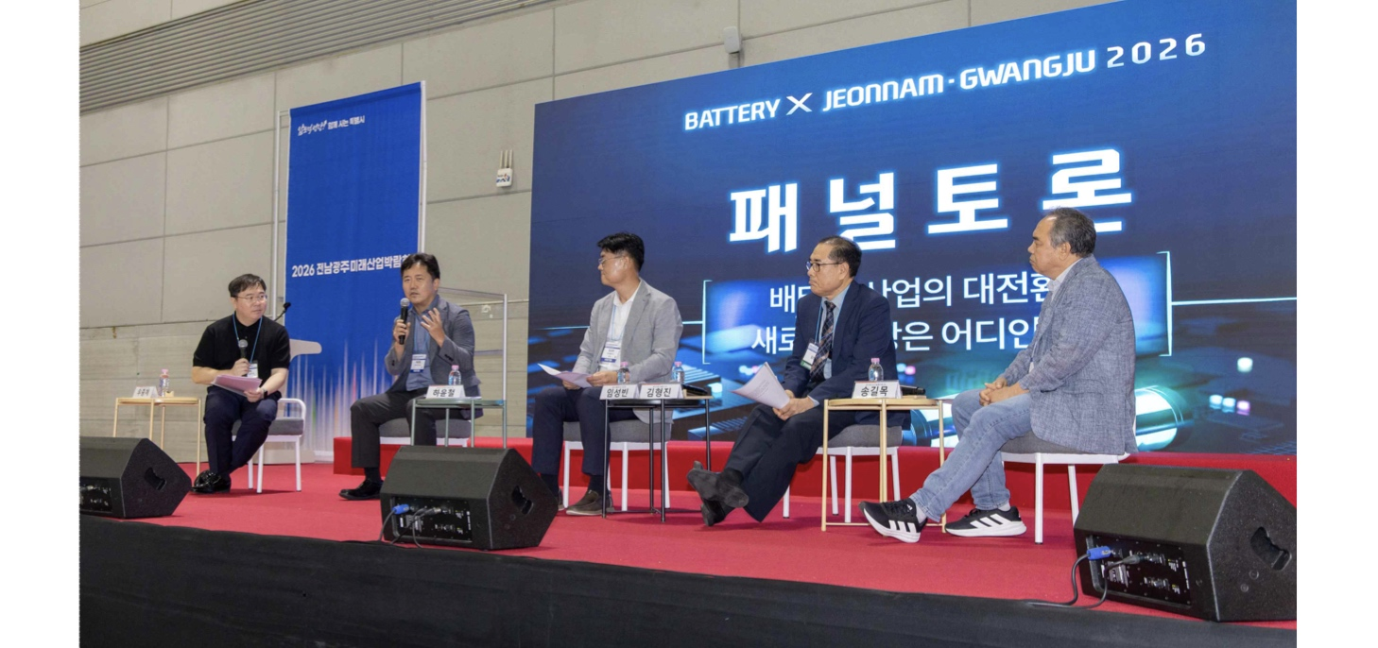

▲ Key speakers are holding a panel discussion on the topic ‘Great transformation of the battery industry. Where is the new market?’ (From left) Korea Institute of Energy Research Center Director Jung-je Woo (Chairman), Korea Institute of Electrical Engineers Senior Researcher Yun-cheol Ha, Sebang Lithium Battery Division Director Seong-bin Lim, GIST Department of Chemistry Distinguished Visiting Professor Hyeong-Jin Kim, Korea Institute of Energy Technology Evaluation and Planning PD Gil-mok Song
GIST Department of Chemistry Distinguished Visiting Professor Hyeong-Jin Kim noted that the battery market has been changing faster than expected recently and predicted, “In the future, new technologies that complement the different characteristics of existing batteries will be able to create new markets and business opportunities in various fields such as electric vehicles and energy storage devices.”
Gil-mok Song, PD of the Korea Institute of Energy Technology Evaluation and Planning, suggested, “If batteries used in electric vehicles, etc. are reused in energy storage devices and this is developed into an industry, it could become a new competitive edge for the domestic battery industry.”
Kwanghee Lee, Director of Energy Valley Technology Institute, said, “Through this forum, we were able to share the trends of the rapidly changing global battery industry and look at the possibilities of new markets such as energy storage devices and robotics beyond electric vehicles and the possibilities of next-generation battery technology.” He added, “Based on cooperation between industry, academia, research institutes, and government, we will continue to provide a venue for exchange where local companies can discover new battery markets and business opportunities and connect technology and industry.”

