GIST, ‘Add integrity. Change GIST.' A culture of integrity created through participation and communication
- From sharing practice cases to participatory education… ‘2026 GIST Integrity Focus Week’ with members
- President Kichul Lim directly participated in everything from the ‘Open GIST’ site to the town hall meeting and communicated with members
- 7 activities linked to ‘Integrity Passport’… Member opinions are reflected in future integrity education and system improvement
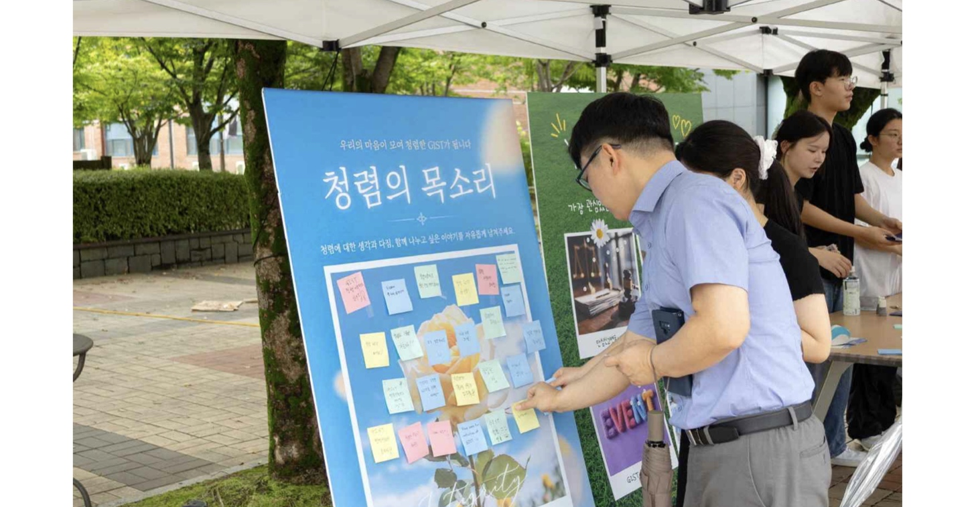

▲ At ‘OPEN GIST: Getting Integrity Closer’ held near GIST Student Center No. 1 on Monday, August 31, members are participating in a participation program in which they write down their wishes and commitments to create an organizational culture of integrity.
The Gwangju Institute of Science and Technology (GIST, President Kichul Lim) is holding a ‘Add Integrity’ campaign from Monday, August 31 to Friday, September 4. It was announced that the ‘2026 GIST Integrity Focus Week’ was held under the slogan ‘Change GIST.’
This ‘Integrity Focus Week’ was designed to help all members easily understand GIST’s integrity policy*, review the integrity standards required for members, and spread a culture of integrity through participation and communication.
By linking integrity policy guidance, discovery of integrity practice cases, participatory education using AI, online awareness check, and dialogue with the head of the organization, various programs were operated for one week in which members could directly participate and share opinions.
* integrity policy: These are policies or measures such as integrity education, reporting/counseling system, corruption prevention, and system improvement that the organization promotes to create a fair and transparent organizational culture.
On Monday, August 31, the first day of Integrity Focus Week, ‘OPEN GIST: Bringing Integrity Closer’ was held in front of Student Cafeteria No. 1 to introduce the integrity activities promoted by GIST and provide an opportunity for members to write down and share their wishes and pledges for a clean organizational culture.
On the participation board set up at the event venue, about 270 messages containing thoughts on integrity, pledges to practice, and wishes for the organizational culture were collected, such as ‘GIST respects each other’, ‘Principles and procedures are fair’, and ‘From small actions to integrity’.
President Kichul Lim also visited the event site on this day, listened directly to the opinions of students and members, and encouraged participation in the integrity week, practicing on-site communication led by the head of the institution.
On September 1 (Tuesday), members shared examples of integrity that they had practiced in the field, while also running a participatory program where members could judge the standards of integrity for themselves in actual situations.
First, at the ‘2026 GIST Integrity Practice Best Practice Contest’ awards ceremony held in Room 115 of Building A of the university, four cases of applying the value of integrity to actual work, such as ▴ transparent task management and research ethics ▴ responsible use of AI ▴ improvement of user-centered administrative services, were selected and awarded 1 Grand Prize, 1 Excellence Award, and 2 Encouragement Awards.
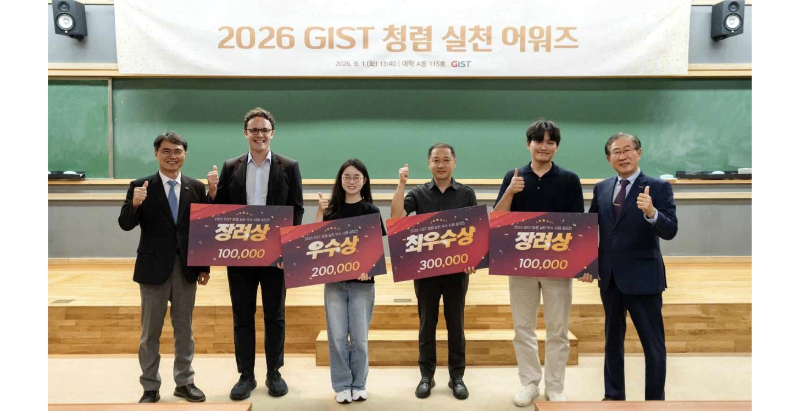

▲ Winners are taking a commemorative photo at the ‘2026 GIST Integrity Practice Best Practice Contest’ award ceremony held on Tuesday, September 1. (First from right) GIST President Kichul Lim
The grand prize was given to a case that increased transparency and responsibility in task performance and improved management procedures through on-site inspection of waste disposal services, and the excellence award was given to a case of handbook production to help new students adapt to the lab and practice research ethics.
The encouragement award was given to ▴ a case of creating a responsible educational culture by establishing principles for the use of generative artificial intelligence (AI), and ▴ a case of active administration that improved the research equipment management system by reflecting user opinions.
Next was the ‘Challenge! Integrity Golden Bell’ was operated as an interactive education combining quizzes, discussions, and anonymous surveys incorporating AI and game elements, with about 105 members participating.
Participants examined various situations they may encounter in research, education, and administration related to the Anti-Graft Act, Conflict of Interest Prevention Act, and research ethics, and had time to understand the integrity standards in detail by checking the basis for judgment presented by AI and the results of participants' responses.
On Wednesday, September 2, students went one step further in learning the integrity standards for each situation and ran an online participation program called ‘Integrity Gray Zone, Is this OK?’, which allowed people to check their own integrity standards in situations where judgments differ.
Members looked at 10 situations they may encounter in their daily lives and work, and had time to think about how they would make decisions in a situation that requires integrity.
This intensive week also provided an opportunity for communication where the head of the organization could directly hear and respond to the voices of members.
About 60 members, including President Kichul Lim, Vice President for Academic Affairs Sungho Jeong, and Minister of Public Administration and Security Young-wook Cho, attended the ‘ASK:G 2026 Integrity Town Hall Meeting’ held in the small theater on the first floor of the Central Library on Thursday, September 3.
At the event, which was held under the theme of ‘Ask, Listen, and Change Together’, GIST’s integrity status and major policies were introduced, and members’ opinions were heard based on 24 anonymous questions submitted in advance and on-site questions.
The questions covered a variety of topics, including ▴ fair work performance and horizontal communication ▴ prevention of unfair work practices ▴ accessibility for foreign students to report ▴ execution of research funds ▴ research ethics and protection of reporters.
Following his participation in the ‘Open GIST’ field, President Lim actively communicated with members at the town hall meeting, making clear his commitment to integrity and the direction of action. Together with key officials, we directly answered questions from members, discussed ways to improve, and helped spread integrity as an organizational culture created together with members.
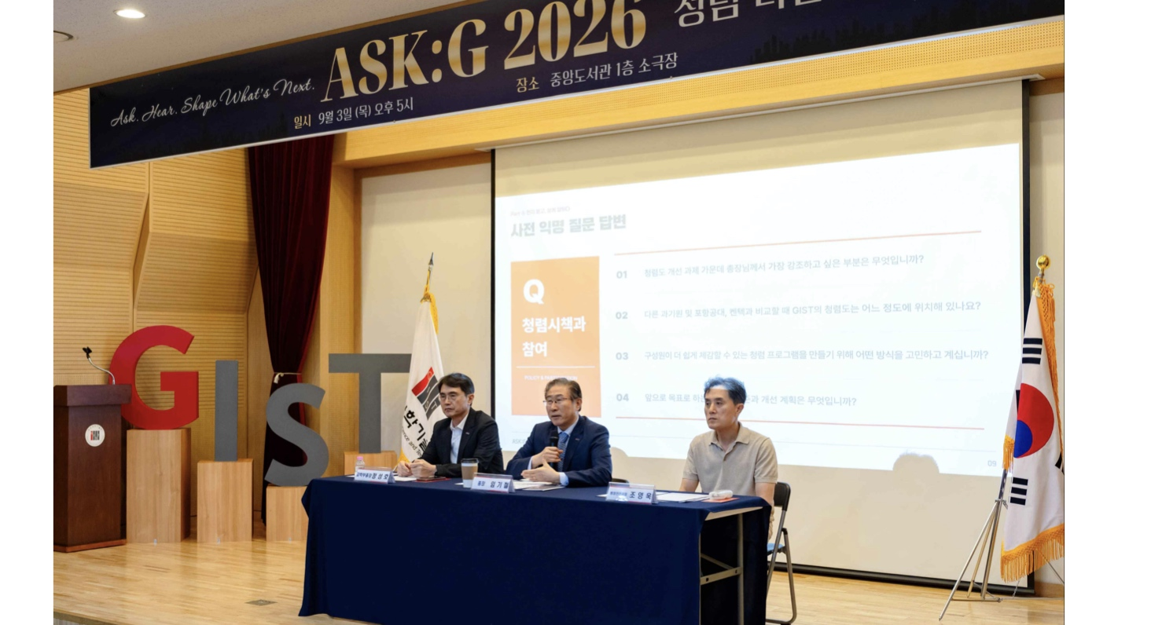

▲ Answering questions from members at the ‘ASK:G 2026 Integrity Town Hall Meeting’ held at the GIST Central Library Small Theater on Thursday, September 3. (From left) GIST Vice President for Academic Affairs Sungho Jeong, President Kichul Lim, and Young-wook Cho, Minister of Public Administration and Security
GIST also operated the ‘2026 GIST Integrity Passport’ to connect individual programs into one participation flow and encourage continued participation of members.
Starting with the integrity policy awareness survey last July, members participated in a total of seven activities, including the main program of the intensive week and the final satisfaction survey, and accumulated stamps in the ‘Integrity Passport’.
On Friday, September 4, the last day of Integrity Focus Week, a satisfaction and effectiveness survey was conducted to collect members' opinions on the program.
President Kichul Lim said, “Integrity is not a grandiose slogan, but only becomes established as an organizational culture when it is practiced in everyday judgments and actions.” He added, “It is important to create an organizational culture where everyone can voice their opinions with confidence, as well as honesty in research and education, fairness in decision-making, and mutual respect among members.”
He continued, “We will fulfill our responsibilities of transparent decision-making and leading by example, starting with the head of the institution, and we will lead the diverse voices of members gathered during this Integrity Focus Week to lead to real change,” and added, “We will work with our members to ensure that the values ​​of fairness and respect take root throughout the lab, classroom, and administrative field.”
Meanwhile, GIST plans to analyze member opinions collected during this intensive week and the participation and response results for each program to check members' awareness of integrity and the effectiveness of the program, and to reflect this in future integrity education, guidance materials, and system improvement.

