Chemistry, physics, and life sciences meet in Gwangju, the ‘City of Light’… GIST and IBS Optical Science Research Cluster hold first joint symposium
- Three IBS research groups based at the GIST campus hold their first joint symposium, ‘Photon Science 2026’
- Around 80 researchers in basic science gather to exchange ideas centered on ‘light’ and explore possibilities for interdisciplinary and collaborative research
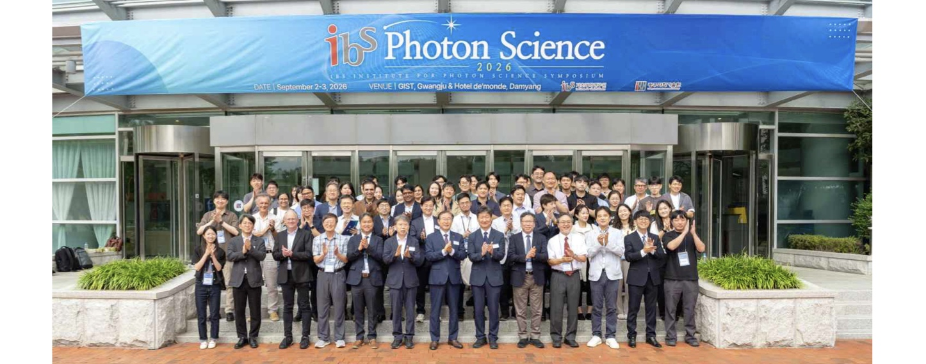

▲ Attendees of the ‘Photon Science 2026’ symposium, held at the GIST Oryong Hall on September 2 (Wed), pose for a commemorative photo. (Front row, 5th from left) Director Kyung Taec Kim of the IBS Center for Relativistic Laser Science; (Front row, 7th from left) GIST President Kichul Lim; (Front row, 5th from right) Director Yousoo Kim of the IBS Center for Quantum Conversion Research (Head of the IBS Photon Science Research Cluster); (Front row, 3rd from right) Director Seong-Bae Suh of the IBS Center for Microbiome-Body-Brain Physiology.
The Gwangju Institute of Science and Technology (GIST; President Kichul Lim) announced that three research centers affiliated with the ‘IBS Photon Science Research Cluster’ (Director: Yousoo Kim), located at GIST, held their first joint symposium, ‘Photon Science 2026,’ from September 2 (Wed) to September 3 (Thu) at GIST and in Damyang, Jeollanam-do.
The IBS Photon Science Research Cluster consists of the ‘Center for Quantum Conversion Research’ (Director Yousoo Kim) in chemistry, the ‘Center for Relativistic Laser Science’ (Director Kyung Taec Kim) in physics, and the ‘Center for Microbiome-Body-Brain Physiology’ (Director Seong-Bae Suh) in life sciences.
This marks the first time these three research centers, each specializing in a different field, have jointly hosted a symposium. The event served as a platform to share current research status and achievements, identify intersections between the different fields, and explore possibilities for new convergence and collaborative research.
Although their research subjects and approaches differ, the three centers share a commonality: they all utilize light—either as a subject of study or as a tool for observation and measurement—while investigating natural phenomena across various spatiotemporal scales.
The Center for Quantum Conversion Research (QCR) conducts research on observing light-matter interactions at the atomic and molecular levels, as well as precisely measuring and controlling the processes by which matter absorbs, transfers, and converts energy.
The Center for Relativistic Laser Science (CoReLS) studies light-matter interactions using a 4-petawatt (PW) class ultra-high-power laser and explores physical phenomena characteristic of extreme environments—such as those found in space—within a terrestrial laboratory setting.
The Center for Microbiome-Body-Brain Physiology (MBB) employs various research techniques, including light-based neuronal activity monitoring, to investigate the processes by which nutrients are sensed in the body and trigger feeding behavior, as well as the interactions among the gut, brain, and microbiome.
Approximately 80 participants—including researchers from the three IBS centers and invited speakers from Korea and abroad—attended the event, which featured presentations on research achievements, invited lectures, poster sessions, networking opportunities, and tours of shared laboratory facilities.
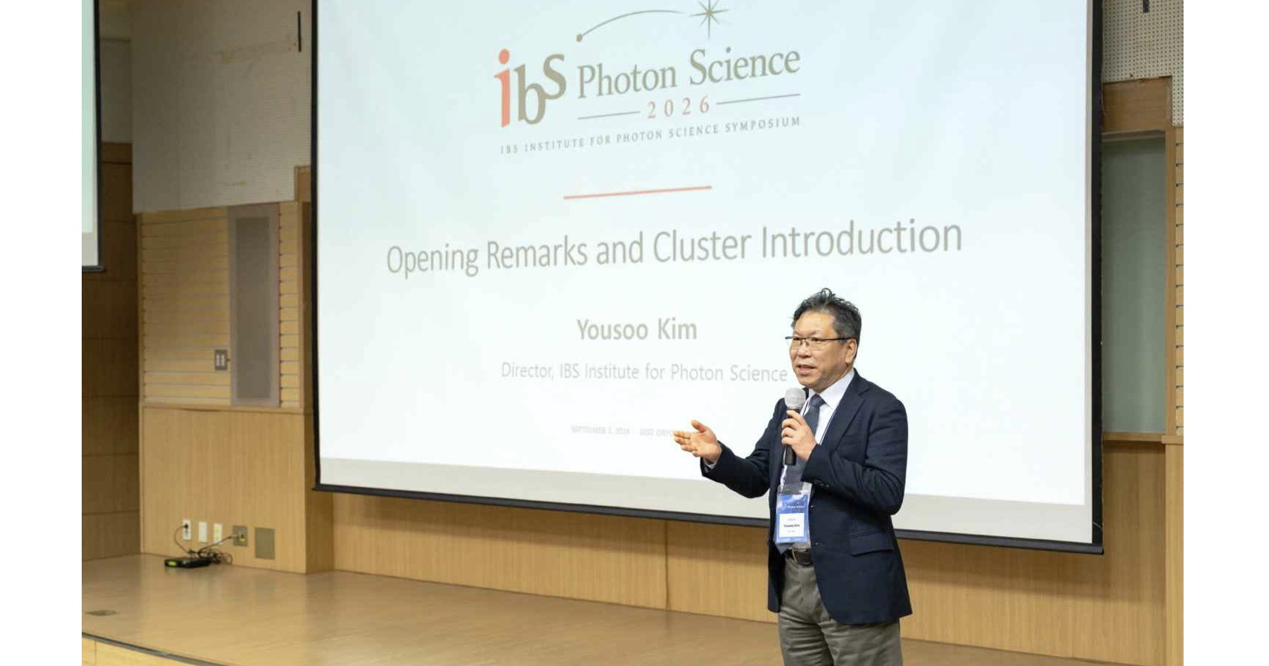

▲ Director Yousoo Kim of the Center for Quantum Conversion Research (also Director of the IBS Photon Science Research Cluster) delivers the opening remarks and introduces the Photon Science Research Cluster at ‘Photon Science 2026.’
On Wednesday the 2nd, the event kicked off at the GIST Oryong Hall with opening remarks by Director Yousoo Kim of the IBS Center for Photon Science. Participants then moved to a venue in Damyang, South Jeolla Province, where three research groups presented their key research areas and achievements, followed by invited lectures from three researchers from Korea and abroad.
The invited speakers were Dr. Tahei Tahara, Chief Scientist at RIKEN (Japan); Professor Emeritus Nam Chang-Hee of the GIST Department of Physics and Photon Science; and Professor Thomas R. Clandinin of the Department of Neurobiology at Stanford University (USA).
Dr. Tahara presented research on observing the structures and dynamics of complex molecular systems—such as proteins, DNA, and RNA—using advanced spectroscopy.
Professor Emeritus Chang Hee Nam outlined his research journey, ranging from the development of terawatt-class femtosecond lasers at KAIST to the construction of a world-class petawatt laser at the IBS Center for Relativistic Laser Science. He also presented the progress and key achievements in "strong-field physics"—the study of physical phenomena occurring in intense electromagnetic field environments using ultra-high-power lasers.
Professor Clandinin shared his research journey, which has spanned fields from genetics to developmental and systems neuroscience, and discussed his experiences in identifying new scientific questions and developing them into research topics.
That evening, a poster session was held, providing an opportunity for researchers to personally present their findings and exchange ideas.
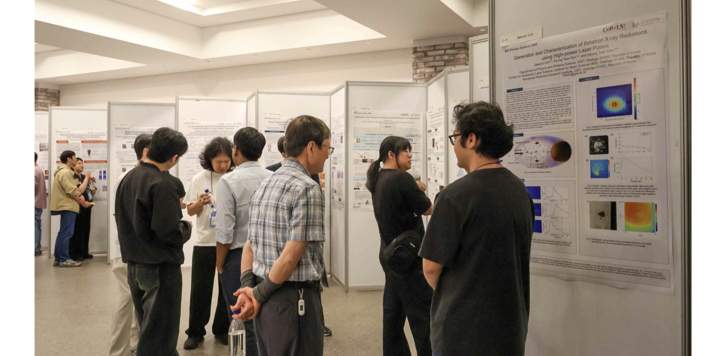

▲ Participants share research findings and exchange ideas during the ‘Photon Science 2026’ poster session.
The poster session showcased a variety of research achievements, including: research observing the electronic states within single molecules at the atomic level; technology for measuring the temperature of heated electrons inside semiconductor devices at the nanometer scale; spectroscopic techniques for precisely examining interactions between molecules and material surfaces; research utilizing machine learning to discover high-performance catalysts; and studies leveraging the interaction between ultra-high-power lasers and plasma.
On the second day (Thursday, the 3rd), an awards ceremony for outstanding posters and a networking program for participants were held. Afterward, the group visited GIST for a laboratory tour to explore the key research facilities of the Center for Quantum Conversion Research (QCR) and the Center for Relativistic Laser Science (CoReLS).
Six entries were selected as outstanding posters based on a comprehensive evaluation of their content and research results: Ju-hee Oh, Hyun-ju Kim, and Ji-hyun Ra from the Center for Quantum Conversion Research; and Jae-won Lim, Anandam Choudhary, and Bin Kim from the Center for Relativistic Laser Science.
Subsequently, participants toured the laboratories and key research equipment of both centers, gaining insight into the actual experimental environments and research infrastructure.
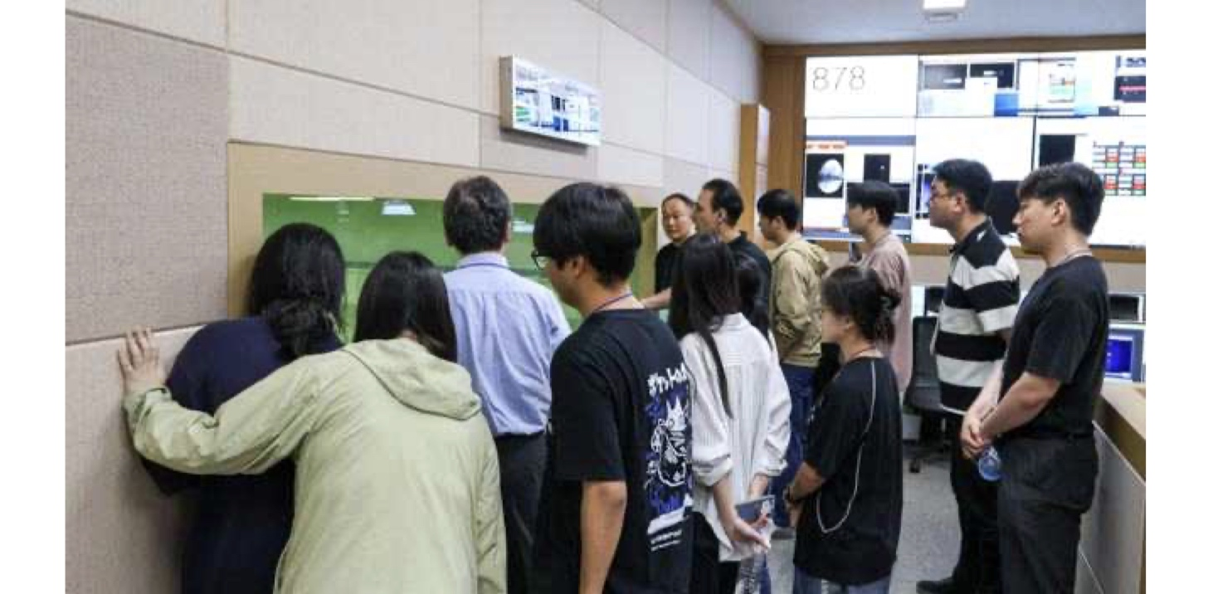

▲ ‘Photon Science 2026’ participants listen to an explanation about key research equipment at the IBS Center for Relativistic Laser Science laboratory at GIST.
Yousoo Kim, Director of the IBS Photon Science Research Cluster, stated, "This symposium serves as a first step for researchers from diverse fields to share their expertise, discover unexpected points of intersection in their work, and pave the way for new collaborations." He added, "We will continue to foster ongoing exchanges to build an interdisciplinary research community centered at GIST."
Meanwhile, following this symposium, GIST has scheduled an international collaboration event with Japan’s RIKEN in October and a joint academic event with domestic IBS research groups specializing in quantum science in November, ensuring continued academic exchange among researchers from home and abroad.

