GIST hosts Korea-Switzerland Quantum Optical Technology Forum; Signs MOU with University of Bern and opens Joint Research Office
- Approximately 70 researchers and officials from both countries gathered at GIST from September 1 (Tue) to 3 (Thu) to share the latest research findings
- GIST’s Advanced Photonics Research Institute (APRI) and the Institute of Applied Physics (IAP) at the University of Bern signed an MOU to expand joint research in quantum photonics and opened the "APRI-IAP Joint Research Office"
- Building on a partnership with the University of Bern that dates back to 2009, the two institutions plan to identify joint R&D projects and pursue further collaboration
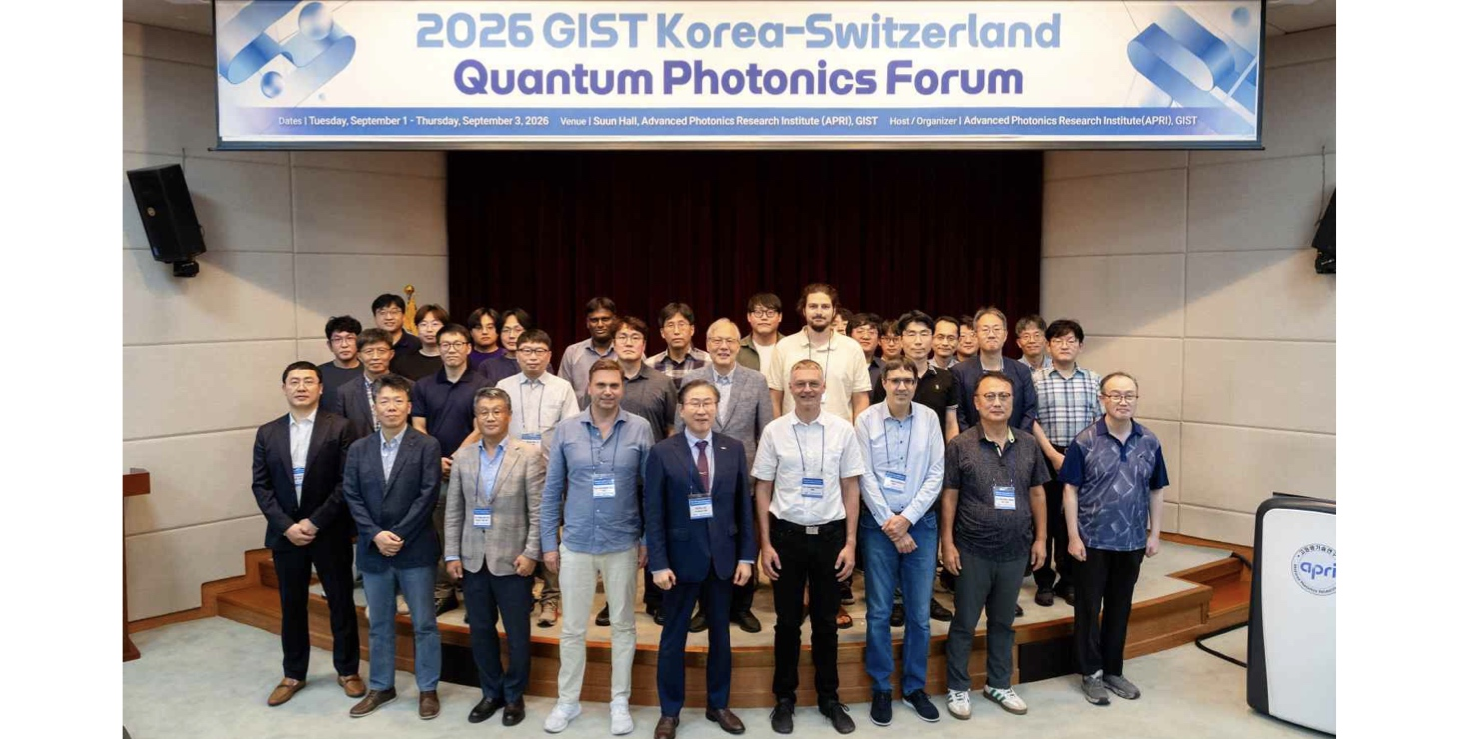

▲ Attendees of the ‘2026 GIST Korea-Switzerland Quantum Photonics Forum’ pose for a group photo. (From second from the left in the front row) Woo-jin Shin (Principal Researcher, GIST APRI), Yeung Lak Lee (Director, GIST APRI), Prof. Alexander Heidt (Institute of Applied Physics IAP, University of Bern), Kichul Lim (President, GIST), Prof. Christoph Wildfeuer (University of Applied Sciences and Arts Northwestern Switzerland), Prof. Andre Stefanov (IAP, University of Bern), and Hoon-soo Kang (Principal Researcher, GIST APRI).
The Gwangju Institute of Science and Technology (GIST; President Kichul Lim) announced that it hosted the ‘2026 GIST Korea-Switzerland Quantum Photonics Forum’ at the GIST Advanced Photonics Research Institute (APRI) from September 1 (Tue) to 3 (Thu). The event brought together experts in quantum photonics from Korea and Switzerland to share the latest research achievements and discuss strategies for international joint research collaboration.
Hosted and organized by GIST APRI, the forum was attended by approximately 70 researchers and officials from both countries. Participants shared the latest findings in fields such as quantum optics, quantum communication, and quantum computing, and explored avenues for collaborative research.
Notably, during the forum, GIST APRI and the Institute of Applied Physics (IAP) at the University of Bern signed a Memorandum of Understanding (MOU) to expand joint research in quantum photonics and opened a ‘Joint APRI-IAP Research Office’ at GIST. Through this initiative, the two institutions have laid the groundwork to elevate their existing research cooperation into a more systematic international joint research partnership.
Since 2009, the GIST Advanced Photonics Research Institute (APRI) has engaged in joint research in the fields of lasers and optics with the Institute of Applied Physics at the University of Bern, and has recently expanded the scope of this collaboration to include quantum science and technology.
Notably, in 2024, South Korea—represented by GIST APRI—became the eighth member nation of the International Foundation High Altitude Research Stations Jungfraujoch and Gornergrat. This milestone has paved the way for joint international research between Korea and Switzerland utilizing these high-altitude research facilities.
Currently, under a joint Korea-Switzerland quantum science and technology research program, a study is underway to verify the feasibility of stable long-distance quantum information transmission by linking the University of Bern’s Zimmerwald Observatory with the Jungfraujoch High Altitude Research Station in the Swiss Alps, located at an altitude of 3,500 meters and approximately 57 km away.
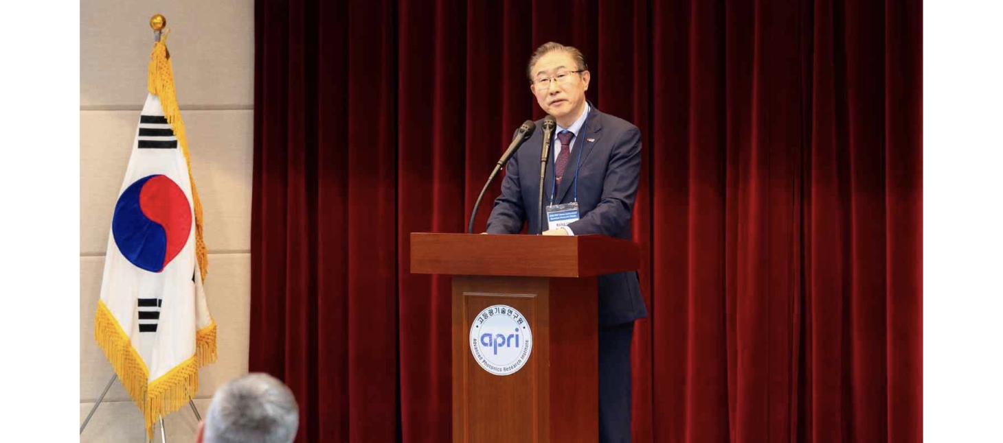

▲ GIST President Kichul Lim delivers the opening remarks at the "2026 GIST Korea-Switzerland Quantum Photonics Forum" held on Tuesday, September 1.
On the first day of the forum (September 1), the event began with opening remarks by PresidentKichul Lim, followed by presentations from eight experts representing both Korea and Switzerland.
Presenters from Switzerland included Professors Alexander Heidt and André Stefanov from the University of Bern’s Institute of Applied Physics, and Professor Christoph Wildfeuer from the University of Applied Sciences and Arts Northwestern Switzerland.
Presenters from Korea included Professors Do-Kyeong Ko and Sang-Yun Lee (GIST Department of Physics and Photon Science), Professor Yoon-Ho Kim (POSTECH Department of Physics), Senior Researcher Hoon-soo Kang (GIST APRI), and Principal Researcher Ki-Won Moon (Electronics and Telecommunications Research Institute, ETRI).
The presentation showcased the latest research achievements in the field of quantum optical technology—ranging from fundamental research to applications in communication and computing—including: ▴ basic research on the conversion of quantum states of light and interactions between multiple atoms; ▴ precision laser technology utilizing light-matter interactions; ▴ technology for transmitting high-dimensional quantum entanglement using various light structures; ▴ free-space quantum communication and secure communication applications for transmitting quantum information through the air rather than optical fibers; and ▴ quantum computing that processes information using the quantum properties of light.
Notably, research results reflecting real-world communication environments were also shared, such as technology for transmitting quantum information while minimizing external noise in a 40km-long urban optical communication network, and aerial quantum communication technology utilizing drones or high-altitude balloons.
Subsequently, on Wednesday, September 2, GIST’s Advanced Photonics Research Institute (APRI) and the Institute of Applied Physics (IAP) at the University of Bern signed a memorandum of understanding (MOU) for joint research in the field of quantum optical technology.
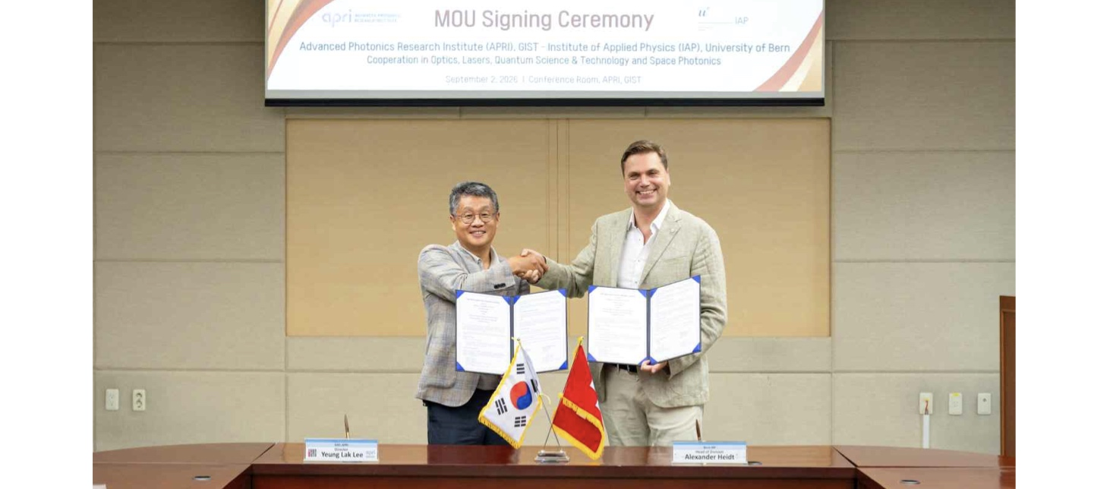

▲ On Wednesday, September 2, Director Yeung Lak Lee of GIST’s Advanced Photonics Research Institute (left) and Professor Alexander Heidt of the University of Bern’s Institute of Applied Physics (right) pose for a commemorative photo after signing an MOU for joint research in quantum optical technology.
Based on this agreement, the two institutions plan to share research information and technological trends, and to identify joint international R&D projects that leverage their respective strengths in areas such as free-space quantum communication, quantum optics, single-photon technology, lasers, and optical technologies.
Following the signing ceremony, the "APRI-IAP Joint Research Office" was opened in Room 409-1 of GIST’s Advanced Photonics Research Institute (APRI) for use by researchers from both institutions. This office will serve as a hub for ongoing cooperation, facilitating the sharing of project progress and continued discussions.
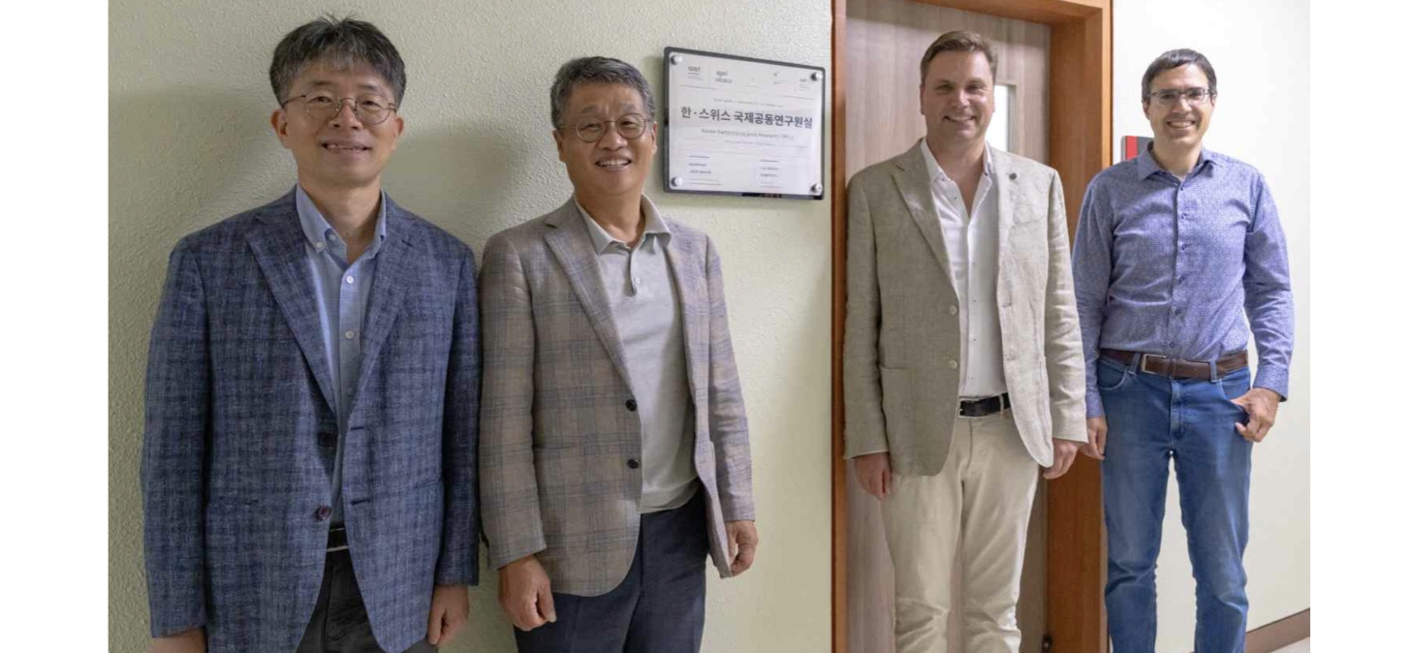

▲ Representatives from both institutions pose for a commemorative photo in front of the "APRI-IAP Joint Research Office" at GIST’s Advanced Photonics Research Institute. (From left) Sung-gu Lee (Deputy Director, APRI), Yeung Lak Lee (Director, APRI), and Professors Alexander Heidt and André Stefanov (Institute of Applied Physics, University of Bern).
On September 3 (Thursday), the final day of the event, a working-level meeting was held to share research plans and ongoing projects. Participants discussed identifying joint Korea-Switzerland projects, defining roles for researchers, and outlining future implementation plans.
GIST President Kichul Lim stated, "This forum went beyond merely sharing the latest research achievements in quantum photonics between Korean and Swiss researchers; it served as an opportunity to translate the research capabilities of both nations into tangible international joint research." He added, "Building on this agreement with the University of Bern and the establishment of the joint research office, we will actively support the identification of competitive research topics and ensure that this partnership leads to sustained cooperation and concrete research outcomes."

