GIST Oryong Art Hall hosts solo exhibition by Artist Yong-an Kim: 'The Blind Spot of Concealment and Revelation'
- 3rd Invitational Exhibition at Oryong Art Hall (2026): September 2 (Wed) – October 27 (Tue)
- Dreamlike landscapes crafted from lush forests and mist; an expression of the blurred boundary between reality and the ideal
- Incorporating the anxiety of modern life and invisible forces into elements such as forests spared from development, artificial landscaping, zebras, and birds
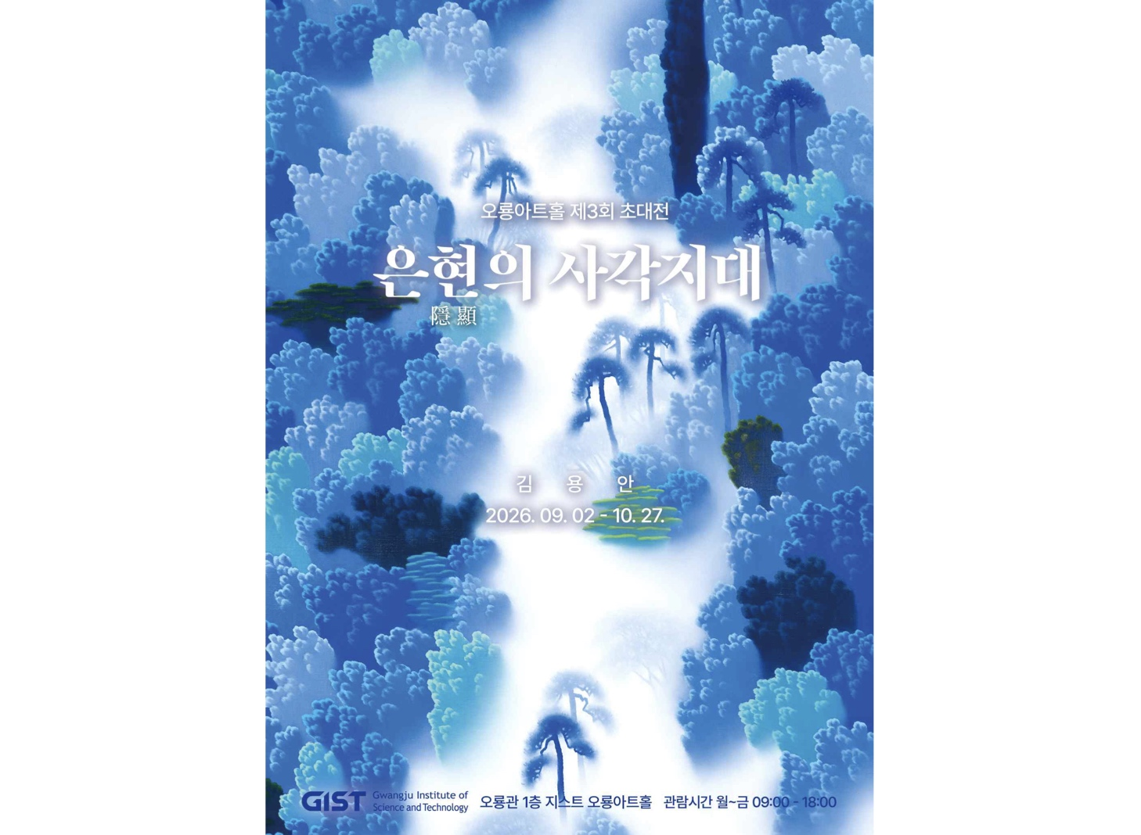

▲ Poster for the Yong-an Kim Invitational Exhibition at GIST Oryong Art Hall
The Gwangju Institute of Science and Technology (GIST; President Kichul Lim) announced that it will host an invitational exhibition by artist Yong-an Kim, titled The Blind Spot of Concealment and Revelation, at Oryong Art Hall from Wednesday, September 2, to Tuesday, October 27.
Organized as the third invitational exhibition at Oryong Art Hall for 2026, this exhibition showcases paintings that express the "gap between the visible and the invisible"—a theme the artist has consistently explored—through imagery such as forests, fog, and animals.
Artist Yong-an Kim creates landscapes that feel a step removed from reality, utilizing forests dominated by blue hues and fog that envelops the canvas as if floating.
While the forest in the artwork appears to be a landscape recreating actual nature, elements such as trees washed in deep blue-green hues, blurred boundaries, and an unrealistically rising mist transform it into a space that belongs fully to neither reality nor the ideal.
Notably, although the work is painted in oil on canvas, the artist avoids emphasizing the thick texture of the paint; instead, the imagery is rendered softly and hazily—reminiscent of ink soaking into paper—to evoke a distinctive, dreamlike atmosphere.
The forest depicted by the artist does not merely represent a beautiful, peaceful utopia. By capturing both the forests left behind amidst indiscriminate development and industrialization and the artificial landscaping that has replaced them within a single frame, the work reveals the anxiety and tension lurking beneath the beautiful scenery.
The "mist" that appears repeatedly in the work serves as a dual-natured element: it creates a beautiful, mysterious landscape while simultaneously obscuring vision and blurring boundaries.
Through this ambivalence of the mist, the artist metaphorically portrays the invisible forces that weigh upon life and the anxieties inherent in society.
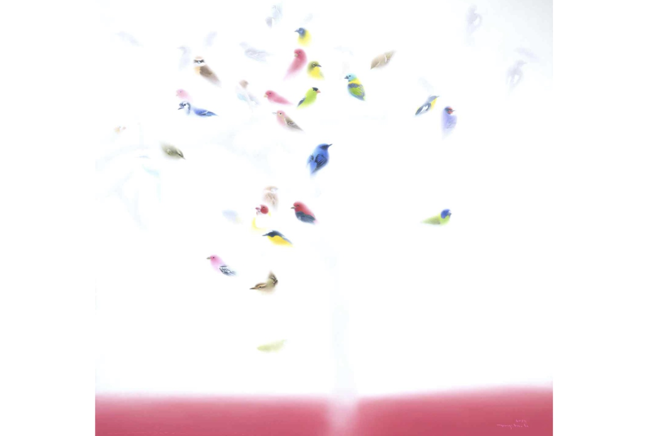

▲ Artwork from the invitational exhibition of artist Yong-an Kim at GIST Oryong Art Hall (Camouflage, 120×120cm, acrylic on canvas, 2017)
This artistic vision extends beyond forests and fog to incorporate images such as zebras and birds into the composition.
This imagery draws a parallel between modern individuals adapting to a rapidly changing urban environment and the concept of "camouflage"—blending into one's surroundings to remain unseen.
The zebra’s stripes and the birds—symbols of freedom—represent modern people who must conform to the vast structures of the city in order to survive.
The exhibition title, The Blind Spot of Concealment and Revelation, encapsulates the artist’s world, where such contrasting elements coexist within a single frame.
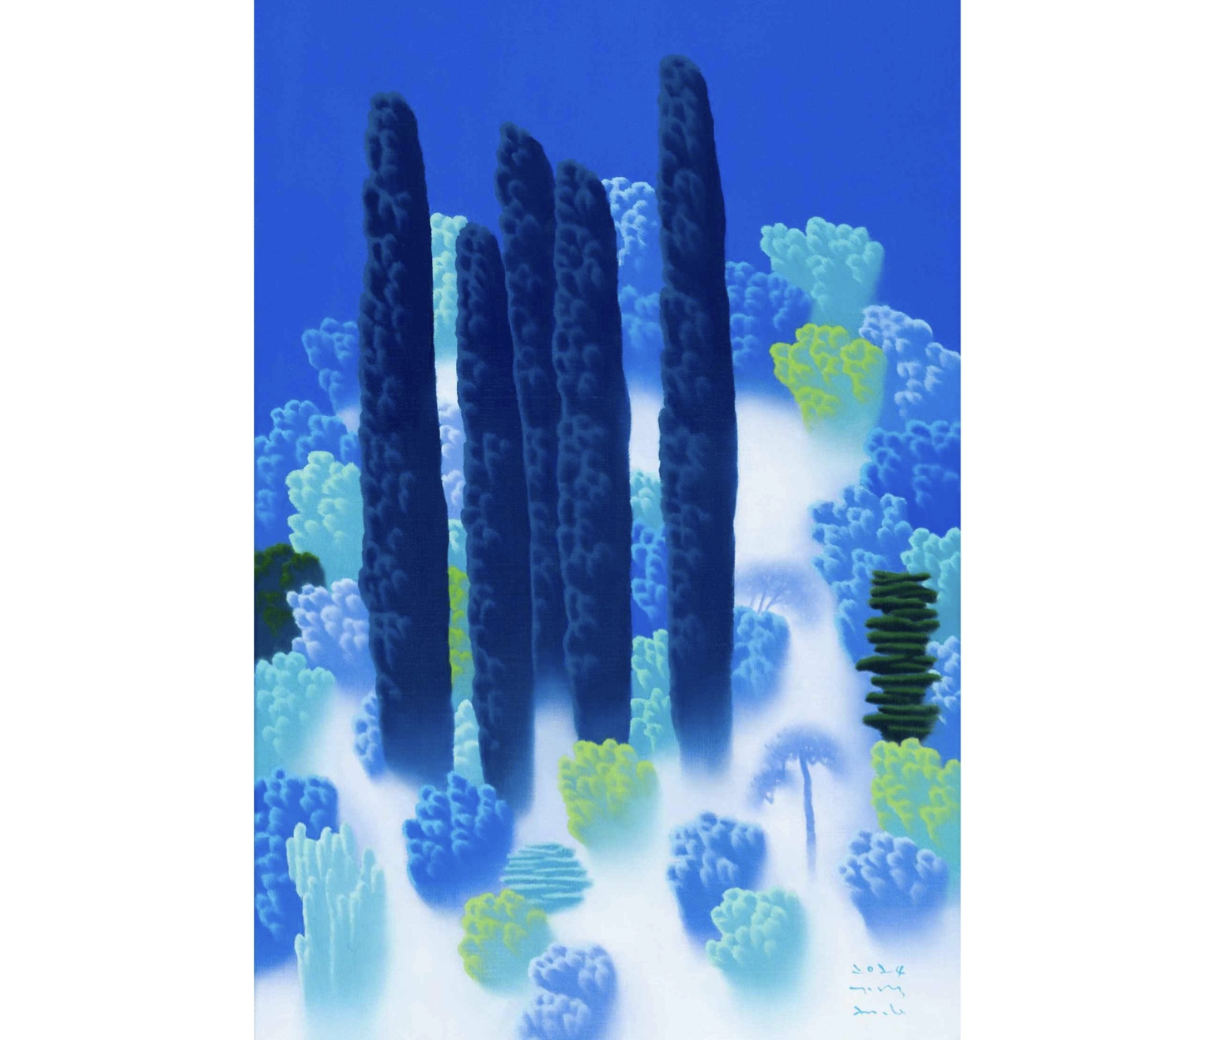

▲ Artwork from the Yong-an Kim invitational exhibition at GIST Oryong Art Hall (Hidden, 53 × 33.4 cm, acrylic on canvas, 2024)
"Eunhyeon" (Hidden and Revealed) refers to the contrasting states of concealment and visibility, while "blind spot" signifies an area that exists right before one's eyes yet often goes unnoticed.
The forests and fog depicted in the artworks simultaneously reveal and conceal elements, unveiling aspects of reality that are not easily perceived within what appears to be a familiar, beautiful landscape.
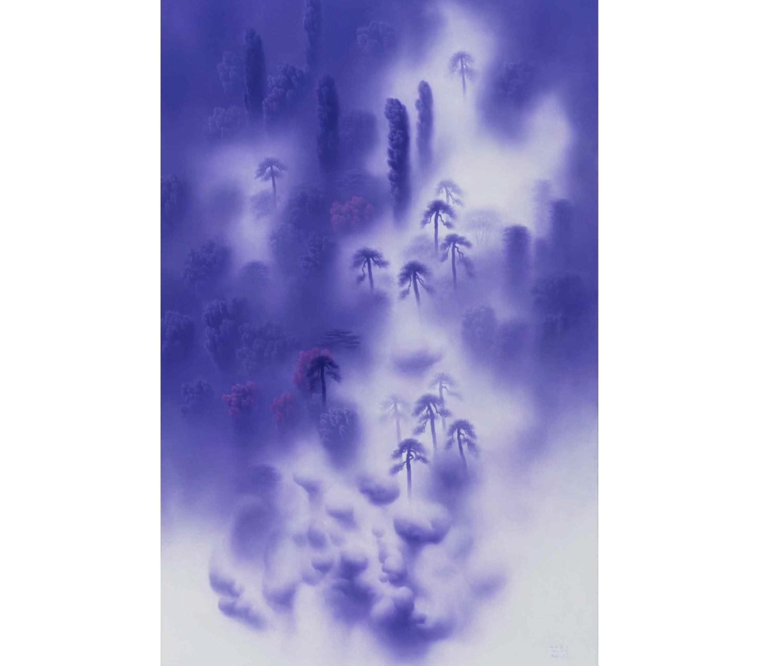

▲ An artwork from artist Yong-an Kim’s invitational exhibition at the GIST Oryong Art Hall (White Darkness, 116.7 × 72.7 cm, acrylic on canvas, 2021). For over two decades, artist Kim Yong-an has consistently explored the boundaries of reality and the world beyond through the medium of landscape.
Kim graduated from the Department of Fine Arts at Chosun University and completed the doctoral program at the same university's graduate school. Since Kim's first solo exhibition, Landscape That Opens the Heart, in 2008, Kim has held nine solo exhibitions in Seoul and Gwangju.
Kim has received awards such as the Excellence Award at the Gwangju Shinsegae Art Festival and the Grand Prize at the Gwangju Metropolitan City Art Exhibition. Kim actively participates in domestic and international exhibitions, including the Gwangju International Art Fair and the Busan International Gallery Art Fair (BAMA). In May of this year, Kim showcased his work at the Affordable Art Fair Hong Kong.
Meanwhile, Oryong Art Hall is an exhibition space created by GIST on the interior walls of the first and second floors of the Oryong Hall—a multi-purpose building—to foster communication with the local community. Since launching its first invitational exhibition in December 2022, it has operated as an open cultural and artistic space that connects the local community with art within the research-focused university campus.

