GIST launches consultative body to accelerate commercialization of perovskite solar cells
- Kick-off meeting held on August 31 (Mon) and chairpersons appointed for four specialized subcommittees; approximately 30 experts from industry, academia, and research institutes set to participate
- Bridging the gap from the demonstration and certification of R&D outcomes to product commercialization and mass production; addressing key issues across the entire commercialization process
- Linking with the Ministry of Science and ICT’s strategic research projects to resolve commercialization challenges and flesh out specific policy and commercialization tasks
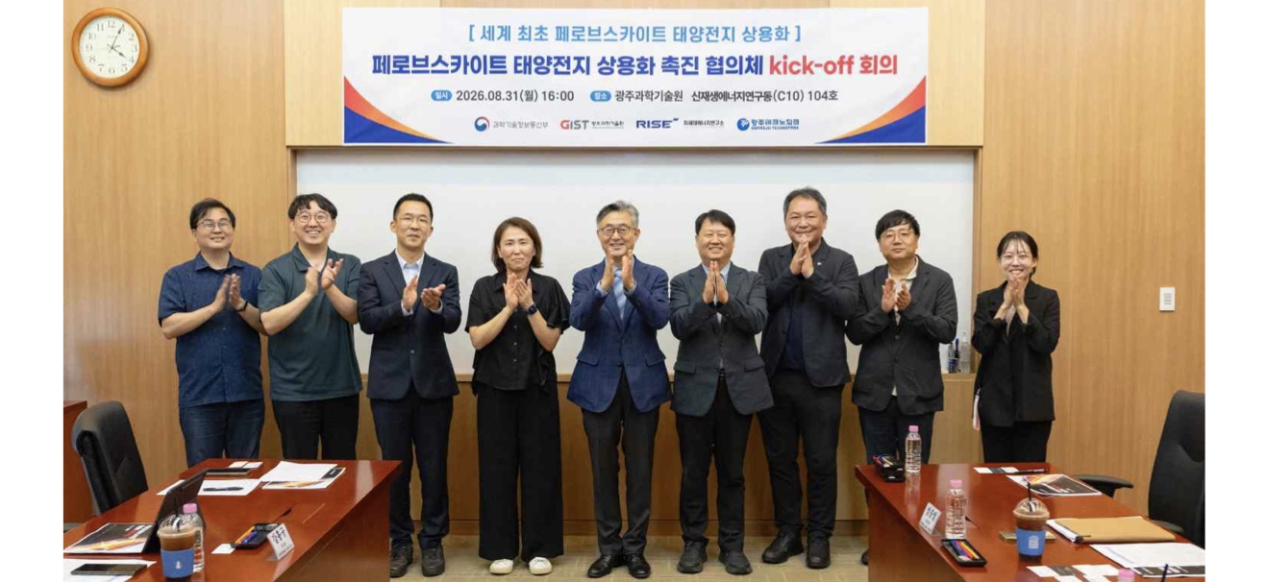

▲ Participants pose for a commemorative photo at the kickoff meeting for the "Consortium for Accelerating the Commercialization of Perovskite Solar Cells," held on Monday, August 31, at the GIST Research Institute for Solar and Sustainable Energies Building. Pictured are Hongkyu Kang, Deputy Director of the GIST Research Institute for Solar and Sustainable Energies (second from left), and Kwanghee Lee, Head of the Strategic Research Project Group and Distinguished Visiting Professor in the Department of Materials Science and Engineering (fifth from left).
On Monday, August 31, the Gwangju Institute of Science and Technology (GIST; President Kichul Lim) held a kickoff meeting for the "Consortium for Accelerating the Commercialization of Perovskite Solar Cells" at the Research Institute for Solar and Sustainable Energies Building, announcing the official launch of a cooperative framework aimed at the early commercialization of perovskite solar cells.
This consortium operates under the leadership of the "World’s First Perovskite Solar Cell Commercialization Strategic Research Project Group" (hereinafter referred to as the Strategic Research Project Group), which is managed by GIST as part of a strategic research initiative funded by the Ministry of Science and ICT.
The consortium was established to go beyond simple information exchange and expert consultation; its specific goal is to identify key issues arising during the commercialization process of perovskite solar cells and to devise concrete solutions.
Perovskite solar cells are garnering attention as a next-generation solar technology. In addition to offering high power generation efficiency, they can be manufactured in various forms—such as lightweight, flexible, and semi-transparent types—allowing for application in diverse areas, including building facades and windows.
In particular, to translate the expanded adoption of renewable energy into the growth of domestic solar technology and industries, it is crucial to scale up the material and device technologies developed in the laboratory into large-area modules and manufacturing processes, and to secure commercialization technologies that enable actual product manufacturing and mass production.
At the kickoff meeting, Kwanghee Lee, Head of the Strategic Research Project Group (Distinguished Visiting Professor, Department of Materials Science and Engineering), delivered opening remarks. Participants then shared the project's current status and plans for the consultative body's composition and operation, and discussed future operational strategies.
The consultative body for accelerating commercialization comprises four specialized subcommittees—Technology, Certification & Standards, Industrialization, and Investment—and operates by having experts in each field collaborate to resolve pending issues in the commercialization process, drawing upon their professional expertise and practical experience.
During the event, appointment letters were presented to the four subcommittee chairs who will lead these groups.
The appointed chairs are: ▴ Technology Subcommittee: Professor Dong-seok Kim (Graduate School of Carbon Neutrality, UNIST); ▴ Certification & Standards Subcommittee: Director Seung-jun Lee (Building Energy Convergence Center, KCL); ▴ Industrialization Subcommittee: Director Su-jin Moon (Pangyo R&D Center, Hanwha Solutions Q CELLS Division); and ▴ Investment Subcommittee: Director Byung-jun Ahn (Moneyball Ventures).
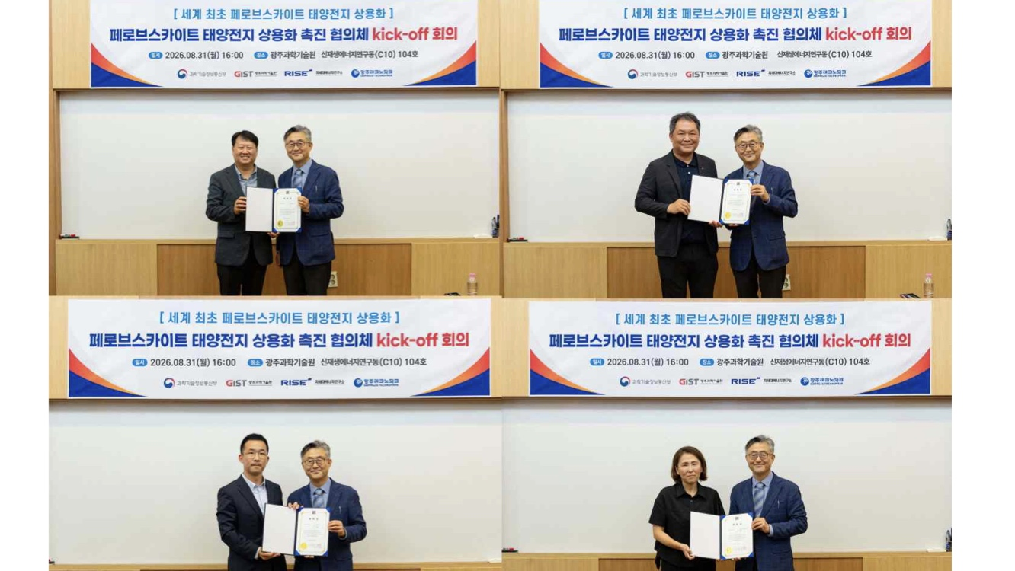

▲ The chairs of the four specialized subcommittees of the ‘Perovskite Solar Cell Commercialization Acceleration Consultative Body’ pose for a commemorative photo with Lee Kwanghee Lee, Head of the Strategic Research Project Group (right in each photo), after receiving their appointment letters. (Pictured on the left in each photo, clockwise from top left): Technology Subcommittee Chair Dong-seok Kim, Certification & Standards Subcommittee Chair Seung-jun Lee, Industrialization Subcommittee Chair Su-jin Moon, and Investment Subcommittee Chair Byung-jun Ahn.
Each subcommittee will initially consist of approximately 5 to 7 members, including a chairperson; the plan is to subsequently expand the consultative body to about 30 members by appointing experts from industry, academia, research institutes, and relevant specialized organizations.
The Technology Subcommittee will address key technical issues regarding commercialization, while the Certification & Standards Subcommittee will focus on testing, evaluation, and standardization strategies. The Industrialization Subcommittee will concentrate on product development, mass production, and market entry, and the Investment Subcommittee will discuss technology commercialization and ways to link it with private investment.
Based on the discussions within each subcommittee, the group plans to formulate specific policy and commercialization tasks aimed at accelerating the commercialization of perovskite solar cells.
Kwanghee Lee, Director of the Strategic Research Project Group, stated, "Solar power plays a crucial role in achieving the goal of deploying 100 GW of renewable energy by 2030—a target set in the government's '1st Basic Plan for Renewable Energy' announced this past May. Therefore, the expansion of deployment must not lead to increased reliance on foreign sources but rather to the growth and strengthened competitiveness of the domestic solar industry." He added, "Through this project, we aim to secure competitiveness in the next-generation solar industry by translating world-class research achievements into domestic technologies, products, and mass production capabilities."
Meanwhile, this strategic research project—funded by the Ministry of Science and ICT with a total budget of 43.7 billion KRW over five years—is led by GIST.
Participating industry, academic, and research institutions—including GIST, ▴ the Ulsan National Institute of Science and Technology (UNIST), ▴ the KEPCO Research Institute, ▴ LEECELL Co., Ltd., ▴ the Korea Institute of Industrial Technology (KITECH), and ▴ Gwangju Technopark—will collaborate to develop various types of high-efficiency, high-stability perovskite solar cell modules and secure the manufacturing process technologies required for large-area fabrication and mass production.
In addition, the goal is to establish domestic and international certification and standardization systems and to build a commercialization foundation that encompasses the entire process—from demonstration and certification to technology transfer, product development, and mass production.

