GIST launches full-scale ‘Honam Region Autonomous R&D’ project worth 13.1 billion won
- MSIT’s ‘4-Pole, 3-Specialty Science & Technology Innovation Support Project’ – Honam Region Pilot Program: Promoting region-specific R&D focused on three key sectors—semiconductors, energy, and mobility—and linking efforts from demonstration to commercialization
- Project briefing session to be held on Friday, September 4, at GIST’s Oryong Hall: Presentation on project direction and specific research tasks, followed by a Q&A session
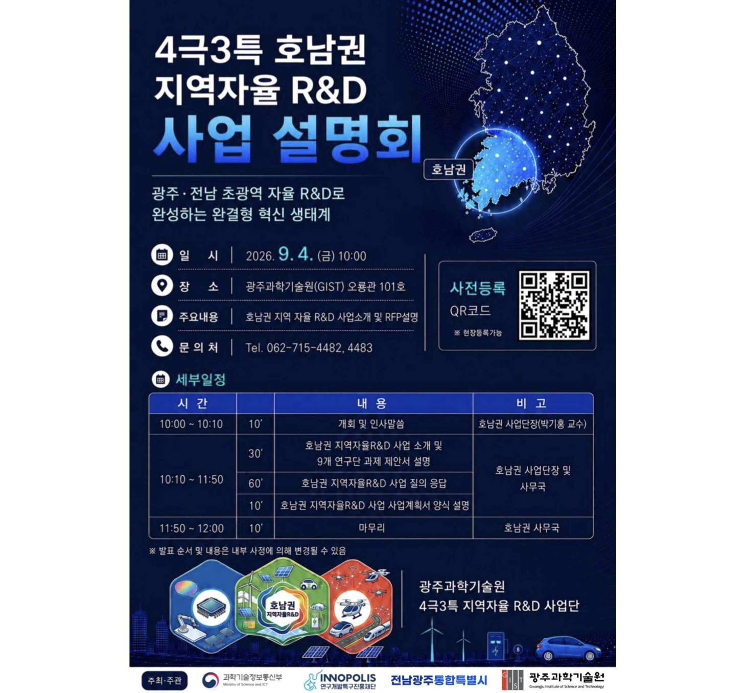

▲ Poster for the ‘2026 Honam Region Autonomous R&D Project Briefing’
The Gwangju Institute of Science and Technology (GIST; President Kichul Lim) announced that the Honam Region Autonomous R&D Project Group (led by Professor Kihong Park of the GIST Department of Environment and Energy Engineering) will hold a briefing session for the ‘2026 Honam Region Autonomous R&D Project’ on Friday, September 4, at 10:00 AM in Room 101 of the GIST Oryong Hall.
The briefing will outline the direction of the ‘Honam Region Autonomous R&D Pilot Project’—which launches this year with a state budget of 13.1 billion KRW—and introduce specific research tasks across three key technology areas. It will also provide essential information on the application process to researchers from industry, academia, and research institutes interested in participating.
The ‘Honam Region Autonomous R&D Project’ is part of the ‘4-Hub, 3-Special Zone Science and Technology Innovation Support Project’ organized by the Ministry of Science and ICT (MSIT). It is designed to empower regions to directly plan and execute R&D projects tailored to their specific needs.
The term ‘4-Hub, 3-Special Zone’ refers to the regional classification established by the MSIT for its innovation support project. It encompasses four major regional hubs—the Central Region (Daejeon, Sejong, Chungbuk, Chungnam), Honam Region (Gwangju-Jeonnam Integrated Special City), Daegu-Gyeongbuk Region, and Southeast Region (Busan, Ulsan, Gyeongnam)—along with three special autonomous regions: Gangwon, Jeonbuk, and Jeju.
Unlike traditional R&D projects led by the central government, this initiative is characterized by its bottom-up approach: identifying research tasks based on local industrial and research capabilities as well as on-the-ground demand, and subsequently linking developed technologies to local demonstration and commercialization. A pilot project is scheduled to launch in 2026, with a full-scale rollout planned for 2027.
The Honam region has selected three key technology sectors: semiconductors (AI and optical semiconductors), energy (renewable energy), and mobility.
In the semiconductor sector, development will focus on technologies such as "advanced packaging and thermal management" to address heat generation caused by the high integration of AI semiconductors, and "high-reliability AI, optical, and power semiconductor technologies" capable of stable operation across diverse industrial environments.
In the energy sector, R&D efforts will center on "Virtual Power Line (VPL) technology"—which enables more efficient use of renewable energy without constructing new transmission lines—as well as sodium-ion battery-based Energy Storage Systems (ESS) and "next-generation clean energy technologies" like green hydrogen and laser nuclear fusion.
In the mobility sector, plans include developing "AI autonomous manufacturing technology" that allows for task switching between different industrial robots; "battery diagnosis and circulation technology" that assesses the condition and remaining lifespan of EV batteries without disassembly; and "AI-based mobility technology" designed to predict and respond to urban traffic, safety, and disaster situations.
These projects aim to translate R&D achievements into regional industrial competitiveness by linking the AI ​​and semiconductor research and design capabilities of the integrated Jeonnam-Gwangju Metropolitan City with its infrastructure for renewable energy and mobility demonstration.
In particular, the initiative will focus on establishing a region-led R&D ecosystem where technologies developed in laboratories are directly validated in local industrial and public settings, facilitating a seamless progression from technical demonstration to commercialization.
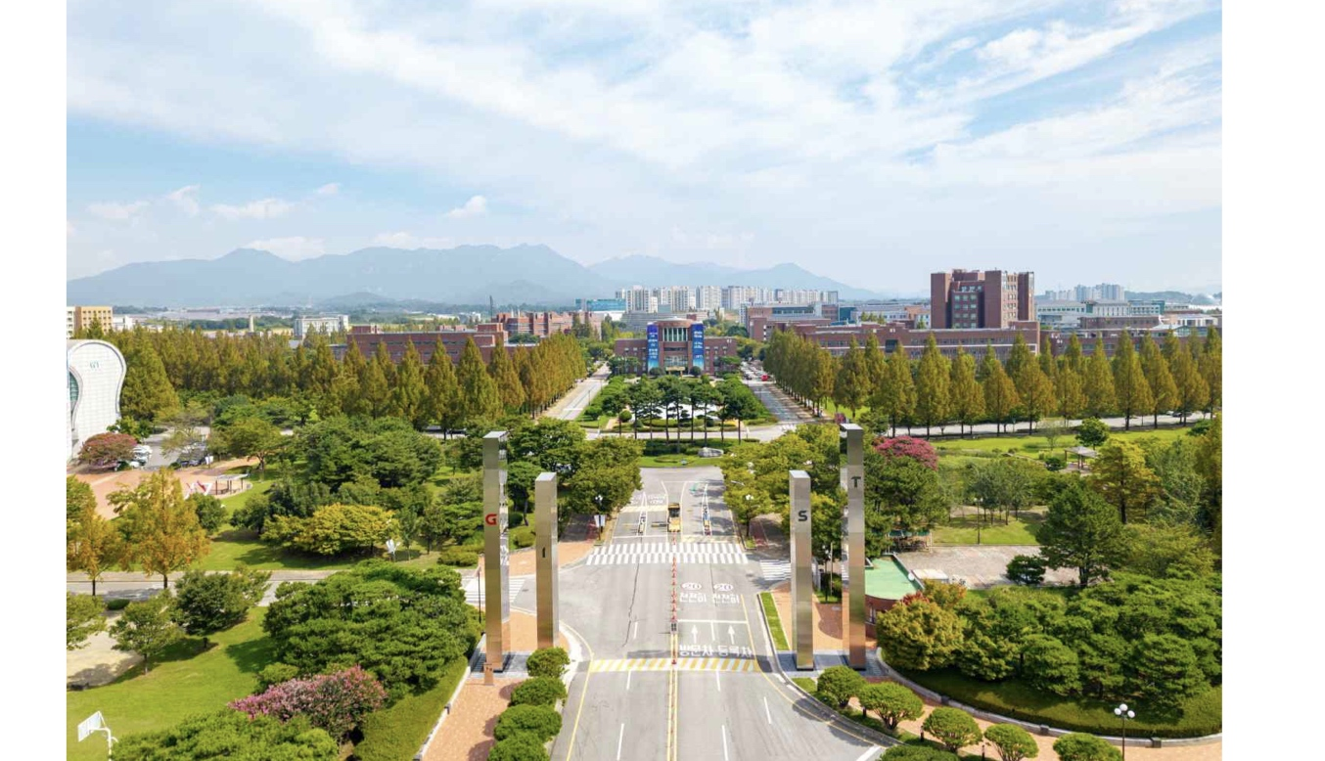

▲ A view of GIST, the venue for the ‘2026 Honam Region Autonomous R&D Project Briefing’
The briefing is open to researchers and officials from industry, academia, and research institutes, as well as representatives from local governments and related organizations. The event will begin with opening remarks by Project Director Kihong Park, followed by an introduction to the Honam Region Autonomous R&D project and an explanation of the Request for Proposals (RFP), a Q&A session, and guidance on project proposal templates and application procedures.
In particular, the one-hour Q&A session aims to provide comprehensive information regarding the details of specific research tasks and the requirements for project participation, including the application and selection processes.
Project Director Kihong Park stated, “This project is highly significant in that local researchers and companies directly identify technologies essential to regional industries and collaborate on the entire process—from R&D to demonstration and commercialization.” He added, “We hope for strong interest and participation from local stakeholders in industry, academia, and research so that we can translate the Honam region’s strengths in AI, semiconductors, renewable energy, and mobility into tangible industrial competitiveness.”
Attendees can register in advance via the QR code on the event poster or register on-site on the day of the event.

