GIST hosts 10th 'Creative Convergence AX-Challenge'... Discovering AI and robotics talent among university students
- 69 students from 15 universities conducted projects in three fields at GIST for two months: Robot AX (building a table tennis robot), Human-AI Interaction (creating experiential AI demos), and AI research
- GIST provided full support for the entire project process, including education, mentoring, equipment, and workspace
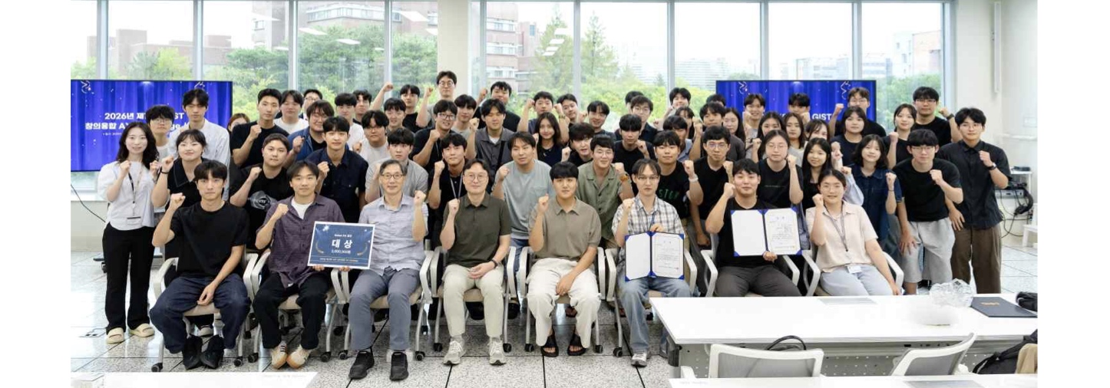

▲ Participants and officials pose for a commemorative photo at the awards ceremony for the ‘2026 10th GIST Creative Convergence AX-Challenge.’ (From the third person from the left in the front row) Track 1 Director Professor Jung Won Yoon of the Department of AI Convergence, Track 2 Director Professor SeungJun Kim, and Track 3 Director Professor Kwanyoung Kim.
The Gwangju Institute of Science and Technology (GIST, President Kichul Lim) announced that it held the ‘2026 10th GIST Creative Convergence AX-Challenge,’ a competition for undergraduate students from domestic universities to test their creative and convergent capabilities in future technology fields such as artificial intelligence (AI) and robotics, and concluded its approximately two-month schedule with an awards ceremony on Wednesday, August 19.
Organized by the GIST Department of AI Convergence (Dean Jongwon Kim), this competition saw 69 undergraduate students from 15 universities participate, carrying out various projects including robot manufacturing, the implementation of Human-AI Interaction (HAI) systems, and AI research.
* AX (AI Transformation): Refers to innovating problem-solving methods and experiences by applying artificial intelligence to various fields.
The ‘GIST Creative Convergence AX-Challenge,’ which began in 2017 and marks its 10th anniversary this year, aims to discover AI convergence talents in diverse fields such as artificial intelligence (AI), intelligent robots, virtual environments, and healthcare.
This year, the event ran from June 22 (Mon) to August 19 (Wed) in three tracks: Track 1: Robot AX Competition, Track 2: Human-AI Interaction Experience Design Competition, and Track 3: AI Research Competition.
Professors Jung Won Yoon, Seung-Jun Kim, and Kwanyoung Kim of the GIST Department of AI Convergence served as the supervising faculty for each track.
Participating students completed track-specific training at GIST and carried out projects under the mentorship of faculty, researchers, and graduate students. GIST provided project workspace, equipment, material costs, and dormitory accommodations, enabling students to focus on development and research for approximately two months.
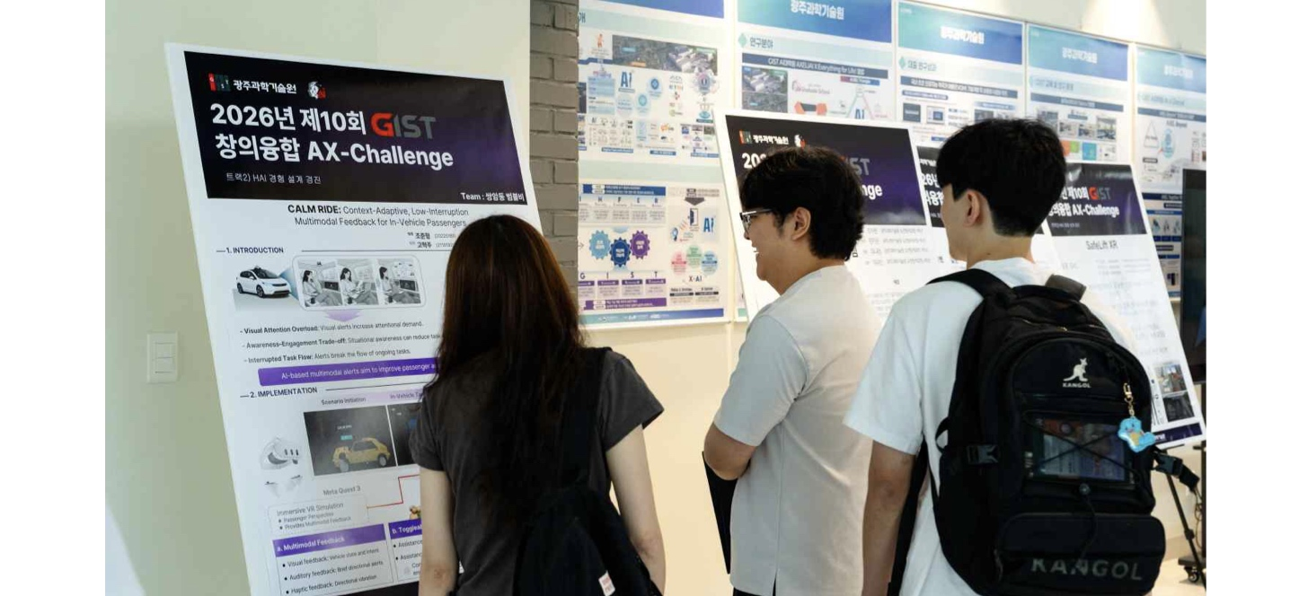

▲ Attendees view research posters from participating teams at the awards ceremony for the ‘2026 10th GIST Creative Convergence AX-Challenge.’
Following approximately two months of training, project execution, and final evaluation, the awards ceremony was held on Wednesday, August 19, at 2:00 PM in the AI ​​Department and TED Hall. Nine teams that advanced to the finals received awards including the Grand Prize, Top Excellence Award, and Excellence Award, while two teams that did not advance to the finals were awarded Encouragement Awards.
The Track 1 Grand Prize team was awarded 3 million won, and the Track 2 Top Excellence Award team was awarded 2 million won in prize money.
In the Track 1 ‘Robot AX Competition,’ participants built table tennis robots based on theoretical education in robot kinematics (an academic field analyzing the movement and structure of robots), AI and computer vision, and system integration.
The completed robots first verified their basic function of hitting balls sent by a table tennis ball launcher, and then competed in actual table tennis matches against humans without remote control; the finals were held on Friday, August 14, by playing a real table tennis match against a human without remote control.
The awards were presented to: ▴ Grand Prize: ‘Gwangju Shin Yubin’ team (students Dong-hyeok Kwak, Geon-hyeong Kim, and Young-taek Lee, 3rd year, Department of Electrical Engineering and Computer Science, GIST); ▴ Top Excellence Award: ‘AI Shin Yubin’ team (student Jun-beom Park, 2nd year, Department of Mechanical and Robotics Engineering, GIST), and students Jang-yeop Jeong and Woo-young Yang (1st year, Challenge & Exploration Program, GIST); ▴ Excellence Award: ‘Love all’ team (student Seung-min Lee, 2nd year, Department of AI Convergence, GIST), students Seong-jin Park and Bo-seong Lee (3rd year, Department of Electrical Engineering and Computer Science, GIST), and student Hyun-seung Ryu (2nd year, Department of Electrical Engineering and Computer Science, GIST); ▴ Bronze Award: ‘Binding of Isaac’ team (students Si-jun Park and Seo-yeon Hong, 1st year, Challenge & Exploration Program, GIST), and student Su-an Lee (2nd year, Department of Mechanical and Robotics Engineering, GIST).
Donghyeok Kwak, a student from the Grand Prize-winning ‘Gwangju Shinyubin’ team, said, “Through this competition, I was able to personally experience the entire process of implementing physical AI by applying computer engineering knowledge to a real physical environment.” He added, “I gained experience in predicting the movement of a ball and controlling a robot to resolve various variables and limitations that arise in real-world environments. I want to continue challenging myself to develop AI convergence technologies that solve real-world problems.”
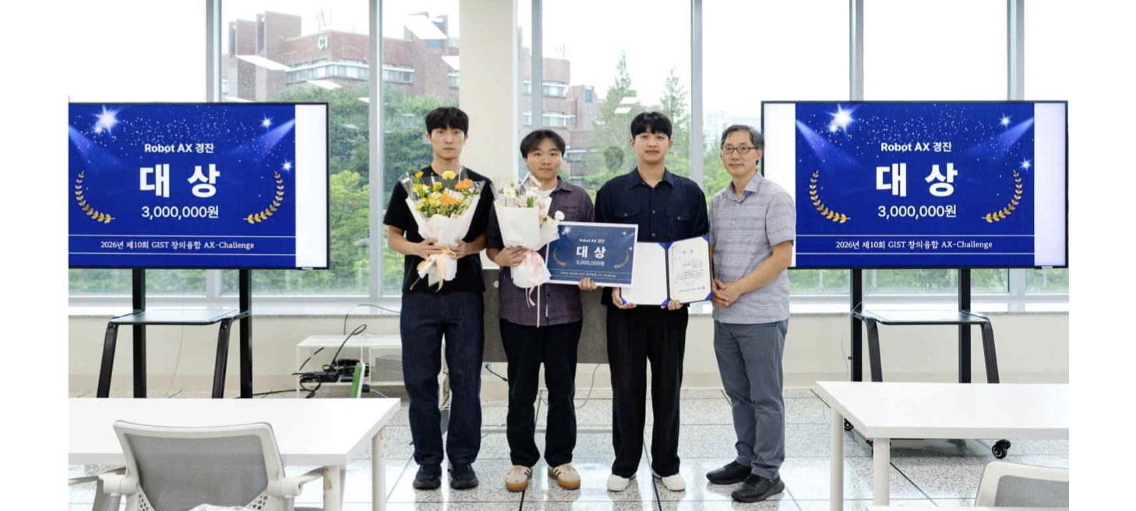

▲ The ‘Gwangju Shinyubin’ team, winners of the Grand Prize in the ‘Track 1 Robot AX Competition’ category, poses for a commemorative photo at the awards ceremony for the ‘2026 10th GIST Creative Convergence AX-Challenge.’ (Right) Professor Jung Won Yoon, Department of AI Convergence, faculty overseeing Track 1.
In the Track 2 ‘Human-AI Interaction (HAI) Experience Design Competition,’ participants received training on the use of equipment such as Head-Mounted Displays (HMDs) and 3D printers. Afterward, they defined potential problems that could arise during the interaction between humans and physical AI systems and implemented solutions using AI through experiential demos.
At the final evaluation held on Friday, August 7, participating teams showcased their directly implemented results through poster presentations and live demos.
In Track 2, the Grand Prize was awarded to the ‘EHC’ team (students Dong-chan Lee, Seong-heum Cho, and Seung-jun Lee, 3rd year students in the School of Computer Science at Hanyang University ERICA) and the Excellence Award to the ‘ARTEMIS’ team (students Dong-woo Kim, 4th year student in the Department of Electrical Engineering and Computer Science at GIST, and Su-young Kim, 4th year student in the Department of Computer Engineering at Daegu University).
Dong-woo Kim, a 4th-year student in the Department of Electrical Engineering and Computer Science at GIST and a member of the Excellence Award-winning ‘ARTEMIS’ team, said, “It was meaningful to have the experience of directly utilizing virtual reality (VR) technology, which is usually difficult to access, to contemplate potential problems that may arise during the interaction between humans and AI, and to implement solutions through actual demos.”
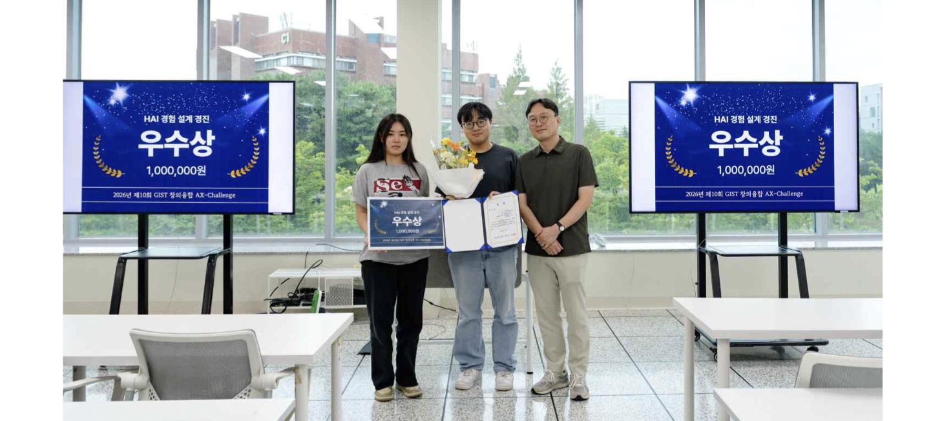

▲ The ‘ARTEMIS’ team, winners of the Excellence Award in the ‘Track 2 Human-AI Interaction (HAI) Experience Design Competition’ category, poses for a commemorative photo at the awards ceremony for the ‘2026 10th GIST Creative Convergence AX-Challenge.’ (Right) Professor SeungJun Kim, faculty overseeing Track 2.
In the Track 3 ‘AI Research Competition (Research Internship),’ participating students engaged in research activities for approximately eight weeks under the guidance of mentor professors at individual GIST laboratories and presented their results as posters.
In Track 3, the Grand Prize was awarded to student Gun-hee Son (4th year, School of Artificial Intelligence, Kongju National University), and the Excellence Awards were given to students Min-ah Kim and Dong-woo Kim (4th year, Department of Electrical Engineering and Computer Science, GIST).
In particular, Min-ah Kim (4th year, Department of Electrical Engineering and Computer Science, GIST), who won the Excellence Award, conducted research in Professor Hyunju Lee’s laboratory at the Department of AI Convergence to improve a deep learning model that predicts the binding affinity between proteins and ligands used in new drug development.
Student Min-ah Kim said, “It was fun to analyze the limitations of existing models, design a model to complement them, and test it myself.” She added, “The process of analyzing the experimental results to identify the model’s limitations and directions for future improvement was a meaningful research experience in itself.” She further stated, “Taking this competition as an opportunity, I plan to continue my research in Professor Lee Hyun-ju’s lab.”
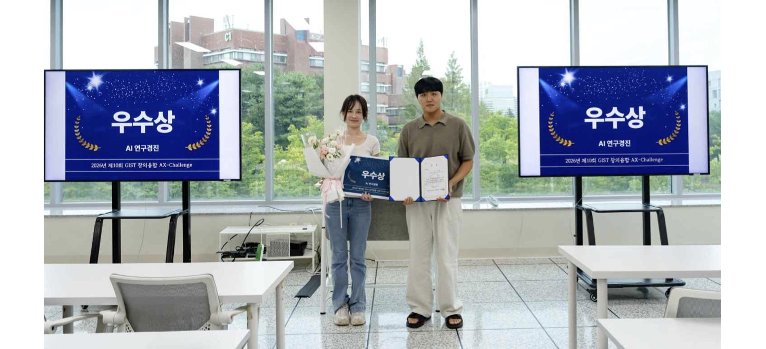

▲ Student Min-ah Kim (4th year, Department of Electrical Engineering and Computer Science, GIST), who won the Excellence Award in the ‘Track 3 AI Research Competition (Research Intern)’ category at the ‘2026 10th GIST Creative Convergence AX-Challenge’ awards ceremony, poses for a commemorative photo. (Right) Professor Kwanyoung Kim, faculty overseeing Track 3.
Jongwon Kim, Head of the AI ​​Department at GIST, said, “In this 10th competition, new attempts were made to address various interactions between humans, robots, and AI models based on ‘D·N·A (Data (D), Networking (N), and Artificial Intelligence (A)).’ We will continue to discover practical convergence talents equipped with the creativity and problem-solving skills needed for the AX era and provide a platform for them to directly implement various ideas.”

