GIST Research Institute for Solar and Sustainable Energies expands research scope to 8 research centers… Launches 'Energy Harvesting Research Center'
- Opening of 8th research center under affiliation… Developing ‘self-reliant distributed power’ technology to recover and utilize wasted energy
- Holding first integrated workshop for 8 centers to fully launch cooperation in energy technology convergence, demonstration, and commercialization
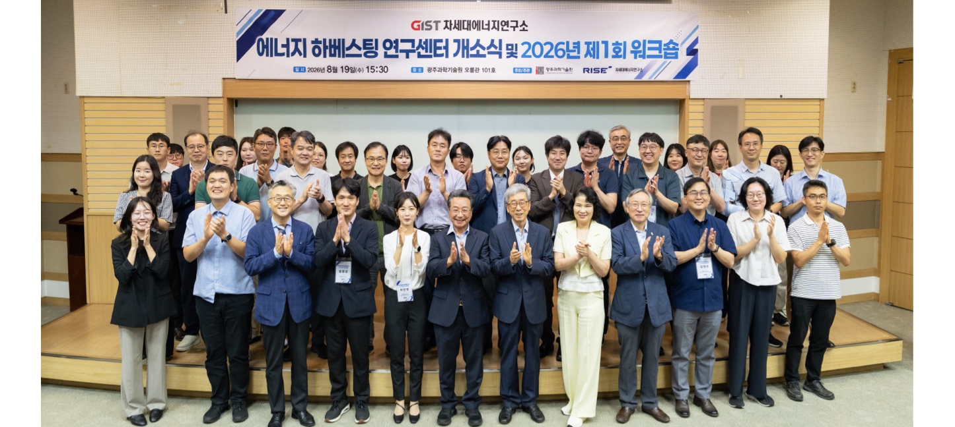

▲ Attendees pose for a commemorative photo at the opening ceremony of the GIST ‘Energy Harvesting Research Center.’ (From the third person from the left in the first row) Kwanghee Lee, Director of the Energy Valley Institute of Technology; KwangSup Eom, Director of the Research Institute for Solar and Sustainable Energies; Minjeong Ha, Director of the Energy Harvesting Research Center; Yong-guk Choi, Chairman of the 1.5℃ Forum; Seung-Hyeon Moon, Visiting Scholar of the Department of Environment and Energy Engineering; Seo-yeon Park, Team Leader of the Energy Industry Division of Gwangju Metropolitan City; and Young-jip Kim, Chairman of the Asia Science Park Association.
The Gwangju Institute of Science and Technology (GIST, President Kichul Lim) announced that on August 19 (Wednesday), it launched the ‘Energy Harvesting Research Center’ (Director Minjeong Ha, Professor of Materials Science and Engineering), the eighth research center under the Research Institute for Solar and Sustainable Energies, at the GIST Oryong Hall. During this occasion, the institute also held the ‘2026 1st Next Generation Energy Research Institute Workshop,’ bringing together all eight research centers.
The event consisted of the opening ceremony of the Energy Harvesting Research Center, followed by the first integrated workshop among research centers under the Research Institute for Solar and Sustainable Energies. Approximately 100 people attended, including GIST professors, students, and researchers, as well as officials from local governments, public institutions, research institutes, and companies.
The event began with a welcome address by KwangSup Eom, Director of the Research Institute for Solar and Sustainable Energies, followed by congratulatory remarks from Yong-guk Choi, Chairman of the 1.5℃ Forum; Young-jip Kim, Chairman of the Asia Science Park Association; and Seo-yeon Park, Team Leader of the Energy Industry Division of the Jeonnam-Gwangju Integrated Metropolitan City. This was followed by a presentation by Center Director Minjeong Ha on the center's vision and plans for research and demonstration, an unveiling ceremony for the plaque, and finally, the Next Generation Energy Research Institute workshop.
The GIST Research Institute for Solar and Sustainable Energies has established the ‘Energy Harvesting Research Center’ as its eighth affiliated research center to expand its research scope into future self-reliant energy technologies.
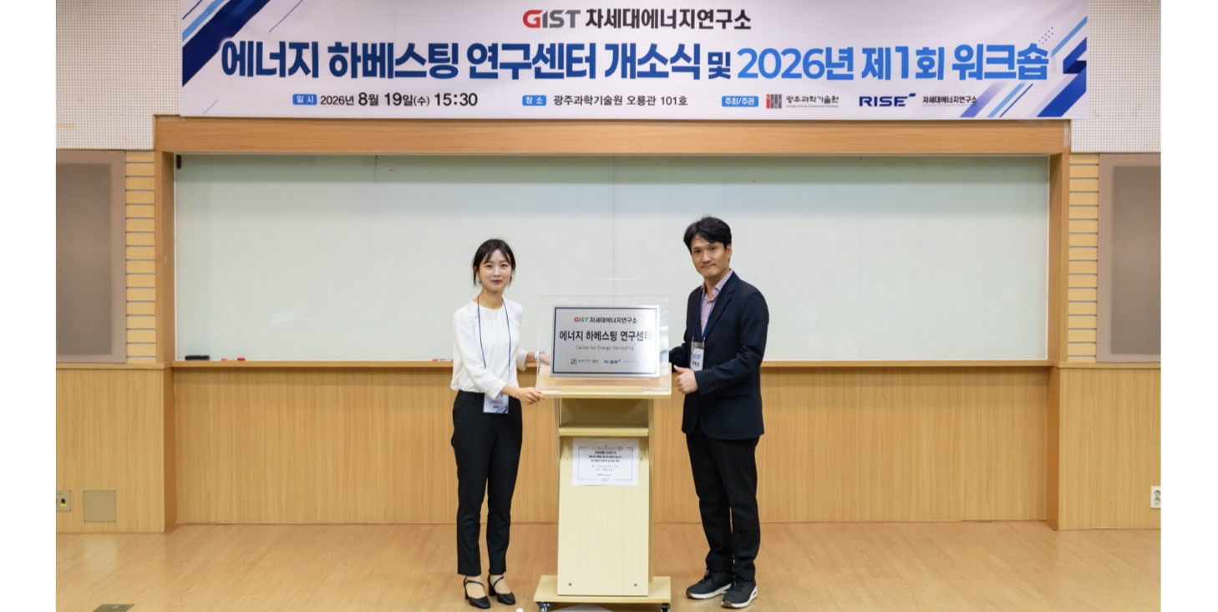

▲ At the opening ceremony of the GIST ‘Energy Harvesting Research Center,’ Center Director Minjeong Ha (left) and Research Institute for Solar and Sustainable Energies Director KwangSup Eom (right) pose for a commemorative photo in front of the signboard.
‘Energy Harvesting’ is a technology that collects energy such as vibrations, heat, light, and electromagnetic waves—which are wasted in daily life and industrial settings—and converts it into electrical energy.
Through this, the Research Institute for Solar and Sustainable Energies plans to expand its research scope beyond the existing focus on energy production, transportation, and storage to the field of ‘self-reliant distributed power,’ which involves recovering wasted energy from the surroundings to independently produce and utilize electricity where needed.
The Energy Harvesting Research Center plans to develop material and device technologies that convert various surrounding energies into electricity and apply them to self-generating sensors, wearable devices, and robots.
The center includes Director Minjeong Ha, Professors Gun-Young Jung and Haneol Lee from the Department of Materials Science and Engineering, Professor Jongho Lee from the Department of Mechanical and Robotics Engineering, and Professor Chanho Pak from the Department of Chemistry.
Director Minjeong Ha stated, “We will organically connect GIST’s research capabilities in the fields of materials, devices, mechanics, and AI, centering on the Energy Harvesting Research Center, and continuously discover new energy technologies and potential applications through interdisciplinary convergence.”
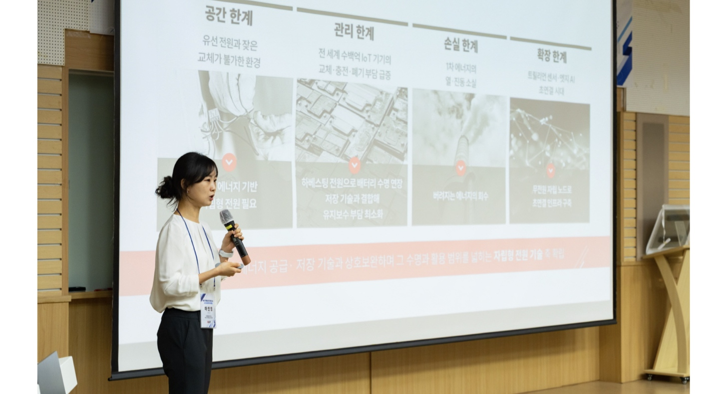

▲ Minjeong Ha, Director of the GIST ‘Energy Harvesting’ Center, presents the center’s vision and plans for research and demonstration at the opening ceremony.
At the ‘2026 1st Next Generation Energy Research Institute Workshop,’ held following the opening ceremony, the eight research centers, which had been launched by sector, gathered in one place for the first time to share their key research areas and future directions.
At the workshop, Seung-Hyeon Moon, a Visiting Scholar in the Department of Environment and Energy Engineering who served as the inaugural director of the Research Institute for Solar and Sustainable Energies, delivered a congratulatory address. This was followed by congratulatory remarks from Vice Vice President for R&DB Yong-Chul Kim and Director Kwanghee Lee of the Energy Valley Institute of Technology; KwangSup Eom, Director of the Research Institute for Solar and Sustainable Energies. Director KwangSup Eom presented the institute's operational direction and mid-to-long-term vision.
The participating centers consist of eight institutions: ▴ the Power Grid Research Center (Director Yun-Su Kim), ▴ the Battery and Electrochemistry Research Center (Director Sangryun Kim), ▴ the Hydrogen and Photoelectrochemical Energy Transition Research Center (Director Sanghan Lee), ▴ the Solar Photovoltaic and Photoenergy Systems Research Center (Director Hee Joo Kim), ▴ the AI ​​Energy Materials Analysis Center (Director Su-young Jang), ▴ the Thermal Energy Utilization Technology Research Center (Director Seunghyun Lee), ▴ the Wind Power Research Center (Director Taeseong Kim), and the Energy Harvesting Research Center, which was newly launched on this day.
This workshop went beyond merely sharing the research fields of each center; it also discussed the potential for convergence research linking different energy technologies and the promotion of joint projects.
In particular, the participating institutions shared the research fields and technologies of each center and explored future cooperation strategies, including joint research, technology demonstration, joint planning of national R&D projects, and technology commercialization.
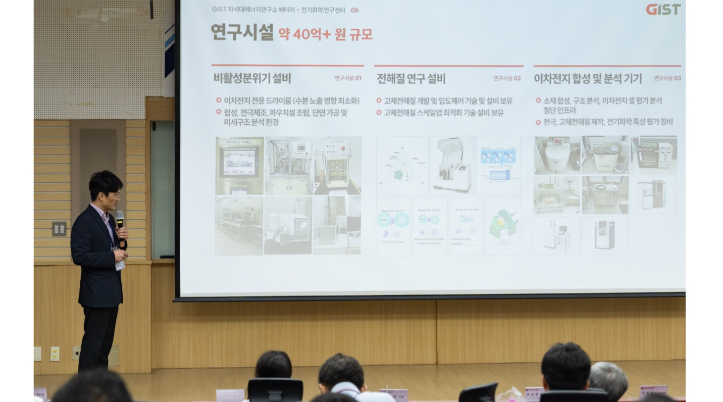

▲ Director KwangSup Eom of the GIST Research Institute for Solar and Sustainable Energies is presenting the institute's operational direction and mid-to-long-term vision at the "1st Institute of Next-Generation Energy Workshop of 2026."
Director Um stated, "The launch of the Energy Harvesting Research Center has significantly expanded the institute's scope of next-generation energy research." He added, "Starting with this first workshop, we will expand research exchanges among the eight research centers and collaborate with local governments, public institutions, research institutes, and companies to develop into a central hub for next-generation energy research and cooperation, leading to joint research, demonstration, commercialization, and national R&D projects."
Meanwhile, Director Minjeong Ha, who leads the Energy Harvesting Research Center, has been researching the field of energy harvesting-based self-generating sensors. In recognition of her related research achievements, she received a commendation from the Minister of Science and ICT in 2024.

