GIST connects lab technology to startups… '2026 TeX-Corps' validates domestic and international markets
- As part of the Ministry of Science and ICT’s ‘2026 Public Technology-Based Market-Linked Startup Exploration Support Project,’ GIST’s ‘Honam Region Lab Startup Innovation Group’ discovered nine teams and verified market demand by meeting with domestic and international customers
- Business models and market entry strategies were refined through activities such as conducting 289 interviews in the U.S.… The exploration teams, having completed market exploration training, have entered the startup incubation phase based on customer demand and market verification results
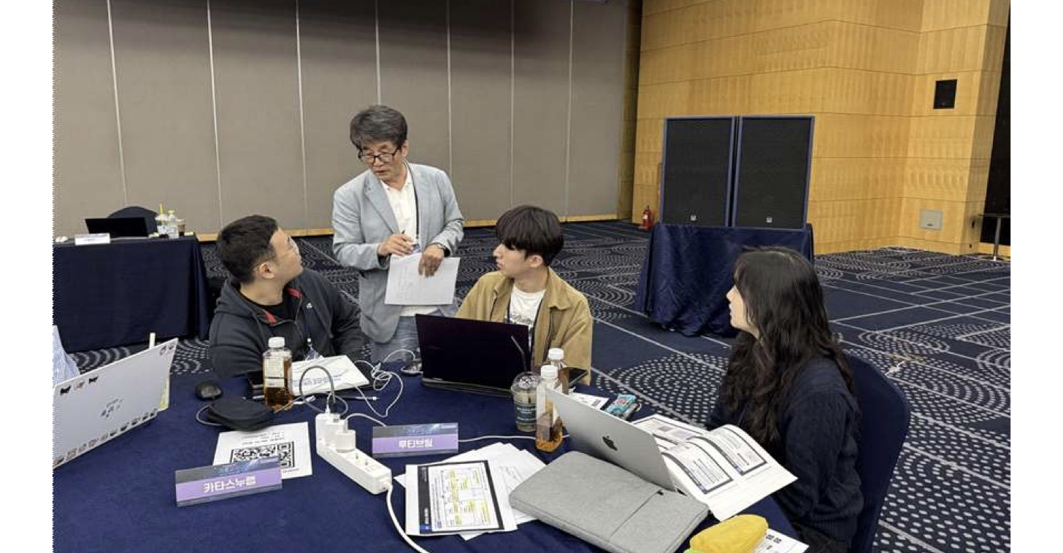

▲ Participants of the ‘GIST Laboratory Startup Exploration Teams’ are participating in domestic basic training.
The Gwangju Institute of Science and Technology (GIST, President Kichul Lim) announced that the Startup Innovation Strategy Center (Director Jae Gwan Kim) has operated a step-by-step startup education program to verify the startup potential of technologies developed in laboratories in the actual market through the ‘2026 Public Technology-Based Market-Linked Startup Exploration Support Project (TeX-Corps).’
GIST selected nine ‘Laboratory Startup Exploration Teams’ (hereinafter ‘Exploration Teams’) this year to prepare for startups based on their research achievements. After receiving basic training and expert mentoring since April, these teams participated in domestic and overseas practical training in July to meet potential customers in person and confirm demand for their technologies and business potential.
Based on customer feedback obtained during the market verification process, the Exploration Teams plan to continue preparing for actual startups by receiving follow-up support, such as prototype production and mentoring.
The ‘Public Technology-Based Market-Linked Startup Exploration Support Program’ is a project organized by the Ministry of Science and ICT and managed by the Korea Science and Technology Commercialization Agency (COMPA). Its goal is to validate public research outcomes from universities and government-funded research institutes in the market and link them to laboratory-based startups.
Following the selection of exploration teams, the program proceeds through the following stages: ▴ market exploration training, ▴ startup incubation, ▴ completion ceremony, and ▴ dissemination of results.
There are currently 14 Laboratory Startup Innovation Centers* operating nationwide, among which GIST operates the Honam Region Laboratory Startup Innovation Center. GIST supports local laboratory-based startups over five years, from 2026 to 2030, with a total project budget of 7.5 billion KRW.
* 14 Laboratory Startup Innovation Groups Nationwide: 5 in the Capital Region (Konkuk University, Korea University, Sungkyunkwan University, Chung-Ang University, Hanyang University), 2 in the Chungcheong Region (Chungbuk National University, KAIST), 1 in the Daegu-Gyeongbuk Region (POSTECH), 2 in the Honam Region (GIST, Wonkwang University), 2 in the Southeast Region (Gyeongsang National University, UNIST), 1 Women-Specialized Group (Ewha Womans University), and 1 Government-funded Research Institute-Specialized Group (Korea Science and Technology Holdings (KST)).
Starting with an inauguration ceremony held at COEX in Seoul last April, the GIST exploration teams participated in the first stage, "Market Exploration Training," through July.
Market Exploration Training is a process that first verifies whether actual customers need the technology or product, rather than turning the technology into a product first. It consists of: ▴ basic education; ▴ "Pretotype Training," which verifies customer demand in advance of actual product development; and ▴ domestic and overseas practical training.
The exploration teams mastered business model establishment, customer scouting, and interview methodologies, and refined their methods for identifying and analyzing customer demand through expert mentoring.
Based on this foundation, in July, the teams were divided into "Domestic Education" and "Overseas Education" groups based on their target markets for commercialization, and set out to meet actual potential customers to validate the market.
Three teams from GIST participated in the Domestic Education group. Starting with group training held in Daejeon, the participating teams verified domestic market demand and business potential through online training and interviews with potential customers and industry stakeholders.
Based on the actual market demands identified in customer interviews, the teams modified and supplemented their target customers and business models; some teams also performed pivoting, shifting their business direction based on the validation results.
Hyun-woo Park, Exploration Team Leader (integrated master's and doctoral program in AI) of the ‘Itda Voice’ team (developing an AI streaming voice service that enables conversation without waiting), who participated in the domestic educational program, said, “Before meeting customers in person, I thought that we could gain recognition in the market by only emphasizing the advantages of the technology,” adding, “Through this training, I was able to identify what value customers actually want and objectively review the direction of the business.”
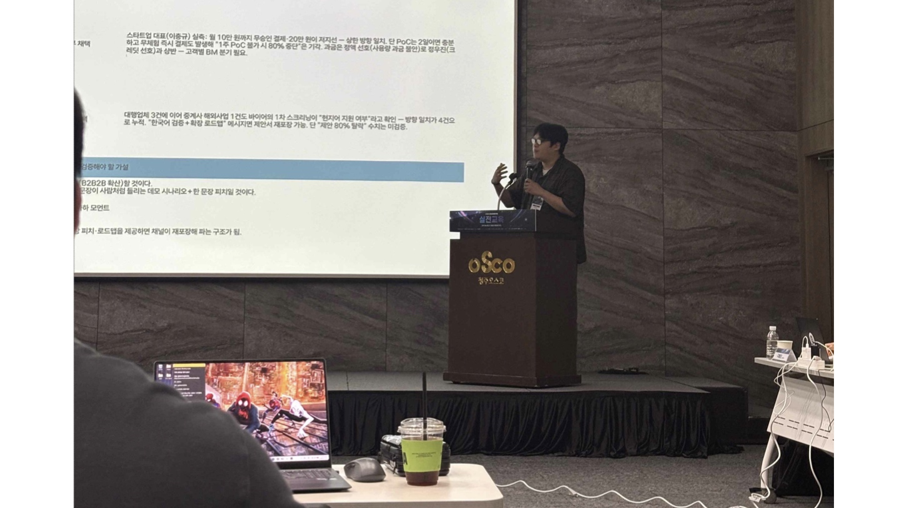

▲ The ‘Itda Voice’ team, participating in the domestic educational market exploration program, is presenting the results of market validation and future commercialization directions during the final presentation of the domestic practical training.
Six teams from the GIST Honam Region Innovation Group for Laboratory Startups participated in the ‘Overseas Educational Program,’ conducting local market validation at the University of California, Berkeley (UC Berkeley) for three weeks.
The participating teams met directly with potential customers in the Business-to-Business (B2B) and Business-to-Consumer (B2C) sectors in the San Francisco and Berkeley areas, conducting a total of 289 interviews.
Through this process, they identified local customer demands and market characteristics, and refined their business models and market entry strategies by incorporating feedback from experts.
Yeon-ju Kim, a third-year student in the Department of Electrical Engineering and Computer Science and a member of the ‘Lutiv’ team (developing an integrated home gardening platform application for home gardening beginners struggling with plant care) who participated in the overseas educational program, said, “I thought that having technical skills was enough to compete overseas, but by meeting local customers in person, I learned that it is important to understand market entry conditions, such as certifications, regulations, and distribution structures, in addition to technical skills.” She added, “Through this training, I was able to realistically assess the potential for global commercialization and concretize market entry strategies.”
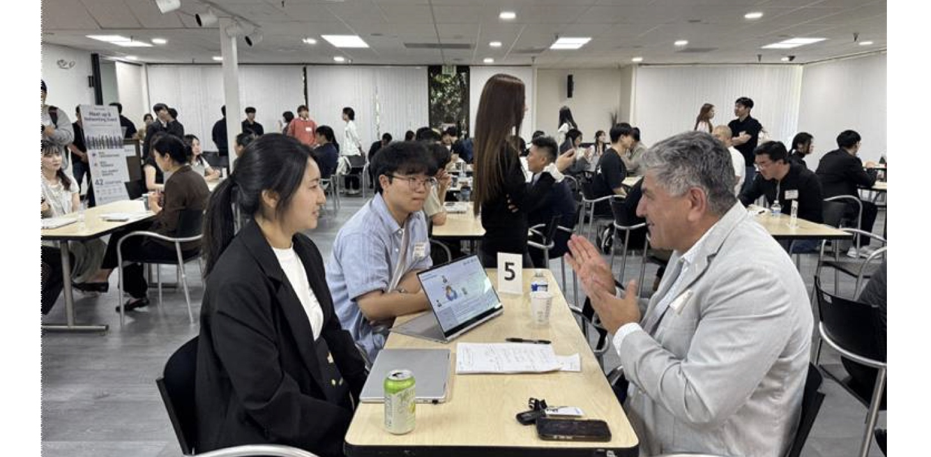

▲ Participants of the ‘GIST Laboratory Startup Exploration Team’ are receiving mentoring on business models and market entry strategies from local U.S. experts.
Having completed the market exploration training, the exploration teams are now entering the next stage: ‘startup incubation.’ GIST plans to support the teams in concretizing their commercialization potential by incorporating the customer demand and market validation results identified during this training into their startup items and business plans.
In particular, this initiative is significant in that it is a market-oriented startup exploration process that goes beyond merely explaining the excellence of technology developed in the laboratory; instead, it first identifies actual customer problems and market demands, modifies and validates business models based on those results, and ultimately develops them into actual startups.
Jae Gwan Kim, Director of the GIST Startup Innovation Strategy Center (Professor of Biomedical Engineering and Co-CEO of TeddyMedi Co., Ltd.), stated, “This training program was a meaningful process that validated excellent technologies developed in laboratories from the perspective of domestic and international markets and developed business models based on the voices of actual customers.” He added, “I hope that the customer interview experience and expert networks accumulated by the participating teams during the program will serve as a solid foundation for future technology startups and market entry.”
He continued, “GIST will continue to strengthen its comprehensive startup support system covering the entire cycle—including market validation, entrepreneurship education, expert mentoring, and investment linkages—to ensure that outstanding research achievements can extend beyond the laboratory to lead to successful technology startups.”
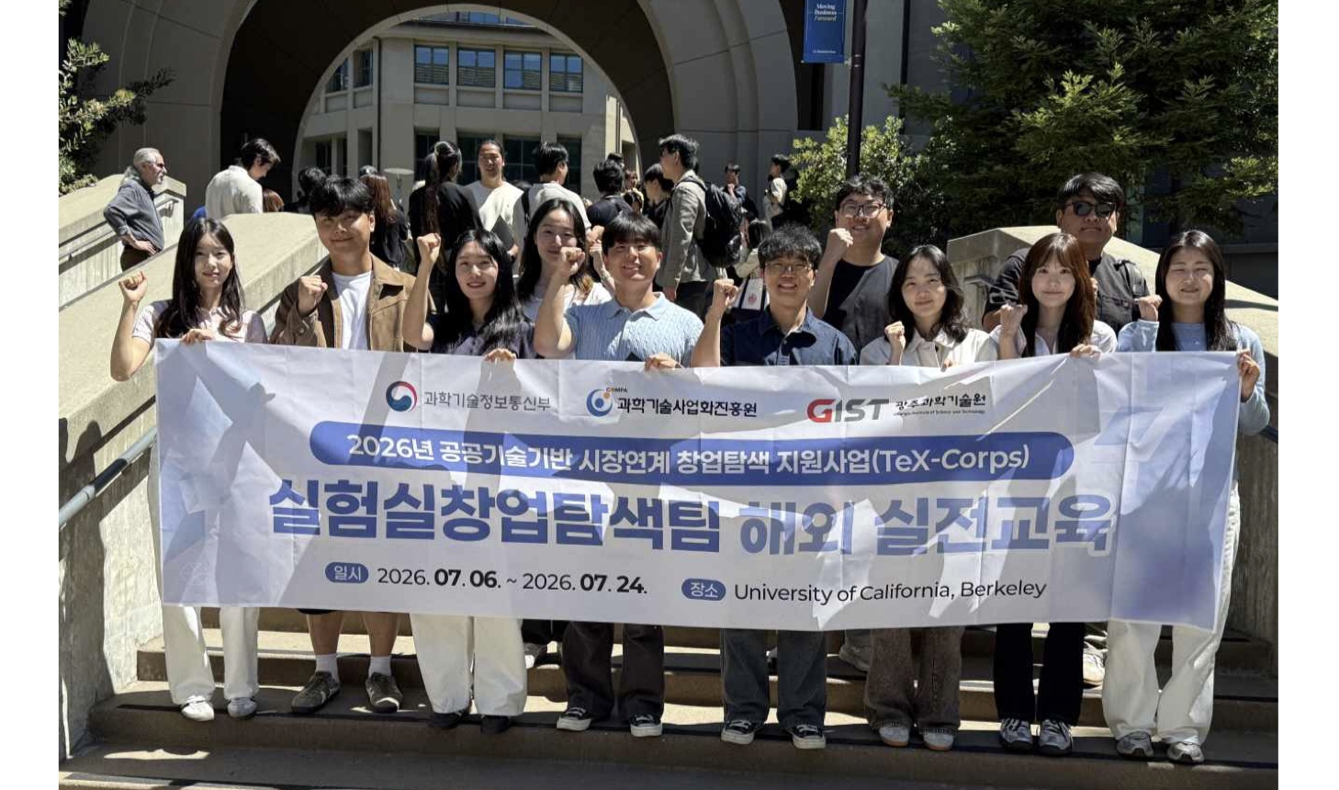

▲ Participants of the ‘GIST Laboratory Startup Exploration Team’ pose for a commemorative photo after completing the overseas practical training held at the University of California, Berkeley (UC Berkeley).

