“From doctors treating patients to disease researchers” GIST to hold commencement ceremony in second half of 2026… 198 graduates embrace ‘individual questions’ as they embrace new paths
- A total of 198 graduates, including 63 PhDs, received their degrees on Thursday, the 20th, at 11:00 AM… From pediatric specialists in Vietnam to university professors, those pursuing overseas graduate studies, and entrepreneurs, they are pioneering their futures through their own individual challenges.
- 63 PhDs published 278 papers in SCI-indexed international journals… An average of 4.34 research papers per person.
- President Kichul Lim emphasized the value of ‘good questions,’ stating, “You must ask what the real problem is and find your own answer.”
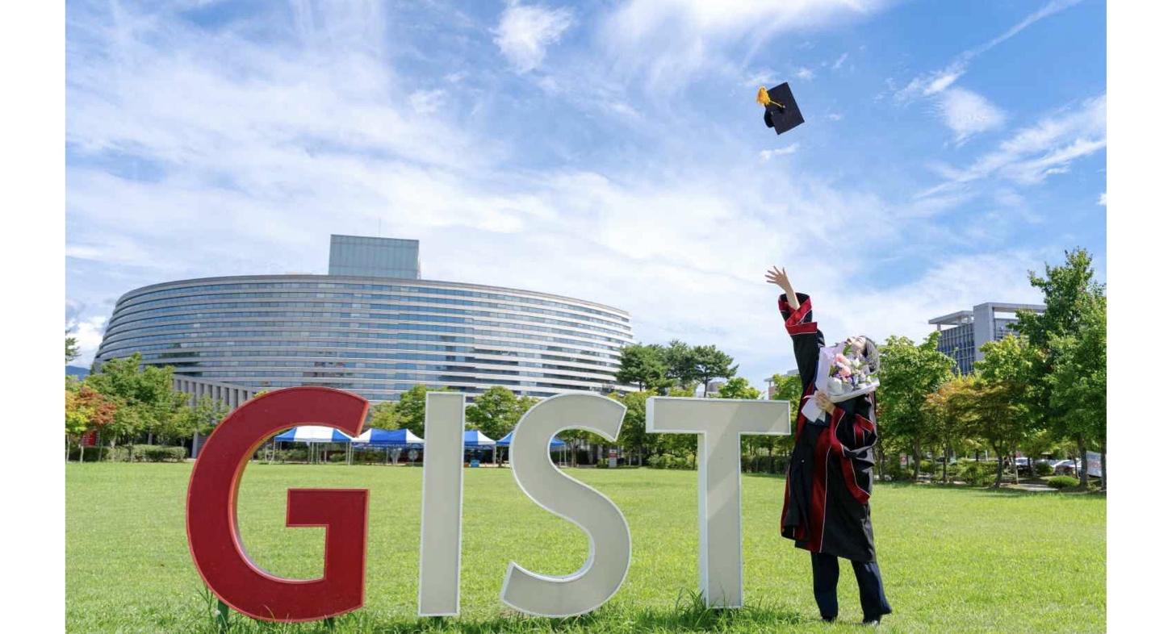

▲ GIST graduates pose for a commemorative photo at the 2026 second-half degree conferment ceremony.
The Gwangju Institute of Science and Technology (GIST, President Kichul Lim) announced that it held the ‘2026 Second-Half Degree Conferment Ceremony’ at 11:00 AM on Thursday, August 20, at the Oryong Hall Auditorium, and conferred degrees upon a total of 198 graduates, including 63 doctorates, 79 master’s degrees, and 56 bachelor’s degrees.
With this, the total number of science and technology talents produced by GIST since its establishment in 1993 has reached 9,364, comprising 2,228 doctorates, 5,480 master’s degrees, and 1,656 bachelor’s degrees.
At this graduation ceremony, the stories of graduates who pioneered new paths through their own questions and challenges drew attention, ranging from a graduate who chose the path of a researcher to uncover the root causes of diseases after treating patients as a pediatrician for over 10 years, to a student who achieved world-class research results while still an undergraduate and is advancing to graduate school abroad, and an entrepreneur who connected research achievements to startups and technology commercialization.
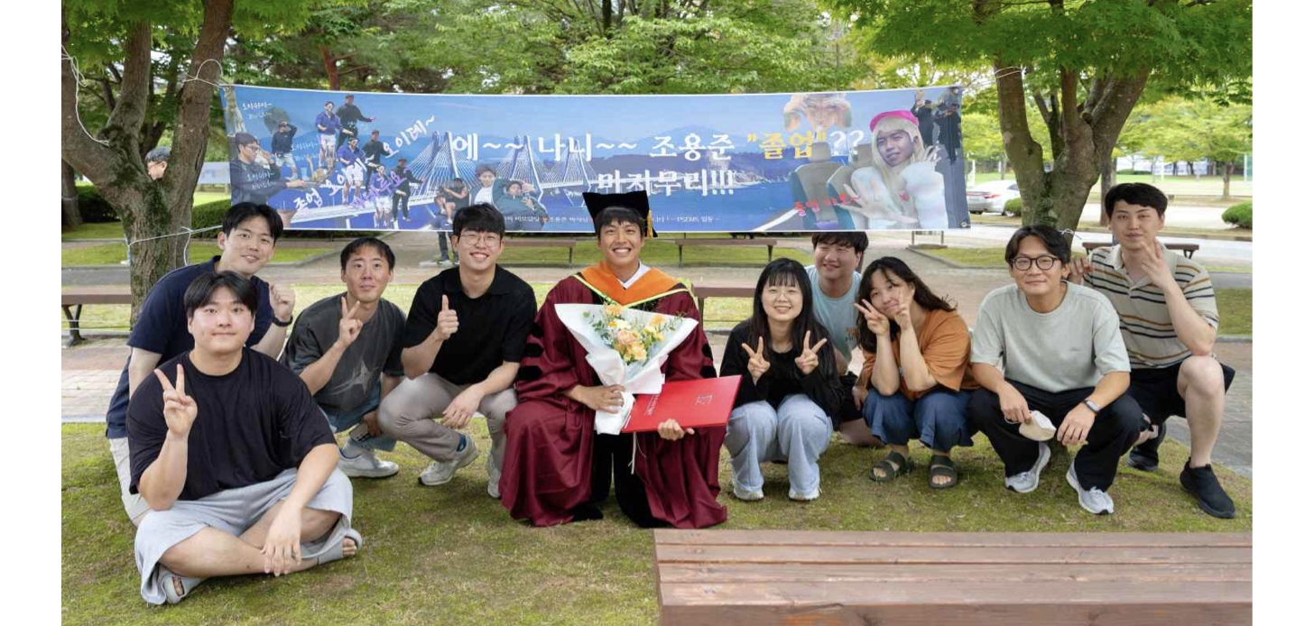

▲ A graduate poses for a commemorative photo with lab colleagues at the second-half 2026 degree conferment ceremony.
Dr. Nguyen Trong Thanh of the Department of Biomedical Science & Engineering conducted research on skeletal muscle biology, aging, metabolism, and molecular medicine at GIST, building upon his experience as a clinician in pediatric endocrinology at the Vietnam National Children's Hospital.
Notably, a paper published in the international journal Experimental & Molecular Medicine was selected as a "Highly Cited Paper" by the Web of Science, an academic information analysis agency. Based on this achievement, he received the Outstanding Research Award at the degree conferment ceremony. Furthermore, he contributed to the signing of a memorandum of understanding between GIST and the Vietnam National Children's Hospital, striving to expand medical and research exchanges between the two institutions.
Dr. Nguyen stated, “As a pediatrician, I encountered questions in the clinical setting that were difficult to answer immediately, and these questions served as the impetus for me to start my research.” He added, “At GIST, I grew as a physician-scientist by learning how to expand clinical questions into laboratory research to explore the mechanisms of diseases. I wish to continue conducting research that connects medicine and science to ultimately benefit patients and society.”
Dr. Nguyen and the other 63 doctoral degree recipients achieved significant research results during their studies, publishing a total of 278 papers in SCI (Science Citation Index) level international journals, with an average of 4.34 papers published per person.
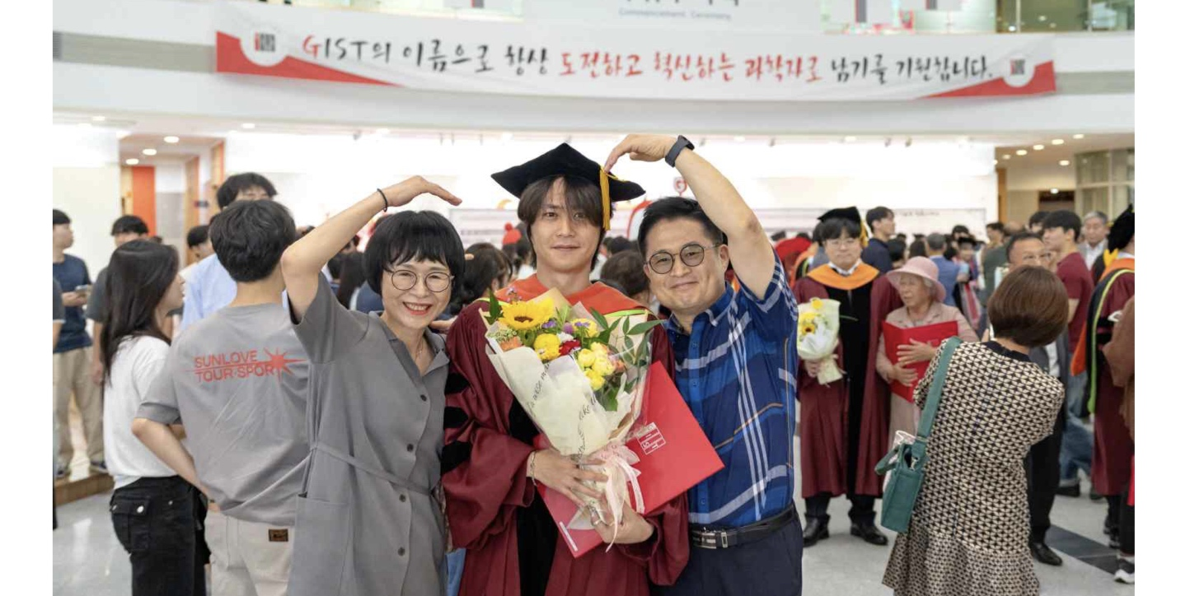

▲ Graduates and their parents are taking a commemorative photo at the second-half 2026 degree conferment ceremony.
There are graduates who achieved world-class research results while still undergraduates and went on to graduate school abroad, as well as those who expanded the boundaries of their majors while practicing learning and sharing.
Geon-woo Jo, a graduate of the Department of Electrical Engineering & Computer Science, published two first-author papers at ‘ICLR 2026,’ the premier international conference in the field of artificial intelligence (AI), while still an undergraduate, and filed three patents related to his research. After graduation, he plans to continue his research by enrolling in the integrated master's and doctoral program at the University of Michigan in the United States.
He also devoted himself to activities that shared his experiences and helped juniors grow, such as holding study abroad information sessions for current students to share his own preparation experiences with them.
Jeong-eun Choi, a graduate of the same department, cultivated her convergence capabilities by majoring in Electrical Engineering & Computer Science while completing minors in Physics & Photon Science and Materials Science & Engineering.
She practiced sharing and volunteering by consistently participating in various activities, such as the GIST student social contribution group ‘Pium’ and the ‘International Freshman Buddy Program’ which helps international freshmen adapt to school life.
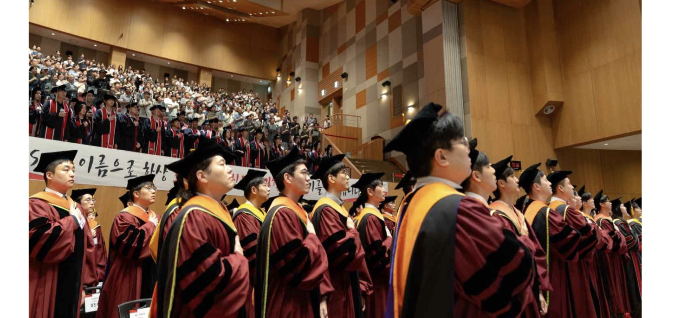

▲ GIST is holding its 2026 Fall Semester Degree Conferment Ceremony at the Oryong Hall Auditorium at 11:00 AM on Friday, August 20.
Dr. Seong-ha Lee of the Department of AI received the GIST Foundation Chairman's Award in recognition of his innovative challenges in connecting research achievements to startups and technology commercialization.
Dr. Lee built his entrepreneurial capabilities by participating in various startup support programs at GIST while still a student, and founded Altrue Co., Ltd., an AI technology-based startup, in 2024.
Since then, through industry-academia collaborative research, he has connected his research achievements to actual business, such as developing an "Automatic Spectator System" that uses AI to analyze e-sports match situations in real time and automatically select the broadcast screen. He has also laid the foundation for technology commercialization by registering two domestic patents and one U.S. patent.
At the degree conferment ceremony, Eun-mo Choi, Chairman of the GIST Foundation, and Cheol-woong Jeong, Director of the ADC Research Institute at Ligachem Bio, delivered congratulatory remarks to celebrate the graduates' new beginnings.
Director Cheol-woong Jeong, who received his master's and doctoral degrees from the Department of Life Sciences at GIST and is currently leading research and development in the global new drug development field, said, “Science and technology that embraces a warm perspective and social responsibility is the most powerful competitive edge we need in the AI ​​era,” and urged junior graduates to continue research that benefits more people.
Director Jeong supported the challenges of junior researchers by donating a total of 100 million won in development funds in January of this year, with 50 million won each going to the Department of Life Sciences and the Department of Chemistry at GIST.
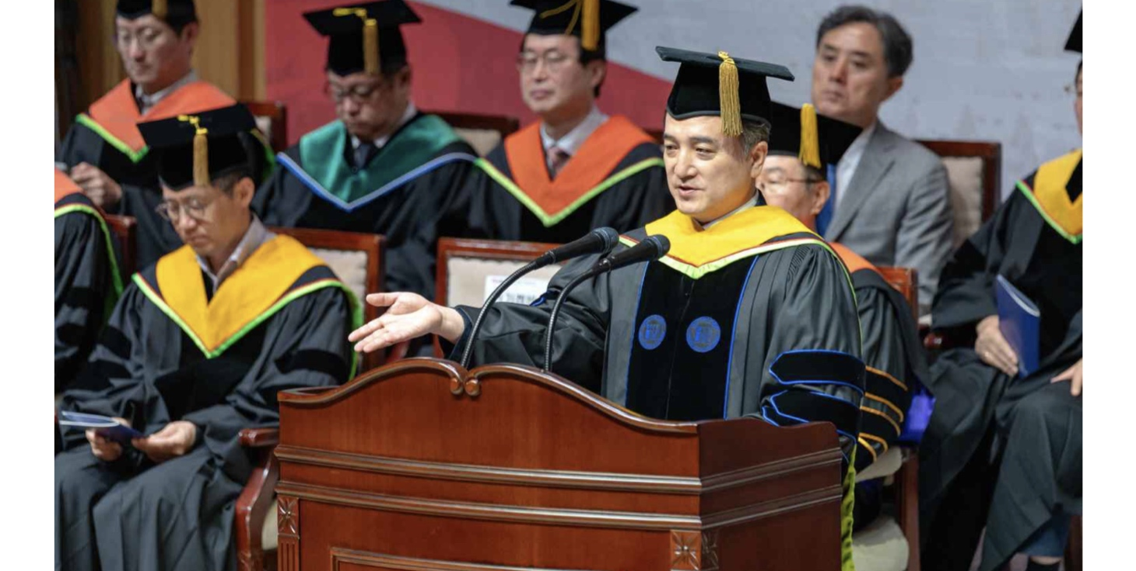

▲ Cheol-woong Jeong, Director of the ADC Research Institute at Ligachem Bio, delivers a congratulatory speech at the GIST 2026 Fall Commencement Ceremony.
In his address, President Kichul Lim urged the graduates to build a better society and a better future for humanity by constantly questioning what constitutes a true problem and finding their own answers, based on the power of "good questions" learned at GIST.
President Lim emphasized the importance of responsibility and values ​​in determining the direction of science and technology, stating, "Innovation does not begin with creating new technology, but with discovering new questions, and good questions stem from a deep understanding and empathy for people and society."
He continued, “Science and technology, businesses, and all sectors of society can only truly have meaning when they are ultimately directed toward people,” adding, “I hope you will utilize your knowledge and capabilities to build a better society and a better future for humanity, going beyond your own personal success.”
Meanwhile, GIST is innovating its education and research systems and strengthening its research capabilities in future strategic fields in line with the “role of universities in the transition period of AI civilization” that President Kichul Lim has emphasized.
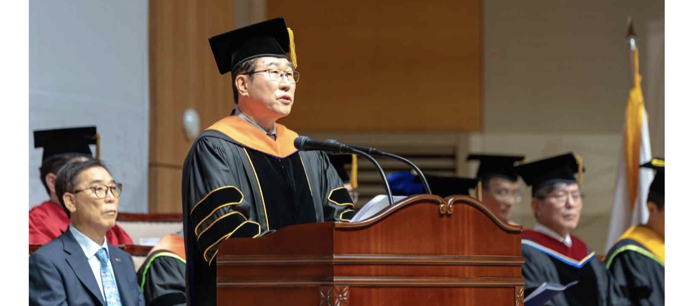

▲ GIST President Kichul Lim is giving a speech at the 2026 second-half degree conferment ceremony.
In particular, following the launch of the ‘Center for Quantum Conversion Research’ (Director Yousoo Kim) in the field of chemistry and the ‘Center for Relativistic Laser Science’ (Director Kyung Taec Kim) in the field of physics in 2024, the ‘Center for Microbiome-Body-Brain Physiology’ (Director Seong-Bae Suh) in the field of life sciences was launched in 2025. With this, GIST now possesses a total of three Institute for Basic Science (IBS) campus research groups across the fields of chemistry, physics, and life sciences, further strengthening its foundation for basic science research.
At the same time, in line with the national policy of fostering the AI ​​and semiconductor sectors, the existing College of Information Computing was expanded and reorganized last July to launch the ‘College of AI.’ By establishing a full-cycle education system extending from undergraduate to master's and doctoral levels with AI and semiconductors as its two main pillars, the university has advanced the system for cultivating AI and semiconductor convergence talent.

