GIST partners with global electron microscope company Gatan to establish advanced analysis technology center
- On Wednesday, August 19, GIST, Gatan, and Lotis Korea signed a business agreement... The 'Gatan Technology Center (GTC)' will be established at the Center for Advanced Instrumental Analysis of the GIST Advanced Institute of Instrumental Analysis
- Operation of an open platform providing training on the latest analytical technologies, equipment demonstrations, and technical support for domestic researchers
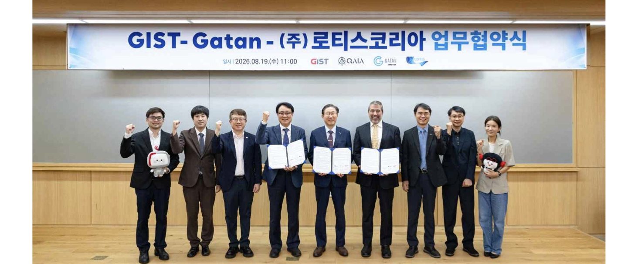

▲ Group photo commemorating the MOU between GIST, Gatan, and Lotis Korea. (From left) Royston Teo, General Manager for Asia at Gatan; Hyunseob Lim, Director of the GIST Advanced Institute of Instrumental Analysis; Yong-Chul Kim, Vice President for R&DB at GIST; Hong-je Seo, CEO of Lotis Korea; Kichul Lim, President of GIST; Stephen Mick, CEO of Gatan; Sungho Jeong, Vice President for Academic Affairs at GIST; Kyung-woo Lee, Director of Lotis Korea; and Eunji Lee, Dean of International and Public Affairs at GIST.
The Gwangju Institute of Science and Technology (GIST, President Kichul Lim) announced that it signed a memorandum of understanding (MOU) with Gatan, a global provider of electron microscope analysis solutions, and its official domestic distributor, Lotis Korea, at the GIST Institute of Machinery and Materials on Wednesday, August 19.
The signing ceremony was attended by key GIST officials, including President Kichul Lim, Vice President for Academic Affairs Sungho Jeong, Vice President for R&DB Yong-Chul Kim, Dean of International and Public Affairs Eunji Lee, and Director of the Advanced Institute of Instrumental Analysis Hyunseob Lim, as well as Gatan CEO Stephen Mick, Asia General Manager Royston Teo, and Lotis Korea, Ltd. CEO Hong-je Seo, Director Kyung-woo Lee, and others attended..
Gatan is a global company that develops and supplies advanced analytical solutions—such as digital cameras, direct electron detectors, energy filters, and image analysis software—necessary for the precise analysis of material structure and composition using electron microscopes. Gatan's equipment and software are utilized in various research projects at major universities, research institutes, and industrial laboratories worldwide.
Lotis Korea Co., Ltd. serves as Gatan's official distributor in Korea, responsible for the domestic supply of related equipment, technical support, and user training, thereby supporting domestic researchers in utilizing electron microscopy analysis technology.
Under this agreement, GIST, Gatan, and Lotis Korea Co., Ltd. will operate the existing electron microscope room at the Center for Advanced Instrumental Analysis of the GIST Advanced Institute of Instrumental Analysis as the "Gatan Technical Center (GTC)."
The Gatan Technical Center is planned to serve as an educational and technical support hub where domestic researchers can learn the latest electron microscopy analysis techniques and experience the equipment firsthand, by combining GIST's advanced electron microscopes with Gatan's latest analysis technology.
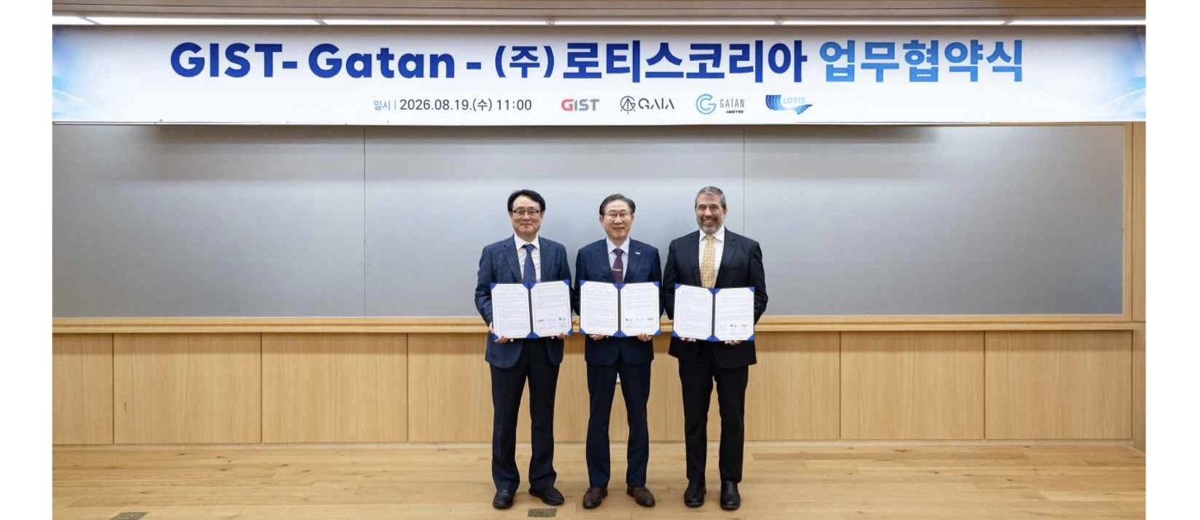

▲ Commemorative photo of the representatives of the GIST-Gatan-Lotis Korea MOU signing institutions. (From left) Hong-je Seo, CEO of Lotis Korea Co., Ltd.; Kichul Lim, President of GIST; and Stephen Mick, CEO of Gatan.
To this end, the three institutions will pursue the following initiatives: ▴ operating user training, technical seminars, and workshops utilizing Gatan equipment; ▴ operating equipment demonstration and experience programs using the latest equipment and software; ▴ providing sample preparation for electron microscope analysis and supporting related equipment and facilities; and ▴ providing analytical technology consulting and equipment utilization support for researchers.
GIST will provide the electron microscopes and related facilities owned by the Center for Advanced Instrumental Analysis at the GIST Advanced Institute of Instrumental Analysis for use in education, equipment demonstrations, and research support.
As Gatan's official domestic partner, Lotis Korea Co., Ltd. supports the operation of the Gatan Technology Center and runs education, seminars, workshops, and technical support programs.
Gatan plans to collaborate by linking its state-of-the-art analytical equipment and application technologies with GIST's electron microscopes, and by providing related software, technical data, and expert technical personnel, enabling domestic researchers to directly experience the latest analytical technologies and utilize them in their research.
Hyunseob Lim, Director of the GIST Advanced Institute of Instrumental Analysis (concurrently serving as Director of the Center for Advanced Instrumental Analysis), stated, "The Gatan Technology Center (GTC) is an important hub for collaboration that connects GIST's excellent research infrastructure with world-class electron microscopy analysis technology." He added, "We will develop it into an open research platform where domestic researchers can learn and utilize the latest analytical technologies, thereby contributing to strengthening national advanced analytical capabilities and research competitiveness."
Stephen Mick, CEO of Gatan, said, "I consider it meaningful that we can provide Korean researchers with world-class analytical technologies and educational programs through our collaboration with GIST." He continued, "I look forward to the Gatan Technology Center establishing itself as a hub that connects the research field with advanced analytical technologies and promotes new research and technological innovation."
Hong-je Seo, CEO of Lotis Korea, stated, “As the official domestic partner of Gatan, we will work closely with GIST to strengthen education and technical support so that researchers can make wider use of the latest electron microscopy analysis technology.”

